  - Operations expansion of the united electronic health information system

Interface Specification and Application Guide
Electronic Recipe Information System
  - NVD.VVIS.REC.PAK.PPS.SIS
  - Version 6.00

2017

Document Change History
Date | Change description | Version | Author | Comment
28.03.2012 | Document structure draft | 0.01 | M. Trušelis
02.05.2012 | Updated document header and footer | 0.02 | M. Trušelis
08.06.2012 | Document draft | 0.03 | J. Džeriņš
02.07.2012 | Document changes according to notes in document NVD.EREC.Analize.NNV.1.00 and changes in functionality of control and supervisor institution. | 0.04 | J. Džeriņš
04.07.2012 | Approved document version | 1.00 | J. Džeriņš
20.07.2012 | Document changes according to project design phase and HL7 standard. | 1.01 | J. Džeriņš
06.08.2012 | Document changes according to notes in document NVD.EREC.SIS.NNV.1.00.  Fixed service “BookMedicationOrders” input parameters. | 1.02 | J. Džeriņš
30.08.2012 | Added CAN.ALL value to table 79 (Element “retrieve” suffix values), renamed field cancellationRequest to cancelMedicationOrderRequest in table table 20 (Payload PORX_MT000025UV01_LV01 elements), corrected data structure CancelMedicationOrderRequest in chapter 5.8. (PORX_MT000025UV01_LV01.CancelMedicationOrderRequest). | 1.03 | J. Džeriņš
04.09.2012 | Removed methods “GetDiagnosisList” and “GetMedicineList” input parameter “retrieve” in chapter 7 (Service usage explanation). | 1.04 | J. Džeriņš
11.10.2012 | Spell error fix:  - potentiallyFullfillableInd -> potentiallyFulfillableInd;  - compensedInd -> compensatedInd;  - physicianSpecialityCode -> physicianSpecialtyCode.  Supplemented data example in chapter 7.1.3.3. Get recipe data.  Removed namespace “hl7” from XML schema examples.  Added error list in appendix.  Added chapter 5.13 HL7 standard data structures usage examples.  Changes in data structure “PORX_MT020070UV01_LV01. CombinedMedicationDispense” (chapter 5.7):  - EHIC.certificateId - removed (EHIC.id will be used);  - EHIC.certificateIssueTime -> EHIC.issueTime;  - EHIC.certificateEffectiveTime -> EHIC.effectiveTime.  Added missed OIDs. | 1.05 | J. Džeriņš
22.11.2012 | Fixed errors, corrected all the XML examples. | 1.06 | J. Džeriņš
07.12.2012 | Fixed data structures: GetCompensationConditions input (payload PORX_MT000003UV01_LV01), COCT_MT050000UV01.Person, COCT_MT230100UV.Medicine, COCT_MT090000UV01.AssignedEntity, PORX_MT010120UV01_LV01.DispenseRequest, PORX_MT020070UV01_LV01.CombinedMedicationDispense, PORX_MT000025UV01_LV01.CancelMedicationOrderRequest, PORX_MT000007UV01_LV01.QueryByParameterPayload.  Fixed OID values, rights spelling mistakes, request and response examples.  Supplemented chapter "5.13 HL7 standard data structures usage examples" with explanation of usage of HL7 structures "name", "address" according to HL7 standard. | 1.07 | J. Džeriņš
15.02.2013 | Fixed pharmacy OID.  Supplemented XML data examples.  GetPatientcontactList rights are fixed. | 1.08 | J. Džeriņš
28.10.2014 | Added continuation services, which are used also in www.latvija.lv. | 1.09 | J. Džeriņš
06.11.2014 | Changes with person address its validation and phone. | 1.10 | J. Džeriņš
19.11.2014 | Updated error list. | 1.11 | M. Trušelis
06.05.2015 | Document updated according to E-Health project 2nd stage requirements (Concluded framework agreements No. VMNVD 2014/3 ERAF and 27 february 2015 contract Nr. VMNVD 2014/3 ERAF 5).  Updated sections: 4. Services subsections, 5.1. PORX_MT010120UV01_LV01LV02.CombinedMedicationRequest, 5.2. COCT_MT050000UV01.Person, 5.3. COCT_MT230100UV.Medicine, 5.4. COCT_MT090000UV01.AssignedEntity, 5.5. PORX_MT010120UV01_LV01LV02.SubstanceAdministrationRequest, 5.6. PORX_MT010120UV01_LV01LV02.DispenseRequest, 5.7. PORX_MT020070UV01_LV01LV02.CombinedMedicationDispense, 5.8. PORX_MT000025UV01_LV01.CancelMedicationOrderRequest, 5.12. QueryByParameterPayload Header, 5.13. PORX_MT000007UV01_LV01LV02.QueryByParameterPayload, 5.14. HL7 standard data structures usage examples, 5.14.1. Medication usage examples, 5.14.3. Quantity usage examples, 7.1.1.5. Get compensation conditions, 7.1.1.6. Book recipe number, 7.1.3.3. Get recipe data, 7.2.1.1. Book medication dispense, 7.2.1.3. Register medication dispense, 7.4.2.3. Get patients contact information by medication, 8.1. Error list  Added sections: 4.22. ValidateMedicationDispense, 7.2.1.2. Validate medication dispense. | 1.12 | J. Džeriņš
28.05.2015 | Document updated according to Customer comments and checklist document “VVIS 1.kārtas dokumentu pārveidošana atbilstoši Projekta prasībām”.  Changed document identifier, number, fonts, updated sections/pages: 1st, 2nd, 3rd pages; 1. Definitions, symbols and abbreviations; 2. Introduction; 5.13. PORX_MT000007UV01_LV02.QueryByParameterPayload – parameter QueryByParameterPayload. parameterList. dispensedMedicine type, ORD.DIS description. | 1.13 | J. Džeriņš
27.07.2015 | Document reviewed. Grammar and formatting corrections done. | 1.14 | V. Rubene | Quality control
06.08.2015 | Document updated according to retrospection. | 1.15 | J. Džeriņš | Updates after retrospection.
18.08.2015 | Document approved version | 2.00 | J. Džeriņš
07.10.2015 | Document updated according to E-Health project 2nd stage requirements (Concluded framework agreements No. VMNVD 2014/3 ERAF and 31 july 2015 contract Nr. VMNVD 2014/3 ERAF 9).  Updated sections (data structures):  6.1. PORX_MT010120UV01_LV02.CombinedMedicationRequest,  6.7. PORX_MT020070UV01_LV02.CombinedMedicationDispense.  Added sections (usage examples):  6.14.1. Potential compensation payer (sponsor) and compensation payer (sponsor) examples,  6.14.2. Person identification and documents examples. | 2.01 | J. Džeriņš
09.10.2015 | Document reviewed | 2.01 | A.Spāģe | Quality control
19.10.2015 | Document updated according to CKS comments. | 2.02 | J. Džeriņš | Update after CKS
22.10.2015 | Document approved version | 3.00 | J. Džeriņš
03.11.2015 | Document updated according to E-Health project 2nd stage requirements (Concluded framework agreements No. VMNVD 2014/3 ERAF and 22 October 2015 contract Nr. VMNVD 2014/3 ERAF 10).  Updated sections (data structures):  6.2. COCT_MT050000UV01.Person,  6.6. PORX_MT010120UV01_LV02.DispenseRequest,  6.7. PORX_MT020070UV01_LV02.CombinedMedicationDispense. | 3.01 | M. Trušelis
10.11.2015 | Document updated according to CKS comments.  Updated sections:  6.2. COCT_MT050000UV01.Person,  6.6. PORX_MT010120UV01_LV02.DispenseRequest,  6.7. PORX_MT020070UV01_LV02.CombinedMedicationDispense,  6.13. PORX_MT000007UV01_LV02.QueryByParameterPayload.  Added sections: 6.14.3. Foreign citizen identification and documents examples. | 3.02 | M. Trušelis | Update after CKS
27.11.2015 | Document updated according to CKS comments.  Updated sections:  6.2. COCT_MT050000UV01.Person,  6.6. PORX_MT010120UV01_LV02.DispenseRequest,  6.7. PORX_MT020070UV01_LV02.CombinedMedicationDispense,  6.13. PORX_MT000007UV01_LV02.QueryByParameterPayload. | 3.03 | M. Trušelis | Update after CKS
07.12.2015 | Document approved version | 4.00 | M. Trušelis
07.12.2015 | Described functions that support permission delegation.  Updated sections:  5.4. GetMedicationOrderData, 5.6. GetMedicationOrderList, 5.15. GetProfile  5.16. SetProfile, 6.9. PORX_MT000019UV01_LV01.ProfileSetupRequest.  Added section:  7. Permission delegation | 4.01 | M. Trušelis
07.04.2016 | Document updated according to March 18 2016 contract Nr. VMNVD 2014/3 ERAF 11.  Updated section:  10.1. Error list. | 5.00 | M. Trušelis
14.04.2016 | Document reviewed | 5.00 | A.Spāģe | Quality control
04.10.2016 | Updated section:  10.1. Error list. | 5.01 | M. Trušelis
05.10.2016 | Updated secitions:  6.7. PORX_MT020070UV01_LV02.CombinedMedicationDispense;  6.14.1. Potential compensation payer (sponsor) and compensation payer (sponsor) examples. | 5.02 | M. Trušelis | Minor fixes.
08.12.2016 | Updated section:  10.1. Error list. | 5.03 | M. Trušelis
09.03.2017 | Updated sections:  6.1. PORX_MT010120UV01_LV02.CombinedMedicationRequest,  6.13. PORX_MT000007UV01_LV02.QueryByParameterPayload,  9.1.3.3. Get recipe data,  9.2.1.1. Book medication dispense,  9.2.1.3. Register medication dispense. | 6.00 | M. Trušelis

Table of Contents
1. No table of figures entries found.Definitions, symbols and abbreviations 16
2. Introduction 16
2.1. Purpose 16
2.1.1. Document purpose 16
2.1.2. Document audience 16
2.2. Scope 16
2.3. References 16
2.4. Document structure 17
3. Interface description 17
4. Interface dependencies 19
5. Services 20
5.1. BookMedicationOrders 20
5.1.1. PORX_IN000001UV01_LV01 interaction 20
5.1.1.1. Payload 20
5.1.2. PORX_IN000002UV01_LV02 interaction 21
5.1.2.1. Payload 21
5.2. GetCompensationConditionList 21
5.2.1. PORX_IN000003UV01_LV01 interaction 22
5.2.1.1. Payload 23
5.2.2. PORX_IN000004UV01_LV01 interaction 24
5.2.2.1. Payload 25
5.3. RegisterMedicationOrder 25
5.3.1. PORX_IN010380UV01_LV02 interaction 26
5.3.1.1. Payload 26
5.3.2. PORX_IN000002UV01_LV02 interaction 26
5.3.2.1. Payload 27
5.4. GetMedicationOrderData 27
5.4.1. PORX_IN000005UV01_LV01 interaction 27
5.4.1.1. Payload 28
5.4.2. PORX_IN000006UV01_LV02 interaction 28
5.4.2.1. Payload 28
5.5. CancelMedicationOrder 28
5.5.1. PORX_IN000025UV01_LV01 interaction 29
5.5.1.1. Payload 29
5.5.2. MCCI_IN000006UV01_LV01 interaction 29
5.6. GetMedicationOrderList 29
5.6.1. PORX_IN000007UV01_LV02 interaction 30
5.6.1.1. Payload 30
5.6.2. PORX_IN000006UV01_LV02 interaction 31
5.6.2.1. Payload 31
5.7. GetMedicationOrderListContinuation 31
5.7.1. QUQI_IN000003UV01_LV01 interaction 31
5.7.1.1. Payload 32
5.7.2. PORX_IN000006UV01_LV02 interaction 32
5.7.2.1. Payload 32
5.8. GetMedicineList 32
5.8.1. PORX_IN000008UV01_LV02 interaction 33
5.8.1.1. Payload 33
5.8.2. PORX_IN000009UV01_LV01 interaction 33
5.8.2.1. Payload 33
5.9. GetDiagnosisList 34
5.9.1. PORX_IN000010UV01_LV02 interaction 34
5.9.1.1. Payload 34
5.9.2. PORX_IN000011UV01_LV01 interaction 35
5.9.2.1. Payload (data) 35
5.10. BookMedicationDispense 35
5.10.1. PORX_IN000012UV01_LV01 interaction 36
5.10.1.1. Payload 36
5.10.2. PORX_IN000013UV01_LV02 interaction 37
5.10.2.1. Payload 37
5.11. RegisterMedicationDispense 37
5.11.1. PORX_IN020170UV01_LV02 interaction 38
5.11.1.1. Payload 38
5.11.2. PORX_IN000013UV01_LV02 interaction 38
5.11.2.1. Payload 39
5.12. CancelMedicationDispense 39
5.12.1. PORX_IN000014UV01_LV01 interaction 39
5.12.1.1. Payload 40
5.12.2. MCCI_IN000006UV01_LV01 interaction 40
5.13. GetMedicationDispenseList 40
5.13.1. PORX_IN000015UV01_LV02 interaction 41
5.13.1.1. Payload 41
5.13.2. PORX_IN000016UV01_LV02 interaction 41
5.13.2.1. Payload 42
5.14. GetMedicationDispenseListContinuation 42
5.14.1. QUQI_IN000003UV01_LV01 interaction 42
5.14.1.1. Payload 43
5.14.2. PORX_IN000016UV01_LV02 interaction 43
5.14.2.1. Payload 43
5.15. GetProfile 43
5.15.1. PORX_IN000017UV01_LV01 interaction 44
5.15.1.1. Payload 44
5.15.2. PORX_IN000018UV01_LV01 interaction 45
5.15.2.1. Payload 45
5.16. SetProfile 45
5.16.1. PORX_IN000019UV01_LV01 interaction 46
5.16.1.1. Payload 46
5.16.2. MCCI_IN000006UV01_LV01 interaction 46
5.17. GetPatientContactList 46
5.17.1. PORX_IN000020UV01_LV02 interaction 47
5.17.1.1. Payload 47
5.17.2. PORX_IN000021UV01_LV01 interaction 47
5.17.2.1. Payload (data) 48
5.18. GetPatientContactListContinuation 48
5.18.1. QUQI_IN000003UV01_LV01 interaction 48
5.18.1.1. Payload 48
5.18.2. PORX_IN000021UV01_LV01 interaction 48
5.18.2.1. Payload (data) 49
5.19. RegisterMedicationWarning 49
5.19.1. PORX_IN000022UV01_LV01 interaction 49
5.19.1.1. Payload 50
5.19.2. MCCI_IN000006UV01_LV01 interaction 50
5.20. GetMedicationWarningList 50
5.20.1. PORX_IN000023UV01_LV01 interaction 50
5.20.1.1. Payload 51
5.20.2. PORX_IN000024UV01_LV01 interaction 51
5.20.2.1. Payload 51
5.21. GetMedicationWarningListContinuation 51
5.21.1. QUQI_IN000003UV01_LV01 interaction 52
5.21.1.1. Payload 52
5.21.2. PORX_IN000024UV01_LV01 interaction 52
5.21.2.1. Payload 52
5.22. ValidateMedicationDispense 53
5.22.1. PORX_IN020170UV01_LV02 interaction 53
5.22.1.1. Payload 53
5.22.2. MCCI_IN000006UV01_LV01 interaction 53
6. Data structures 54
6.1. PORX_MT010120UV01_LV02.CombinedMedicationRequest 54
6.2. COCT_MT050000UV01.Person 60
6.3. COCT_MT230100UV.Medicine 65
6.4. COCT_MT090000UV01.AssignedEntity 67
6.5. PORX_MT010120UV01_LV02.SubstanceAdministrationRequest 70
6.6. PORX_MT010120UV01_LV02.DispenseRequest 73
6.7. PORX_MT020070UV01_LV02.CombinedMedicationDispense 76
6.8. PORX_MT000025UV01_LV01.CancelMedicationOrderRequest 81
6.9. PORX_MT000019UV01_LV01.ProfileSetupRequest 82
6.10. PORX_MT000022UV01_LV01.MedicationWarning 84
6.11. QueyContinuation Header 85
6.12. QueryByParameterPayload Header 86
6.13. PORX_MT000007UV01_LV02.QueryByParameterPayload 88
6.14. HL7 standard data structures usage examples 93
6.14.1. Potential compensation payer (sponsor) and compensation payer (sponsor) examples 94
6.14.2. Person identification and documents examples 95
6.14.3. Foreign citizen identification and documents examples 95
6.14.4. Medication usage examples 96
6.14.5. Period usage examples 96
6.14.6. Quantity usage examples 96
6.14.7. Name usage examples 97
6.14.8. Address usage examples 97
6.14.8.1. Foreign country address 97
6.14.8.2. Latvian address 97
7. Permission delegation 101
8. Traceability matrix 101
9. Services usage explanation 105
9.1. Physician processes 105
9.1.1. Recipe prescription 105
9.1.1.1. Get patient potentially used medicines 105
9.1.1.2. Get frequently used physician diagnoses 106
9.1.1.3. Get medicines frequently prescribed to patient 106
9.1.1.4. Get medicines frequently prescribed by physician 106
9.1.1.5. Get compensation conditions 107
9.1.1.6. Book recipe number 108
9.1.1.7. Prescribe recipe 108
9.1.2. Recipe reservation 108
9.1.2.1. Recipe reservation 108
9.1.3. Get list of recipes 109
9.1.3.1. Get recipes prescribed by physician 109
9.1.3.2. Get patient recipes 109
9.1.3.3. Get recipe data 110
9.1.4. Cancel recipe 112
9.1.4.1. Get recipe 112
9.1.4.2. Cancel recipe 112
9.2. Pharmacist services 112
9.2.1. Medications dispense and dispense cancellation 112
9.2.1.1. Book medication dispense 113
9.2.1.2. Validate medication dispense 115
9.2.1.3. Register medication dispense 115
9.2.1.4. Cancel medication dispense 116
9.2.2. Paper recipe importing 117
9.2.2.1. Get paper recipe data and number 117
9.2.2.2. Import or edit paper recipe data 117
9.2.3. Pharmacy medication 117
9.2.3.1. Get medications prescribed to pharmacy 117
9.2.3.2. Get medications dispensed from pharmacy 118
9.2.4. Patient recipes 118
9.2.4.1. Patient recipes by person code (demo) 118
9.3. Patient services 119
9.3.1. Patients recipes 119
9.3.1.1. Get patient recipes 119
9.3.1.2. Get recipe data 119
9.3.2. Patient pharmacy 119
9.3.2.1. Get pharmacy 119
9.3.2.2. Set pharmacy 120
9.4. Supervisor institution services 120
9.4.1. Recipe management 120
9.4.1.1. Get recipes 120
9.4.1.2. Get recipe data 121
9.4.1.3. Cancel recipe 121
9.4.2. Medication management 121
9.4.2.1. Get medication warnings 121
9.4.2.2. Register medication warning 122
9.4.2.3. Get patients contact information by medication 122
10. Appendixes 123
10.1. Error list 123

List of Images
Picture 1 Interface architecture 18
Picture 2 Messaging concepts 18
Picture 3 Messaging standard 19
Picture 4 BookMedicationOrders service 20
Picture 5 PORX_IN000001UV01_LV01 interaction payload 20
Picture 6 GetCompensationConditionList service 22
Picture 7 PORX_IN000003UV01_LV01 interaction payload 23
Picture 8 PORX_IN000004UV01_LV01 interaction payload 25
Picture 9 RegisterMedicationOrder service 26
Picture 10 GetMedicationOrderData service 27
Picture 11 PORX_IN000005UV01_LV01 interaction payload 28
Picture 12 CancelMedicationOrder service 29
Picture 13 GetMedicationOrderList service 30
Picture 14 GetMedicationOrderListContinuation service 31
Picture 15 GetMedicineList service 33
Picture 16 GetDiagnosisList service 34
Picture 17 PORX_IN000011UV01_LV01 interaction payload (data) 35
Picture 18 BookMedicationDispense service 36
Picture 19 PORX_IN000012UV01_LV01 interaction payload 36
Picture 20 RegisterMedicationDispense service 38
Picture 21 CancelMedicationDispense service 39
Picture 22 PORX_IN000014UV01_LV01 interaction payload 40
Picture 23 GetMedicationDispenseList service 41
Picture 24 GetMedicationDispenseListContinuation service 42
Picture 25 GetProfile service 44
Picture 26 PORX_IN000017UV01_LV01 interaction payload 44
Picture 27 SetProfile service 46
Picture 28 GetPatientContactList service 47
Picture 29 GetPatientContactListContinuation service 48
Picture 30 RegisterMedicationWarning service 49
Picture 31 GetMedicationWarningList service 50
Picture 32 PORX_IN000023UV01_LV01 interaction payload 51
Picture 33 GetMedicationWarningListContinuation service 52
Picture 34 ValidateMedicationDispense service 53
Picture 35 PORX_MT010120UV01_LV02.CombinedMedicationRequest data structure (part 1) 54
Picture 36 PORX_MT010120UV01_LV02.CombinedMedicationRequest data structure (part 2) 55
Picture 37 COCT_MT050000UV01.Person data structure (part 1) 60
Picture 38 COCT_MT050000UV01.Person data structure (part 2) 61
Picture 39 COCT_MT230100UV.Medicine data structure 65
Picture 40 COCT_MT090000UV01.AssignedEntity data structure 67
Picture 41 PORX_MT010120UV01_LV02.SubstanceAdministrationRequest data structure (part 1) 70
Picture 42 PORX_MT010120UV01_LV02.SubstanceAdministrationRequest data structure (part 2) 71
Picture 43 PORX_MT010120UV01_LV02.DispenseRequest data structure 73
Picture 44 PORX_MT020070UV01_LV02.CombinedMedicationDispense data structure 76
Picture 45 PORX_MT000025UV01_LV01.CancelMedicationOrderRequest data structure 81
Picture 46 PORX_MT000019UV01_LV01.ProfileSetupRequest data structure 82
Picture 47 PORX_MT000022UV01_LV01.MedicationWarning data structure 84
Picture 48 QueyContinuation Header data structure 85
Picture 49 QueryByParameterPayload Header data structure 86
Picture 50 PORX_MT000007UV01_LV02.QueryByParameterPayload data structure 88

List of Tables

No table of figures entries found.Definitions, symbols and abbreviations
Table 1 Definitions, acronyms and abbreviations
Acronym, abbreviation | Definition
System | Electronic Recipe Information System
XML | Extensible Markup Language
SOAP | Simple Object Access Protocol
HTTP | Hypertext Transfer Protocol
HTTPS | Hypertext Transfer Protocol Secure
HL7 | Health Level Seven International  (http://www.hl7.org)

Introduction

Purpose

Document purpose
Document describes functional and non-functional requirements to provide the software interface between Electronic Recipe Information System (System) and other central or local information systems involved in healthcare processes. Document includes description of data transfer protocols, data exchange message formats and semantic description.

Document audience
System interface specification (SIS) refers to The National Health Service Latvia (Customer) ordered project “Development of Electronic Recipe Information System” (procurement identification No.VEC 2010/5/ERAF, 1st phase), which is developed by person group Ltd. „In-volv Latvia” & Ltd. „ABC Software” with subcontractor „INDRA SISTEMAS” S.A. (Executor) and project “Expansion of Single Health Information System” (procurement identification No. VM NVD 2014/3 ERAF, 2nd phase) and its contract 27 february 2015 contract Nr. VMNVD 2014/3 ERAF 5 and March 18, 2016 contract Nr. VMNVD 2014/3 ERAF 11, which is developed by Ltd “Lattelecom”.
Document may be made available to third parties by Customer.

Scope
Document refers to compliance with IEEE Std 1016-1998 standard [1] and IEEE Std 1471-2000 standard [10].

References
Table 2 Reference documents
Nr. | Document name (identification, version)
[1] | IEEE Recommended Practice for  Software Design Descriptions (IEEE Std 1016-1998)
[2] | Tehniskās arhitektūras apraksts (NVD.VVIS.TAA.07)
[3] | Projekta Integrācijas platformas informācijas sistēmas izstrāde arhitektūras risinājuma vīzijas documents (NVD.IP.REQ.VIZ.1.07)
[4] | HL7 Version 3 Standard: Transport Specification - Web Services Profile, Release 2  (http://www.hl7.org/v3ballot/html/infrastructure/transport/transport-wsprofiles.html)
[5] | HL7 3.versijas lietotāja ceļvedis (HL7 V3 Guide)
[6] | Programmatūras prasību specifikācija (NVD.VVIS.REC.PAK.PPS.5.00)
[7] | E-veselības Integrācijas Platformas saskarņu vadlīnijas (VEC.STD.WS.1.04)
[8] | E-veselības ziņojumapmaiņā izmantojamo datu struktūras (VEC.STD.HL7.1.02)
[10] | IEEE Recommended Practice for Architectural Description for Software-Intensive Systems (IEEE Std 1471-2000)

Document structure
This document will be structured in the following sections:
- Definitions, symbols and abbreviations – This chapter contains the table of definitions, symbols and abbreviations used in this document.
- Introduction – This chapter contains brief description of the document purpose and content.
- Interface description – This chapter contains a description of the interface architecture and common requirements to data exchange messages and protocols.
- Interface dependencies – This chapter contains a description of the interface dependencies.
- Services – This chapter specifies services published by System, including the detailed description of input and output data structures.
- Data structures – This chapter specifies business data structures used in data exchange messages.
- Permission delegation – This chapter specifies permission delegation.
- Traceability matrix – This chapter contains traceability matrix between specified services and system requirements.
- Services usage explanation – This chapter contains service usage explanation, by providing examples of services and its parameters usage for common processes.
- Appendixes.

Interface description
System provides software interfaces for external service consumers, which are external information systems (i.e. Hospital Information Systems, Pharmacy Information Systems, e-Health Portal), as web services. These web services are published in the e-Health Integration Platform – according to e-Health Architecture Guidelines (see [2]) and e-Health Integration Platform requirements (see [3]).
Next picture illustrates the overall architecture of System interfaces.
Picture 1 Interface architecture
Published web services, as well as XML schemas are available in e-Health Integration Platform catalogue UDDI based catalogue. In terms of messaging, e-Health Integration Platform available web services will use SOAP over HTTP protocol with HL7 v3 extensions for SOAP. Next picture illustrates messaging concepts:
Picture 2 Messaging concepts
For detailed information about Service Catalogue, messaging concepts in e-Health Integration Platform and its message standard see e-Health Integration Platform architectural documentation [3].

System software interface, according to e-Health Integration Platform requirements, supports HL7 message transport standard and uses HL7 message envelope for all messages (see [3], [4], [5], [7] and [8]).

For messages containing clinic information HL7 requirements may also apply to message content itself. Next picture illustrates high level concepts for used message standard in Integration Platform.
Picture 3 Messaging standard

Each service consists of 2 interactions as input and output services. Each interaction consists of 3 layers:
- Transmission wrapper;
- Trigger Event Control Act;
- Payload.

Transmission wrappers used in e-Health are of 2 kinds:
- MCCI_MT000100UV01_LV01 – for input interaction;
- MCCI_MT000200UV01_LV01 – for output interaction.

Trigger Event Control Act used in e-Health is the same for every interaction:
- MCAI_MT700201UV01_LV01.

Payload contains data information. For some of interactions, there can be no data (for example, output iteration with no data); in such cases there have been used interaction:
- MCCI_IN000006UV01_LV01,

In output interactions, there can be returned some messages. For detailed information on services and its interactions see [7].

For every interaction payload and data structure, there is a table of elements, which describes the entire used elements from appropriate schema. Elements, that are not included to table are not used. Additionally, table can contain element, which rows background color is gray – it means that such element is complex type and its further description should be found in appropriate data structure. For every element in table, there is element name, type, cardinality and description.
In service usage explanation, there are main processes and traceability to specific requirement described in the Software requirements specification document [6].

Interface dependencies
Elements of data exchange messages related to patient or healthcare provider identification (name, surname, identification code, etc) depend on the relevant elements definition in the e-Health Integration Platform system analysis and design documents.
Elements – references to common classifiers or central registers depend on the classifier value element definition in the e-Health Integration Platform system analysis and design documents.

Services

BookMedicationOrders
Allows external IS (e-Health Portal or Hospital IS) to book up to X medication orders (X – System parameter) for Y days (Y – System parameter).

Service roles: physician.
Service rights: RegisterMedicationOrder.
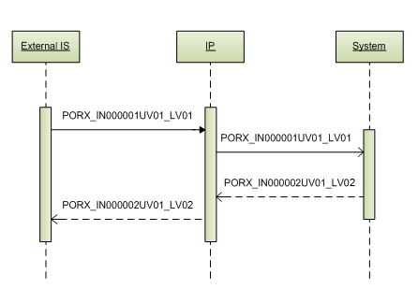
Picture 4 BookMedicationOrders service

PORX_IN000001UV01_LV01 interaction
This is service request interaction to System; its specification is explained in next table.
Table 3 Interaction PORX_IN000001UV01_LV01 interaction specification
Identification | Description
MCCI_MT000100UV01_LV01 | Transmission wrapper
MCAI_MT700201UV01_LV01 | Trigger Event Control Act
PORX_MT000001UV01_LV01 | Payload

Payload
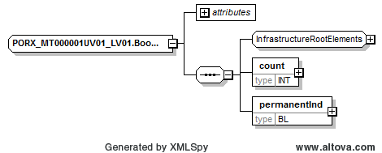
Picture 5 PORX_IN000001UV01_LV01 interaction payload
Payload XML schema:
<xs:complexType name="PORX_MT000001UV01_LV01.BookMedicationOrderRequest">
<xs:sequence>
<xs:group ref="InfrastructureRootElements"/>
<xs:element name="count" type="INT" maxOccurs="1"/>
<xs:element name="permanentInd" type="BL"/>
</xs:sequence>
<xs:attributeGroup ref="InfrastructureRootAttributes"/>
<xs:attribute name="classCode" type="ActClass" use="optional" fixed="ACT"/>
<xs:attribute name="moodCode" type="ActMood" use="optional" fixed="RQO"/>
</xs:complexType>
Table 4 Payload PORX_MT000001UV01_LV01 elements
Element | Type | Cardinality | Description
bookMedicationOrderRequest | PORX_MT000001UV01_LV01.BookMedicationOrderRequest | 1..1
bookMedicationOrderRequest. count | INT | 1..1 | Number of medication orders to book
bookMedicationOrderRequest. permanentInd | BL | 1..1 | Indicator: book permanently medication orders.  Value “true” must be used for recipe reservation (permanent record will be made). Value “false” must be used for recipe prescription (temporary record will be made with its validity date).

PORX_IN000002UV01_LV02 interaction
This is service response interaction from System; its specification is explained in next table.
Table 5 Interaction PORX_IN000002UV01_LV02 interaction specification
Identification | Description
MCCI_MT000200UV01_LV01 | Transmission wrapper
MCAI_MT700201UV01_LV01 | Trigger Event Control Act
PORX_MT010120UV01_LV02 | Payload

Payload
Table 6 Payload PORX_MT010120UV01_LV02 elements
Element | Type | Cardinality | Description
combinedMedicationRequest | PORX_MT010120UV01_LV02.CombinedMedicationRequest | 0..unbounded | See data structure in chapter 6.1.

GetCompensationConditionList
Allows external IS (e-Health Portal, Hospital IS) to get compensation conditions depending on such data: patient, age, gender, diagnosis, medicine, physician specialty.

Service roles: physician.
Service rights: RegisterMedicationOrder.
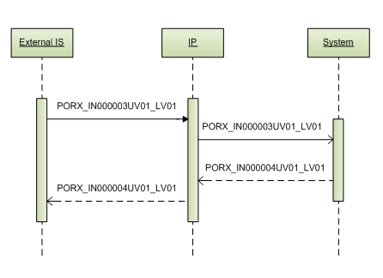
Picture 6 GetCompensationConditionList service

PORX_IN000003UV01_LV01 interaction
This is service request interaction to System; its specification is explained in next table.
Table 7 Interaction PORX_IN000003UV01_LV01 interaction specification
Identification | Description
MCCI_MT000100UV01_LV01 | Transmission wrapper
MCAI_MT700201UV01_LV01 | Trigger Event Control Act
PORX_MT000003UV01_LV01 | Payload

Payload
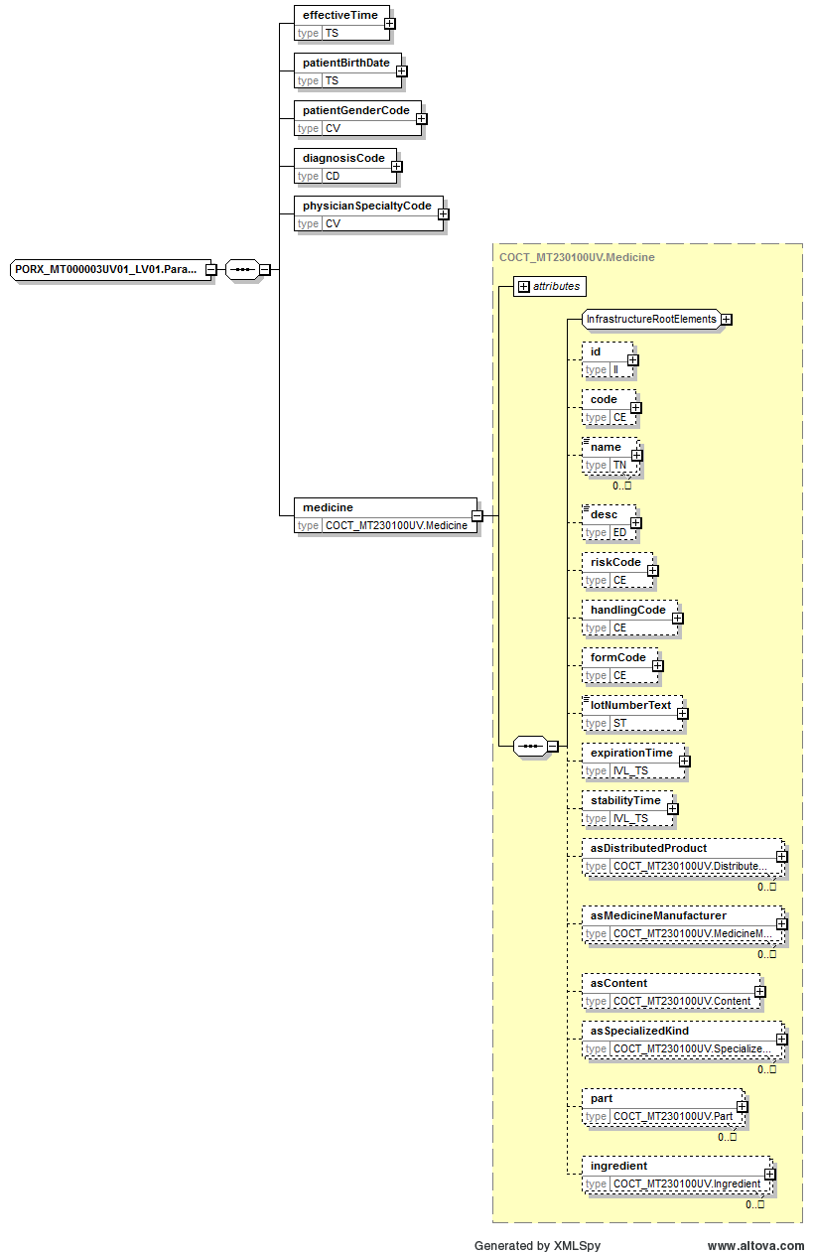
Picture 7 PORX_IN000003UV01_LV01 interaction payload
Payload XML schema:
<xs:complexType name="PORX_MT000003UV01_LV01.ParameterList">
<xs:sequence>
<xs:element name="effectiveTime" type="TS"/>
<xs:element name="patientId" type="II" minOccurs="0"/>
<xs:element name="patientBirthDate" type="TS"/>
<xs:element name="patientGenderCode" type="CV"/>
<xs:element name="diagnosisCode" type="CD"/>
<xs:element name="physicianSpecialtyCode" type="CV"/>
<xs:element name="medicine" type="COCT_MT230100UV.Medicine"/>
</xs:sequence>
</xs:complexType>
Table 8 Payload PORX_MT000003UV01_LV01 elements
Element | Type | Cardinality | Description
QueryByParameterPayload | PORX_MT000003UV01_LV01.QueryByParameterPayload | 1..1 | See data structure in chapter 6.12.
QueryByParameterPayload. parameterList | PORX_MT000003UV01_LV01.ParameterList | 1..1
QueryByParameterPayload. parameterList. effectiveTime | TS | 1..1 | Date for which is requested compensation conditions
QueryByParameterPayload. parameterList. patientId | II | 0..1 | Person identifier.  Personal code for Latvian citizen (OID: 1.3.6.1.4.1.38760.3.1.1).
QueryByParameterPayload. parameterList. patientBirthDate | TS | 1..1 | Patient birth date for compensation validation
QueryByParameterPayload. parameterList. patientGenderCode | CV | 1..1 | Patient gender (OID: 1.3.6.1.4.1.38760.2.111)
QueryByParameterPayload. parameterList. diagnosisCode | CD | 1..1 | Diagnosis and additional diagnosis ICD-10 code (OID: 1.3.6.1.4.1.38760.2.159)
QueryByParameterPayload. parameterList. physicianSpecialtyCode | CV | 1..1 | Physician specialty code (OID: 1.3.6.1.4.1.38760.2.38)
QueryByParameterPayload. parameterList. medicine | COCT_MT230100UV.Medicine | 1..1
QueryByParameterPayload. parameterList. medicine. code | CE | 0..1 | Medical registration number (OID: 1.3.6.1.4.1.38760.2.136) or compensation group (OID: 1.3.6.1.4.1.38760.2.177)
QueryByParameterPayload. parameterList. medicine. formCode | CE | 0..1 | Medicine form code (OID: 1.3.6.1.4.1.38760.2.137)

PORX_IN000004UV01_LV01 interaction
This is service response interaction from System; its specification is explained in next table.
Table 9 Interaction PORX_IN000004UV01_LV01 interaction specification
Identification | Description
MCCI_MT000200UV01_LV01 | Transmission wrapper
MCAI_MT700201UV01_LV01 | Trigger Event Control Act
PORX_MT000004UV01_LV01 | Payload

Payload
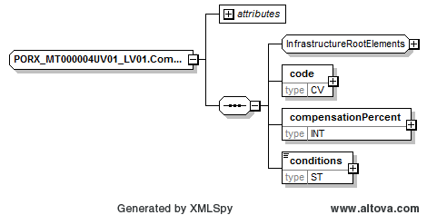
Picture 8 PORX_IN000004UV01_LV01 interaction payload
Payload XML schema:
<xs:complexType name="PORX_MT000004UV01_LV01.CompensationCondition">
<xs:sequence>
<xs:group ref="InfrastructureRootElements"/>
<xs:element name="code" type="CV"/>
<xs:element name="compensationPercent" type="INT"/>
<xs:element name="conditions" type="ST"/>
</xs:sequence>
<xs:attributeGroup ref="InfrastructureRootAttributes"/>
<xs:attribute name="nullFlavor" type="NullFlavor" use="optional"/>
<xs:attribute name="classCode" type="ActClass" use="optional" fixed="ACT"/>
<xs:attribute name="moodCode" type="ActMoodEventCriterion" use="optional" fixed="EVN.CRT"/>
</xs:complexType>
Table 10 Payload PORX_MT000004UV01_LV01 elements
Element | Type | Cardinality | Description
compensationCondition | PORX_MT000004UV01_LV01.CompensationCondition | 0..unbounded
compensationCondition. code | CV | 1..1 | Compensation code (OID: 1.3.6.1.4.1.38760.2.152)
compensationCondition. compensationPercent | INT | 1..1 | Amount of compensation in percentage
compensationCondition. conditions | ST | 1..1 | Conditions of compensation

RegisterMedicationOrder
Allows external IS (e-Health Portal, Hospital IS) to register medication order – prescribe and save it to System by making required validations.
Before this, service “BookMedicationOrders” (see “5.1 BookMedicationOrders”, page 20) must be called to get medication order identifier.

Service role: physician.

Allows external IS (e-Health Portal, Pharmacy IS) to import and edit paper medication order data including all its medication dispenses to System.
Valid paper medication orders which have at least one medication dispense and are dispensed completely can be imported only.

Service roles: pharmacist.

Service rights: RegisterMedicationOrder, ImportMedicationOrder.
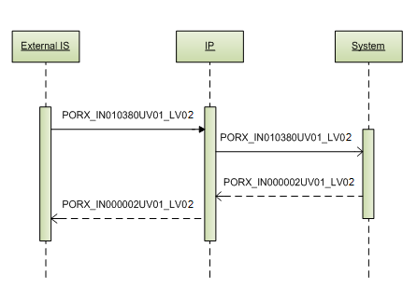
Picture 9 RegisterMedicationOrder service

PORX_IN010380UV01_LV02 interaction
This is service request interaction to System; its specification is explained in next table.
Table 11 Interaction PORX_IN010380UV01_LV02 interaction specification
Identification | Description
MCCI_MT000100UV01_LV01 | Transmission wrapper
MCAI_MT700201UV01_LV01 | Trigger Event Control Act
PORX_MT010120UV01_LV02 | Payload

Payload
Table 12 Payload PORX_MT010120UV01_LV02 elements
Element | Type | Cardinality | Description
combinedMedicationRequest | PORX_MT010120UV01_LV02.CombinedMedicationRequest | 0..1 | See data structure in chapter 6.1.

PORX_IN000002UV01_LV02 interaction
This is service response interaction from System; its specification is explained in next table.
Table 13 Interaction PORX_IN000002UV01_LV02 interaction specification
Identification | Description
MCCI_MT000200UV01_LV01 | Transmission wrapper
MCAI_MT700201UV01_LV01 | Trigger Event Control Act
PORX_MT010120UV01_LV02 | Payload

Payload
Table 14 Payload PORX_MT010120UV01_LV02 elements
Element | Type | Cardinality | Description
combinedMedicationRequest | PORX_MT010120UV01_LV02.CombinedMedicationRequest | 0..unbounded | See data structure in chapter 6.1.

GetMedicationOrderData
Allows external IS (e-Health Portal, Hospital IS, Pharmacy IS) to retrieve all the information about medication order by its identifier. This function supports permission delegation (see chapter 7 Permission delegation).

Service roles: physician, pharmacist, patient, supervising institution.
Service rights: QueryMedicationOrders.
- QueryPatientActiveMedicationOrders – to get specific patient active medication orders;
- QueryPatientAllMedicationOrders – to get specific patient all medication orders;
- QueryOrganizationMedicationOrders – to get specific pharmacy medication orders;
- QueryAllMedicationOrders – to get all medication orders;
- QueryMedicationDispenses – to get medication dispenses;
- QueryCancellationMessages – to get cancelation messages.
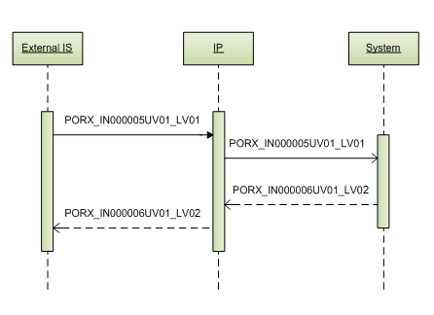
Picture 10 GetMedicationOrderData service

PORX_IN000005UV01_LV01 interaction
This is service request interaction to System; its specification is explained in next table.
Table 15 Interaction PORX_IN000005UV01_LV01 interaction specification
Identification | Description
MCCI_MT000100UV01_LV01 | Transmission wrapper
MCAI_MT700201UV01_LV01 | Trigger Event Control Act
PORX_MT000005UV01_LV01 | Payload

Payload
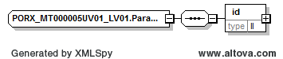
Picture 11 PORX_IN000005UV01_LV01 interaction payload
Payload XML schema:
<xs:complexType name="PORX_MT000005UV01_LV01.ParameterList">
<xs:sequence>
<xs:element name="id" type="II"/>
</xs:sequence>
</xs:complexType>
Table 16 Payload PORX_MT000005UV01_LV01 elements
Element | Type | Cardinality | Description
QueryByParameterPayload | PORX_MT000005UV01_LV01.QueryByParameterPayload | 1..1 | See data structure in chapter 6.12.
QueryByParameterPayload. parameterList | PORX_MT000005UV01_LV01.ParameterList | 1..1
QueryByParameterPayload. parameterList. id | II | 1..1 | Medication order identifier (OID: 1.3.6.1.4.1.38760.3.4.11.1)

PORX_IN000006UV01_LV02 interaction
This is service response interaction from System; its specification is explained in next table.
Table 17 Interaction PORX_IN000006UV01_LV02 interaction specification
Identification | Description
MCCI_MT000200UV01_LV01 | Transmission wrapper
MCAI_MT700201UV01_LV01 | Trigger Event Control Act
PORX_MT010120UV01_LV02 | Payload

Payload
Table 18 Payload PORX_MT010120UV01_LV02 elements
Element | Type | Cardinality | Description
combinedMedicationRequest | PORX_MT010120UV01_LV02.CombinedMedicationRequest | 0..unbounded | See data structure in chapter 6.1.

CancelMedicationOrder
Allows external IS (e-Health Portal, Hospital IS) to cancel medication order by its identifier, requiring passing cancellation reason and date.

Service roles: physician, supervising institution.
Service rights: CancelMedicationOrder.
- CancelAllMedicationOrders – to cancel medication orders.
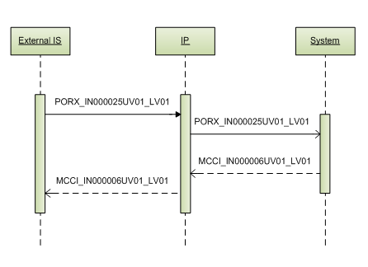
Picture 12 CancelMedicationOrder service

PORX_IN000025UV01_LV01 interaction
This is service request interaction to System; its specification is explained in next table.
Table 19 Interaction PORX_IN000025UV01_LV01 interaction specification
Identification | Description
MCCI_MT000100UV01_LV01 | Transmission wrapper
MCAI_MT700201UV01_LV01 | Trigger Event Control Act
PORX_MT000025UV01_LV01 | Payload

Payload
Table 20 Payload PORX_MT000025UV01_LV01 elements
Element | Type | Cardinality | Description
cancelMedicationOrderRequest | PORX_MT000025UV01_LV01.CancelMedicationOrderRequest | 1..1 | See data structure in chapter 6.8.

MCCI_IN000006UV01_LV01 interaction
This is service response interaction from System; its specification is explained in next table.
Table 21 Interaction MCCI_IN000006UV01_LV01 interaction specification
Identification | Description
MCCI_MT000200UV01_LV01 | Transmission wrapper
MCAI_MT700201UV01_LV01 | Trigger Event Control Act

GetMedicationOrderList
Allows external IS (e-Health Portal, Hospital IS) to retrieve list of medication orders, allowing filtering list by different parameters. This function supports permission delegation (see chapter 7 Permission delegation).
Service roles: physician, pharmacist, patient, supervisor institution.
Service rights: QueryMedicationOrders.
- QueryPatientActiveMedicationOrders – to get specific patient medication orders;
- QueryPatientAllMedicationOrders – to get specific patient all medication orders;
- QueryOrganizationMedicationOrders – to get specific pharmacy medication orders;
- QueryAllMedicationOrders – to get all medication orders;
- QueryMedicationDispenses – to get medication dispenses;
- QueryCancellationMessages – to get cancelation messages.

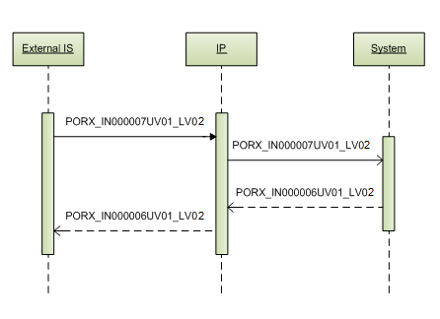
Picture 13 GetMedicationOrderList service

PORX_IN000007UV01_LV02 interaction
This is service request interaction to System; its specification is explained in next table.
Table 22 Interaction PORX_IN000007UV01_LV02 interaction specification
Identification | Description
MCCI_MT000100UV01_LV01 | Transmission wrapper
MCAI_MT700201UV01_LV01 | Trigger Event Control Act
PORX_MT000007UV01_LV02 | Payload

Payload
Table 23 Payload PORX_MT000007UV01_LV02 elements
Element | Type | Cardinality | Description
QueryByParameterPayload | PORX_MT000007UV01_LV02.QueryByParameterPayload | 1..1 | See data structure in chapter 6.13.

PORX_IN000006UV01_LV02 interaction
This is service response interaction from System; its specification is explained in next table.
Table 24 Interaction PORX_IN000006UV01_LV02 interaction specification
Identification | Description
MCCI_MT000200UV01_LV01 | Transmission wrapper
MCAI_MT700201UV01_LV01 | Trigger Event Control Act
PORX_MT010120UV01_LV02 | Payload

Payload
Table 25 Payload PORX_MT010120UV01_LV02 elements
Element | Type | Cardinality | Description
combinedMedicationRequest | PORX_MT010120UV01_LV02.CombinedMedicationRequest | 0..unbounded | See data structure in chapter 6.1.

GetMedicationOrderListContinuation
Allows external IS (e-Health Portal, Hospital IS) to continue retrieving data by pages, started with service “GetMedicationOrderList” request.

Service roles and rights are the same as for service “GetMedicationOrderList”.

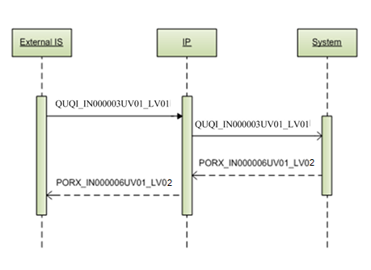
Picture 14 GetMedicationOrderListContinuation service

QUQI_IN000003UV01_LV01 interaction
This is service request interaction to System; its specification is explained in next table.
Table 26 Interaction QUQI_IN000003UV01_LV01 interaction specification
Identification | Description
MCCI_MT000100UV01_LV01 | Transmission wrapper
QUQI_MT000001UV01 | Trigger Event Control Act
QUQI_MT000001UV01 | Payload

Payload
Table 27 Payload PORX_MT000007UV01_LV02 elements
Element | Type | Cardinality | Description
QueryContinuation | QUQI_MT000001UV01.QueryContinuation | 1..1 | See data structure in chapter 6.11.

PORX_IN000006UV01_LV02 interaction
This is service response interaction from System; its specification is explained in next table.
Table 28 Interaction PORX_IN000006UV01_LV02 interaction specification
Identification | Description
MCCI_MT000200UV01_LV01 | Transmission wrapper
MCAI_MT700201UV01_LV01 | Trigger Event Control Act
PORX_MT010120UV01_LV02 | Payload

Payload
Table 29 Payload PORX_MT010120UV01_LV02 elements
Element | Type | Cardinality | Description
combinedMedicationRequest | PORX_MT010120UV01_LV02.CombinedMedicationRequest | 0..unbounded | See data structure in chapter 6.1.

GetMedicineList
Allows external IS (e-Health Portal, Hospital IS) to retrieve list of medicines frequently prescribed by physician or to patient during X month ago (X – System parameter).

Service roles: physician.
Service rights: QueryMedicationOrders.
- QueryPatientActiveMedicationOrders – to get specific patient active medication orders;
- QueryPatientAllMedicationOrders – to get specific patient all medication orders;
- QueryOrganizationMedicationOrders – to get specific pharmacy medication orders;
- QueryAllMedicationOrders – to get all medication orders.

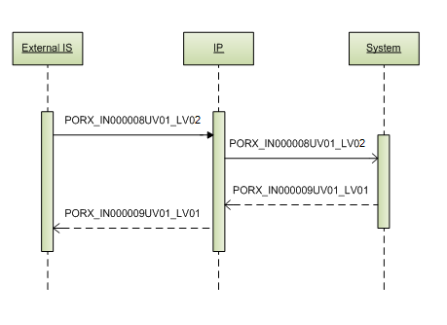
Picture 15 GetMedicineList service

PORX_IN000008UV01_LV02 interaction
This is service request interaction to System; its specification is explained in next table.
Table 30 Interaction PORX_IN000008UV01_LV02 interaction specification
Identification | Description
MCCI_MT000100UV01_LV01 | Transmission wrapper
MCAI_MT700201UV01_LV01 | Trigger Event Control Act
PORX_MT000007UV01_LV02 | Payload

Payload
Table 31 Payload PORX_MT000007UV01_LV02 elements
Element | Type | Cardinality | Description
QueryByParameterPayload | PORX_MT000007UV01_LV02.QueryByParameterPayload | 1..1 | See data structure in chapter 6.13.

PORX_IN000009UV01_LV01 interaction
This is service response interaction from System; its specification is explained in next table.
Table 32 Interaction PORX_IN000009UV01_LV01 interaction specification
Identification | Description
MCCI_MT000200UV01_LV01 | Transmission wrapper
MCAI_MT700201UV01_LV01 | Trigger Event Control Act
COCT_MT230100UV | Payload

Payload
Table 33 Payload COCT_MT230100UV elements
Element | Type | Cardinality | Description
medicine | COCT_MT230100UV.Medicine | 0..unbounded | See data structure in chapter 6.3.

GetDiagnosisList
Allows external IS (e-Health Portal, Hospital IS) to retrieve list of diagnoses frequently used by physician during X month ago (X – System parameter).

Service roles: physician.
Service rights: QueryMedicationOrders.
- QueryPatientActiveMedicationOrders – to get specific patient medication orders;
- QueryPatientAllMedicationOrders to get specific patient all medication orders;
- QueryOrganizationMedicationOrders – to get specific pharmacy medication orders.
- QueryAllMedicationOrders – to get all medication orders.
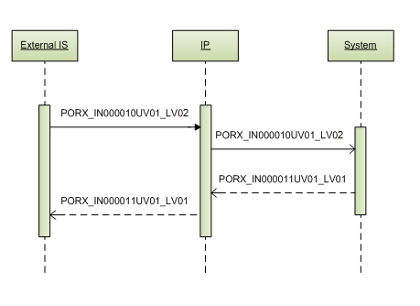
Picture 16 GetDiagnosisList service

PORX_IN000010UV01_LV02 interaction
This is service request interaction to System; its specification is explained in next table.
Table 34 Interaction PORX_IN000010UV01_LV02 interaction specification
Identification | Description
MCCI_MT000100UV01_LV01 | Transmission wrapper
MCAI_MT700201UV01_LV01 | Trigger Event Control Act
PORX_MT000007UV01_LV02 | Payload

Payload
Table 35 Payload PORX_MT000007UV01_LV02 elements
Element | Type | Cardinality | Description
QueryByParameterPayload | PORX_MT000007UV01_LV02.QueryByParameterPayload | 1..1 | See data structure in chapter 6.13.

PORX_IN000011UV01_LV01 interaction
This is service response interaction from System; its specification is explained in next table.
Table 36 Interaction PORX_IN000011UV01_LV01 interaction specification
Identification | Description
MCCI_MT000200UV01_LV01 | Transmission wrapper
MCAI_MT700201UV01_LV01 | Trigger Event Control Act

Payload (data)
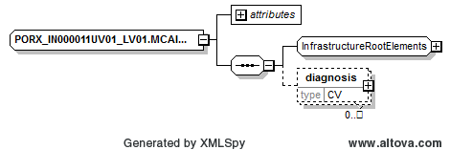
Picture 17 PORX_IN000011UV01_LV01 interaction payload (data)
Payload XML schema:
<xs:complexType name="PORX_IN000011UV01_LV01.MCAI_MT700201UV01_LV01.Subject">
<xs:sequence>
<xs:group ref="InfrastructureRootElements"/>
<xs:element name="diagnosis" type="CV" minOccurs="0" maxOccurs="unbounded"/>
</xs:sequence>
<xs:attributeGroup ref="InfrastructureRootAttributes"/>
<xs:attribute name="nullFlavor" type="NullFlavor" use="optional"/>
<xs:attribute name="typeCode" type="ActRelationshipHasSubject" use="required" fixed="SUBJ"/>
<xs:attribute name="contextConductionInd" type="bl" use="optional" default="false"/>
</xs:complexType>
Table 37 Payload (data) elements
Element | Type | Cardinality | Description
diagnosis | CV | 0..unbounded | Diagnosis ICD-10 code (OID: 1.3.6.1.4.1.38760.2.159)

BookMedicationDispense
Allows external IS (e-Health Portal, Pharmacy IS) to retrieve medication order data for medication dispensing (including new medication dispense identifier, which is valid for Y hours, where Y – System parameter), in addition, blocking the medication order for submitting or canceling medication dispense, if necessary pass the real medication dispense date to validate medication dispensing correctly.

Service roles: pharmacist.
Service rights: QueryMedicationOrders, RegisterMedicationDispense.
- QueryPatientActiveMedicationOrders – to get specific patient active medication orders;
- QueryPatientAllMedicationOrders – to get specific patient all medication orders;
- QueryOrganizationMedicationOrders – to get specific pharmacy medication orders;
- QueryAllMedicationOrders – to get all medication orders.

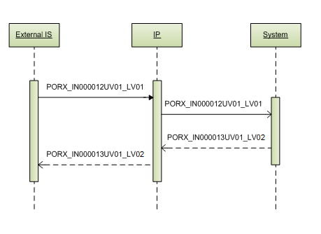
Picture 18 BookMedicationDispense service

PORX_IN000012UV01_LV01 interaction
This is service request interaction to System; its specification is explained in next table.
Table 38 Interaction PORX_IN000012UV01_LV01 interaction specification
Identification | Description
MCCI_MT000100UV01_LV01 | Transmission wrapper
MCAI_MT700201UV01_LV01 | Trigger Event Control Act
PORX_MT000012UV01_LV01 | Payload

Payload
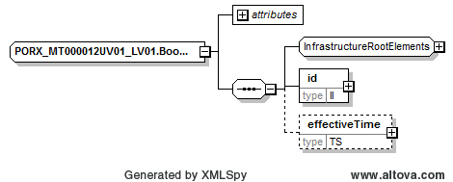
Picture 19 PORX_IN000012UV01_LV01 interaction payload
Payload XML schema:
<xs:complexType name="PORX_MT000012UV01_LV01.BookMedicationDispenseRequest">
<xs:sequence>
<xs:group ref="InfrastructureRootElements"/>
<xs:element name="id" type="II" minOccurs="1" maxOccurs="1"/>
<xs:element name="effectiveTime" type="TS" minOccurs="0"/>
</xs:sequence>
<xs:attributeGroup ref="InfrastructureRootAttributes"/>
<xs:attribute name="classCode" type="ActClass" use="optional" fixed="ACT"/>
<xs:attribute name="moodCode" type="ActMood" use="optional" fixed="RQO"/>
</xs:complexType>
Table 39 Payload PORX_MT000012UV01_LV01 elements
Element | Type | Cardinality | Description
bookMedicationDispenseRequest | PORX_MT000012UV01_LV01.BookMedicationDispenseRequest | 1..1
bookMedicationDispenseRequest. id | II | 1..1 | Medication order id (OID: 1.3.6.1.4.1.38760.3.4.11.1)
bookMedicationDispenseRequest. effectiveTime | TS | 0..1 | Medication dispense time, required only if fulfillment of medication dispense to System is being made after a time

PORX_IN000013UV01_LV02 interaction
This is service response interaction from System; its specification is explained in next table.
Table 40 Interaction PORX_IN000013UV01_LV02 interaction specification
Identification | Description
MCCI_MT000200UV01_LV01 | Transmission wrapper
MCAI_MT700201UV01_LV01 | Trigger Event Control Act
PORX_MT020070UV01_LV02 | Payload

Payload
Table 41 Payload PORX_MT020070UV01_LV02 elements
Element | Type | Cardinality | Description
combinedMedicationDispense | PORX_MT020070UV01_LV02.CombinedMedicationDispense | 0..1 | See data structure in chapter 6.7.

RegisterMedicationDispense
Allows external IS (e-Health Portal, Pharmacy IS) to add or edit medication dispense data to medication order. For editing medication dispense, medication dispense identifier must be passed.
For new medication dispense submitting, before this, service “BookMedicationDispense” (see “5.10 BookMedicationDispense”, page 35) must be called to block medication order for data modifications and to get appropriate medication dispense identifier.
For existing medication dispense editing, before this, service “GetMedicationOrderData” (see “5.4 GetMedicationOrderData”, page 27) must be called to get appropriate medication dispense identifier.

Service roles: pharmacist.
Service rights: RegisterMedicationDispense.
- EditMedicationDispense –to edit medication dispense.

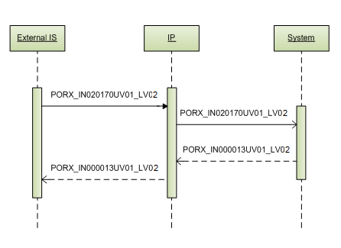
Picture 20 RegisterMedicationDispense service

PORX_IN020170UV01_LV02 interaction
This is service request interaction to System; its specification is explained in next table.
Table 42 Interaction PORX_IN020170UV01_LV02 interaction specification
Identification | Description
MCCI_MT000100UV01_LV01 | Transmission wrapper
MCAI_MT700201UV01_LV01 | Trigger Event Control Act
PORX_MT020070UV01_LV02 | Payload

Payload
Table 43 Payload PORX_MT020070UV01_LV02 elements
Element | Type | Cardinality | Description
combinedMedicationDispense | PORX_MT020070UV01_LV02.CombinedMedicationDispense | 0..1 | See data structure in chapter 6.7.

PORX_IN000013UV01_LV02 interaction
This is service response interaction from System; its specification is explained in next table.
Table 44 Interaction PORX_IN000013UV01_LV02 interaction specification
Identification | Description
MCCI_MT000200UV01_LV01 | Transmission wrapper
MCAI_MT700201UV01_LV01 | Trigger Event Control Act
PORX_MT020070UV01_LV02 | Payload

Payload
Table 45 Payload PORX_MT020070UV01_LV02 elements
Element | Type | Cardinality | Description
combinedMedicationDispense | PORX_MT020070UV01_LV02.CombinedMedicationDispense | 0..1 | See data structure in chapter 6.7.

CancelMedicationDispense
Allows external IS (e-Health Portal, Pharmacy IS) to cancel medication dispense adding or editing. Medication dispense identifier must be passed.
Before this, service ““BookMedicationDispense” (see “5.10 BookMedicationDispense”, page 35) must be called to block medication order for data modifications and to get appropriate medication dispense identifier.

Service roles: pharmacist.
Service rights: RegisterMedicationDispense.
- CancelMedicationDispense – to cancel medication dispense.
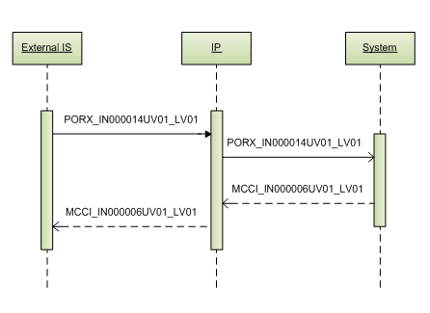
Picture 21 CancelMedicationDispense service

PORX_IN000014UV01_LV01 interaction
This is service request interaction to System; its specification is explained in next table.
Table 46 Interaction PORX_IN000014UV01_LV01 interaction specification
Identification | Description
MCCI_MT000100UV01_LV01 | Transmission wrapper
MCAI_MT700201UV01_LV01 | Trigger Event Control Act
PORX_MT000014UV01_LV01 | Payload

Payload
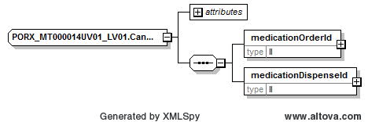
Picture 22 PORX_IN000014UV01_LV01 interaction payload
Payload XML schema:
<xs:complexType name="PORX_MT000014UV01_LV01.CancelMedicationDispenseRequest">
<xs:sequence>
<xs:element name="medicationOrderId" type="II"/>
<xs:element name="medicationDispenseId" type="II"/>
</xs:sequence>
<xs:attribute name="nullFlavor" type="NullFlavor" use="optional"/>
<xs:attribute name="classCode" type="ActClass" use="optional" fixed="ACT"/>
<xs:attribute name="moodCode" type="ActMoodRequest" use="required" fixed="RQO"/>
</xs:complexType>
Table 47 Payload PORX_MT000014UV01_LV01 elements
Element | Type | Cardinality | Description
cancelMedicationDispenseRequest | PORX_MT000014UV01_LV01.CancelMedicationDispenseRequest | 1..1
cancelMedicationDispenseRequest. medicationOrderId | II | 1..1 | Medication order id (OID: 1.3.6.1.4.1.38760.3.4.11.1)
cancelMedicationDispenseRequest. medicationDispenseId | II | 1..1 | Medication dispense id (OID: 1.3.6.1.4.1.38760.3.4.11.3)

MCCI_IN000006UV01_LV01 interaction
This is service response interaction from System; its specification is explained in next table.
Table 48 Interaction MCCI_IN000006UV01_LV01 interaction specification
Identification | Description
MCCI_MT000200UV01_LV01 | Transmission wrapper
MCAI_MT700201UV01_LV01 | Trigger Event Control Act

GetMedicationDispenseList
Allows external IS (e-Health Portal, Pharmacy IS) to retrieve list of medication dispenses, which was made in pharmacy, allowing filtering list by date, compensated/all medicines.

Service roles: pharmacist.
Service rights: QueryMedicationOrders, QueryMedicationDispenses.
- QueryPatientActiveMedicationOrders – to get specific patient active medication orders;
- QueryPatientAllMedicationOrders – to get specific patient all medication orders;
- QueryOrganizationMedicationOrders – to get specific pharmacy medication orders;
- QueryAllMedicationOrders – to get all medication orders.
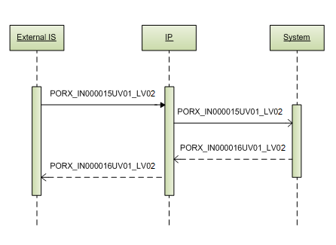
Picture 23 GetMedicationDispenseList service

PORX_IN000015UV01_LV02 interaction
This is service request interaction to System; its specification is explained in next table.
Table 49 Interaction PORX_IN000015UV01_LV02 interaction specification
Identification | Description
MCCI_MT000100UV01_LV01 | Transmission wrapper
MCAI_MT700201UV01_LV01 | Trigger Event Control Act
PORX_MT000007UV01_LV02 | Payload

Payload
Table 50 Payload PORX_MT000007UV01_LV02 elements
Element | Type | Cardinality | Description
QueryByParameterPayload | PORX_MT000007UV01_LV02.QueryByParameterPayload | 1..1 | See data structure in chapter 6.13.

PORX_IN000016UV01_LV02 interaction
This is service response interaction from System; its specification is explained in next table.
Table 51 Interaction PORX_IN000016UV01_LV02 interaction specification
Identification | Description
MCCI_MT000200UV01_LV01 | Transmission wrapper
MCAI_MT700201UV01_LV01 | Trigger Event Control Act
PORX_MT020070UV01_LV02 | Payload

Payload
Table 52 Payload PORX_MT020070UV01_LV02 elements
Element | Type | Cardinality | Description
combinedMedicationDispense | PORX_MT020070UV01_LV02.CombinedMedicationDispense | 0..unbounded | See data structure in chapter 6.7.

GetMedicationDispenseListContinuation
Allows external IS (e-Health Portal, Pharmacy IS) to continue retrieving data by pages, started with service “GetMedicationDispenseList” request.

Service roles and rights are the same as for service “GetMedicationDispenseList”.

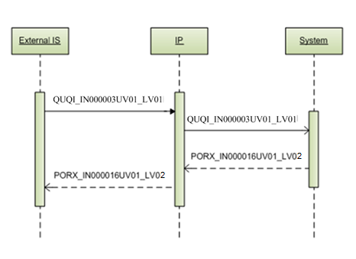
Picture 24 GetMedicationDispenseListContinuation service

QUQI_IN000003UV01_LV01 interaction
This is service request interaction to System; its specification is explained in next table.
Table 53 Interaction QUQI_IN000003UV01_LV01 interaction specification
Identification | Description
MCCI_MT000100UV01_LV01 | Transmission wrapper
QUQI_MT000001UV01 | Trigger Event Control Act
QUQI_MT000001UV01 | Payload

Payload
Table 54 Payload PORX_MT000007UV01_LV02 elements
Element | Type | Cardinality | Description
QueryContinuation | QUQI_MT000001UV01.QueryContinuation | 1..1 | See data structure in chapter 6.11.

PORX_IN000016UV01_LV02 interaction
This is service response interaction from System; its specification is explained in next table.
Table 55 Interaction PORX_IN000016UV01_LV02 interaction specification
Identification | Description
MCCI_MT000200UV01_LV01 | Transmission wrapper
MCAI_MT700201UV01_LV01 | Trigger Event Control Act
PORX_MT020070UV01_LV02 | Payload

Payload
Table 56 Payload PORX_MT020070UV01_LV02 elements
Element | Type | Cardinality | Description
combinedMedicationDispense | PORX_MT020070UV01_LV02.CombinedMedicationDispense | 0..unbounded | See data structure in chapter 6.7.

GetProfile
Allows external IS (e-Health Portal) to retrieve patient’s pharmacy from its profile information. This function supports permission delegation (see chapter 7 Permission delegation).

Service roles: patient.
Service rights: GetProfile.
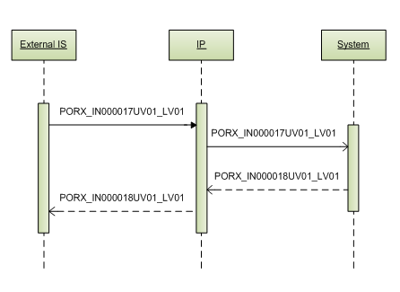
Picture 25 GetProfile service

PORX_IN000017UV01_LV01 interaction
This is service request interaction to System; its specification is explained in next table.
Table 57 Interaction PORX_IN000017UV01_LV01 interaction specification
Identification | Description
MCCI_MT000100UV01_LV01 | Transmission wrapper
MCAI_MT700201UV01_LV01 | Trigger Event Control Act
PORX_MT000017UV01_LV01 | Payload

Payload
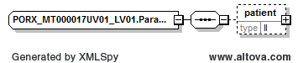
Picture 26 PORX_IN000017UV01_LV01 interaction payload
Payload XML schema:
<xs:complexType name="PORX_MT000017UV01_LV01.ParameterList">
<xs:sequence>
<xs:element name="patient" type="II" minOccurs="0"/>
</xs:sequence>
</xs:complexType>
Table 58 Payload PORX_MT000017UV01_LV01 elements
Element | Type | Cardinality | Description
QueryByParameterPayload | PORX_MT000017UV01_LV01.QueryByParameterPayload | 1..1 | See data structure in chapter 6.12.
QueryByParameterPayload. parameterList | PORX_MT000017UV01_LV01.ParameterList | 1..1
QueryByParameterPayload. parameterList. patient | II | 0..1 | Profile holder’s person identifier.  Personal code for Latvian citizen (OID: 1.3.6.1.4.1.38760.3.1.1).

PORX_IN000018UV01_LV01 interaction
This is service response interaction from System; its specification is explained in next table.
Table 59 Interaction PORX_IN000018UV01_LV01 interaction specification
Identification | Description
MCCI_MT000200UV01_LV01 | Transmission wrapper
MCAI_MT700201UV01_LV01 | Trigger Event Control Act
PORX_MT000019UV01_LV01 | Payload

Payload
Table 60 Payload PORX_MT000019UV01_LV01 elements
Element | Type | Cardinality | Description
profileSetupRequest | PORX_MT000019UV01_LV01.ProfileSetupRequest | 0..1 | See data structure in chapter 6.9.

SetProfile
Allows external IS (e-Health Portal) to save patients pharmacy to its profile information. This function supports permission delegation (see chapter 7 Permission delegation).

Service roles: patient.
Service rights: SetProfile.
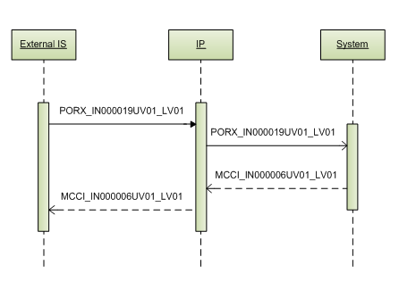
Picture 27 SetProfile service

PORX_IN000019UV01_LV01 interaction
This is service request interaction to System; its specification is explained in next table.
Table 61 Interaction PORX_IN000019UV01_LV01 interaction specification
Identification | Description
MCCI_MT000100UV01_LV01 | Transmission wrapper
MCAI_MT700201UV01_LV01 | Trigger Event Control Act
PORX_MT000019UV01_LV01 | Payload

Payload
Table 62 Payload PORX_MT000019UV01_LV01 elements
Element | Type | Cardinality | Description
profileSetupRequest | PORX_MT000019UV01_LV01.ProfileSetupRequest | 1..1 | See data structure in chapter 6.9.

MCCI_IN000006UV01_LV01 interaction
This is service response interaction from System; its specification is explained in next table.
Table 63 Interaction MCCI_IN000006UV01_LV01 interaction specification
Identification | Description
MCCI_MT000200UV01_LV01 | Transmission wrapper
MCAI_MT700201UV01_LV01 | Trigger Event Control Act

GetPatientContactList
Allows external IS (e-Health Portal) to retrieve list of patient contact, for whom there were prescribed medication orders with recalled medicine, by passing recalled medicine.
Service roles: supervisor institution.
Service rights: QueryMedicationOrders.
- QueryAllMedicationOrders – to get all medication orders.

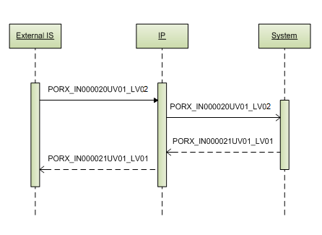
Picture 28 GetPatientContactList service

PORX_IN000020UV01_LV02 interaction
This is service request interaction to System; its specification is explained in next table.
Table 64 Interaction PORX_IN000020UV01_LV02 interaction specification
Identification | Description
MCCI_MT000100UV01_LV01 | Transmission wrapper
MCAI_MT700201UV01_LV01 | Trigger Event Control Act
PORX_MT000007UV01_LV02 | Payload

Payload
Table 65 Payload PORX_MT000007UV01_LV02 elements
Element | Type | Cardinality | Description
QueryByParameterPayload | PORX_MT000007UV01_LV02.QueryByParameterPayload | 1..1 | See data structure in chapter 6.13.

PORX_IN000021UV01_LV01 interaction
This is service response interaction from System; its specification is explained in next table.
Table 66 Interaction PORX_IN000021UV01_LV01 interaction specification
Identification | Description
MCCI_MT000200UV01_LV01 | Transmission wrapper
MCAI_MT700201UV01_LV01 | Trigger Event Control Act

Payload (data)
Table 67 Payload (data) elements
Element | Type | Cardinality | Description
person | COCT_MT050000UV01.Person | 0..unbounded | See data structure in chapter 6.2.

GetPatientContactListContinuation
Allows external IS (e-Health Portal) to continue retrieving data by pages, started with service “GetPatientContactList” request.

Service roles and rights are the same as for service “GetPatientContactList”.
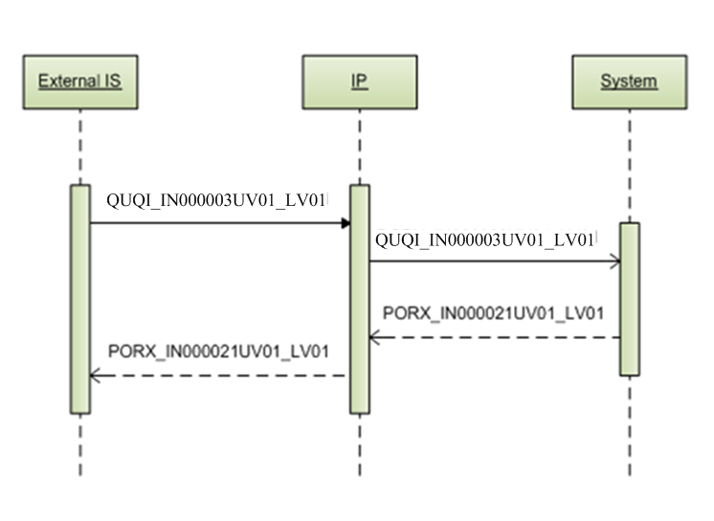
Picture 29 GetPatientContactListContinuation service

QUQI_IN000003UV01_LV01 interaction
This is service request interaction to System; its specification is explained in next table.
Table 68 Interaction QUQI_IN000003UV01_LV01 interaction specification
Identification | Description
MCCI_MT000100UV01_LV01 | Transmission wrapper
QUQI_MT000001UV01 | Trigger Event Control Act
QUQI_MT000001UV01 | Payload

Payload
Table 69 Payload PORX_MT000007UV01_LV02 elements
Element | Type | Cardinality | Description
QueryContinuation | QUQI_MT000001UV01.QueryContinuation | 1..1 | See data structure in chapter 6.11.

PORX_IN000021UV01_LV01 interaction
This is service response interaction from System; its specification is explained in next table.
Table 70 Interaction PORX_IN000021UV01_LV01 interaction specification
Identification | Description
MCCI_MT000200UV01_LV01 | Transmission wrapper
MCAI_MT700201UV01_LV01 | Trigger Event Control Act

Payload (data)
Table 71 Payload (data) elements
Element | Type | Cardinality | Description
person | COCT_MT050000UV01.Person | 0..unbounded | See data structure in chapter 6.2.

RegisterMedicationWarning
Allows external IS (e-Health Portal) to register medication warning, if it is dangerous or because of any other reasonable reason, requiring passing the medicine, warning message and show mode (none, show for physician only, show for physician and pharmacist).

Service roles: supervisor institution.
Service rights: RegisterMedicationWarning.
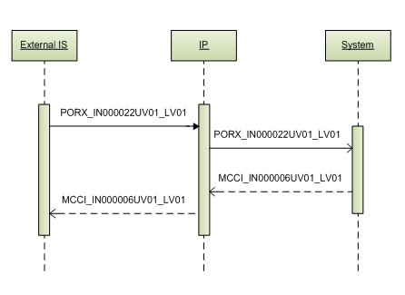
Picture 30 RegisterMedicationWarning service

PORX_IN000022UV01_LV01 interaction
This is service request interaction to System; its specification is explained in next table.
Table 72 Interaction PORX_IN000022UV01_LV01 interaction specification
Identification | Description
MCCI_MT000100UV01_LV01 | Transmission wrapper
MCAI_MT700201UV01_LV01 | Trigger Event Control Act
PORX_MT000022UV01_LV01 | Payload

Payload
Table 73 Payload PORX_MT000022UV01_LV01 elements
Element | Type | Cardinality | Description
medicationWarning | PORX_MT000022UV01_LV01.MedicationWarning | 1..1 | See data structure in chapter 6.10.

MCCI_IN000006UV01_LV01 interaction
This is service response interaction from System; its specification is explained in next table.
Table 74 Interaction MCCI_IN000006UV01_LV01 interaction specification
Identification | Description
MCCI_MT000200UV01_LV01 | Transmission wrapper
MCAI_MT700201UV01_LV01 | Trigger Event Control Act

GetMedicationWarningList
Allows external IS (e-Health Portal) to retrieve list of medication warnings for supervisor institution, allowing filtering by date active/all medicine warnings.

Service roles: supervisor institution.
Service rights: QueryMedicationWarnings.
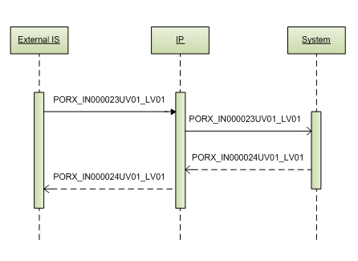
Picture 31 GetMedicationWarningList service

PORX_IN000023UV01_LV01 interaction
This is service request interaction to System; its specification is explained in next table.
Table 75 Interaction PORX_IN000023UV01_LV01 interaction specification
Identification | Description
MCCI_MT000100UV01_LV01 | Transmission wrapper
MCAI_MT700201UV01_LV01 | Trigger Event Control Act
PORX_MT000023UV01_LV01 | Payload

Payload
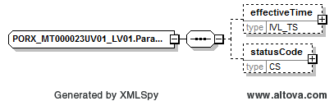
Picture 32 PORX_IN000023UV01_LV01 interaction payload
Payload XML schema:
<xs:complexType name="PORX_MT000023UV01_LV01.ParameterList">
<xs:sequence>
<xs:element name="effectiveTime" type="IVL_TS" minOccurs="0"/>
<xs:element name="statusCode" type="CS" minOccurs="0"/>
</xs:sequence>
</xs:complexType>
Table 76 Payload PORX_MT000023UV01_LV01 elements
Element | Type | Cardinality | Description
QueryByParameterPayload | PORX_MT000023UV01_LV01.QueryByParameterPayload | 1..1 | See data structure in chapter 6.12.
QueryByParameterPayload. parameterList | PORX_MT000023UV01_LV01.ParameterList | 1..1
QueryByParameterPayload. parameterList. effectiveTime | IVL_TS | 0..1 | Date from-to
QueryByParameterPayload. parameterList. statusCode | CS | 0..1 | Medication warning status (active – for active, obsolete – for obsolete)

PORX_IN000024UV01_LV01 interaction
This is service response interaction from System; its specification is explained in next table.
Table 77 Interaction PORX_IN000024UV01_LV01 interaction specification
Identification | Description
MCCI_MT000200UV01_LV01 | Transmission wrapper
MCAI_MT700201UV01_LV01 | Trigger Event Control Act
PORX_MT000022UV01_LV01 | Payload

Payload
Table 78 Payload PORX_MT000022UV01_LV01 elements
Element | Type | Cardinality | Description
medicationWarning | PORX_MT000022UV01_LV01.MedicationWarning | 0..unbounded | See data structure in chapter 6.10.

GetMedicationWarningListContinuation
Allows external IS (e-Health Portal) to continue retrieving data by pages, started with service “GetMedicationWarningList” request.

Service roles and rights are the same as for service “GetMedicationWarningList”.
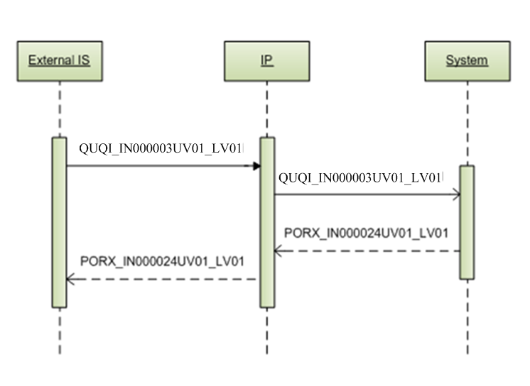
Picture 33 GetMedicationWarningListContinuation service

QUQI_IN000003UV01_LV01 interaction
This is service request interaction to System; its specification is explained in next table.
Table 79 Interaction QUQI_IN000003UV01_LV01 interaction specification
Identification | Description
MCCI_MT000100UV01_LV01 | Transmission wrapper
QUQI_MT000001UV01 | Trigger Event Control Act
QUQI_MT000001UV01 | Payload

Payload
Table 80 Payload PORX_MT000007UV01_LV02 elements
Element | Type | Cardinality | Description
QueryContinuation | QUQI_MT000001UV01.QueryContinuation | 1..1 | See data structure in chapter 6.11.

PORX_IN000024UV01_LV01 interaction
This is service response interaction from System; its specification is explained in next table.
Table 81 Interaction PORX_IN000024UV01_LV01 interaction specification
Identification | Description
MCCI_MT000200UV01_LV01 | Transmission wrapper
MCAI_MT700201UV01_LV01 | Trigger Event Control Act
PORX_MT000022UV01_LV01 | Payload

Payload
Table 82 Payload PORX_MT000022UV01_LV01 elements
Element | Type | Cardinality | Description
medicationWarning | PORX_MT000022UV01_LV01.MedicationWarning | 0..unbounded | See data structure in chapter 6.10.

ValidateMedicationDispense
Allow external IS (e-Health Portal, Pharmacy IS) to validate medication dispense data before its registration.

Service roles: pharmacist.
Service rights: ValidateMedicationDispense.

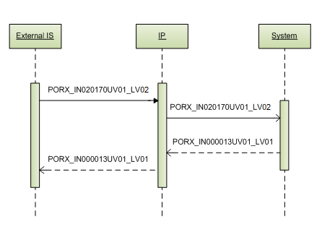
Picture 34 ValidateMedicationDispense service

PORX_IN020170UV01_LV02 interaction
This is service request interaction to System; its specification is explained in next table.
Table 83 Interaction PORX_IN020170UV01_LV02 interaction specification
Identification | Description
MCCI_MT000100UV01_LV01 | Transmission wrapper
MCAI_MT700201UV01_LV01 | Trigger Event Control Act
PORX_MT020070UV01_LV02 | Payload

Payload
Table 84 Payload PORX_MT020070UV01_LV02 elements
Element | Type | Cardinality | Description
combinedMedicationDispense | PORX_MT020070UV01_LV02.CombinedMedicationDispense | 0..1 | See data structure in chapter 6.7.

MCCI_IN000006UV01_LV01 interaction
This is service request interaction to System; its specification is explained in next table.
Table 85 Interaction MCCI_IN000006UV01_LV01 interaction specification
Identification | Description
MCCI_MT000200UV01_LV01 | Transmission wrapper
MCAI_MT700201UV01_LV01 | Trigger Event Control Act

Data structures

PORX_MT010120UV01_LV02.CombinedMedicationRequest
This is complex data structure based on HL7 standard; it describes structure of medication order.
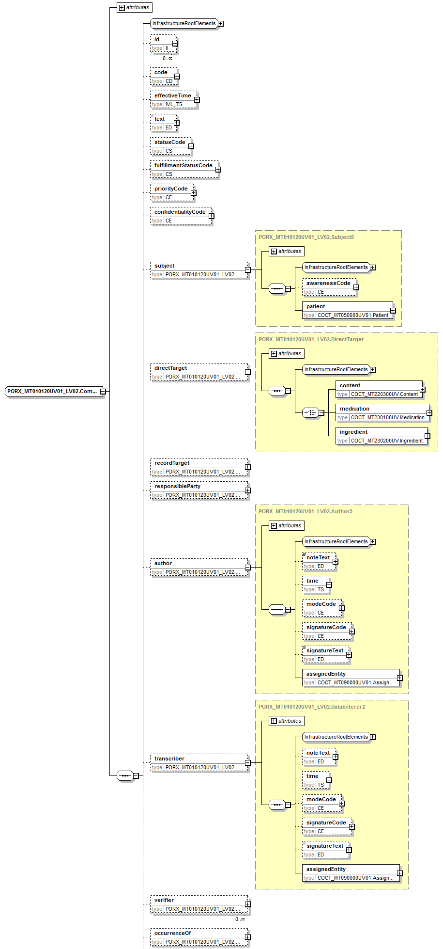
Picture 35 PORX_MT010120UV01_LV02.CombinedMedicationRequest data structure (part 1)

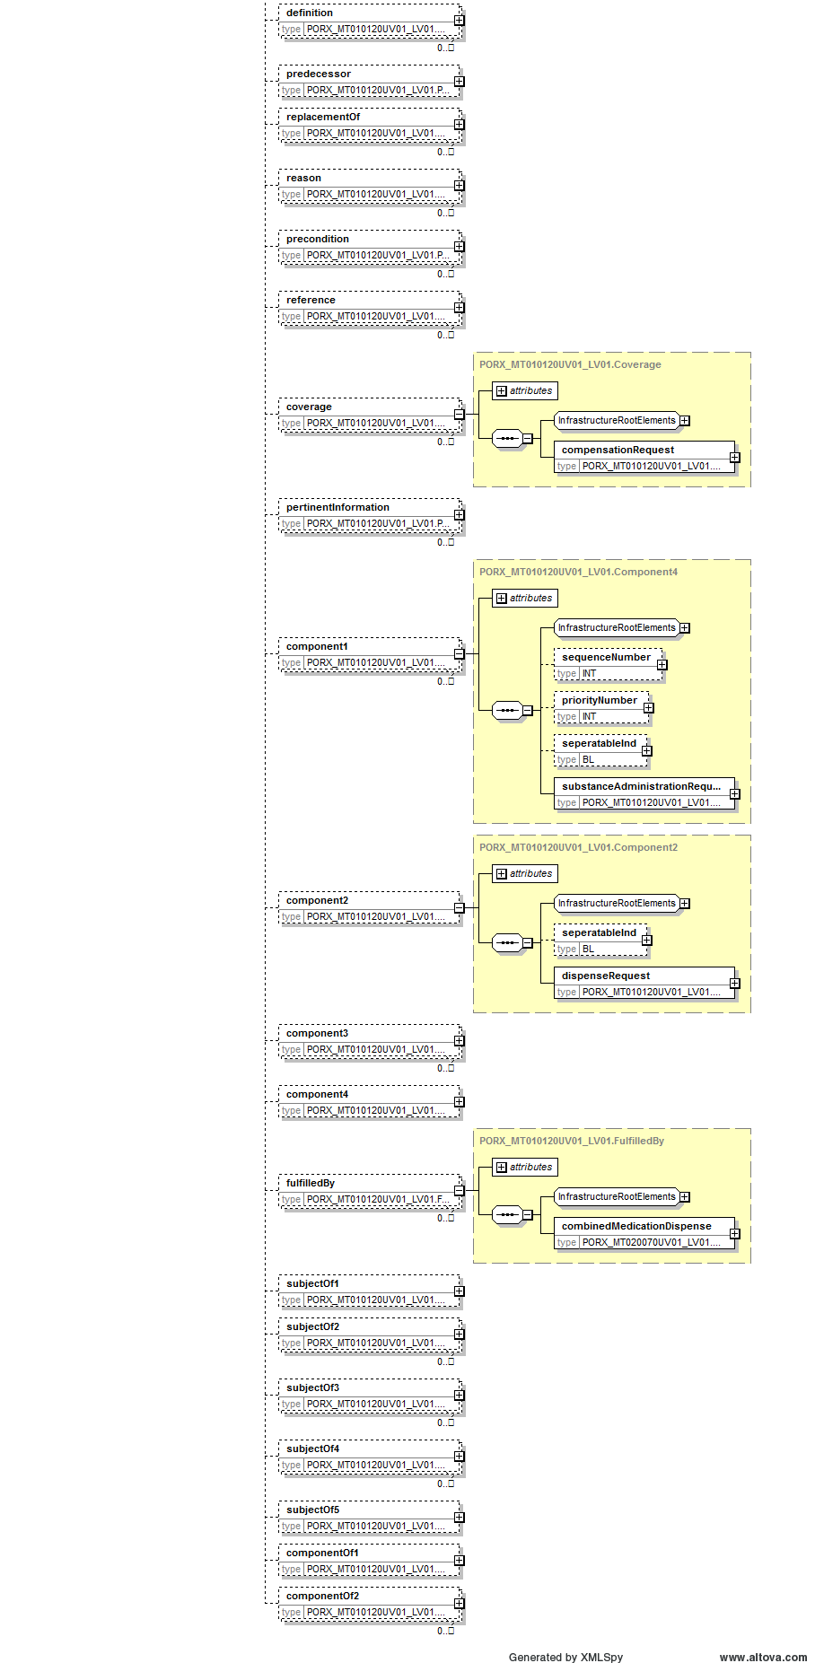
Picture 36 PORX_MT010120UV01_LV02.CombinedMedicationRequest data structure (part 2)

Data structure XML schema:
<xs:complexType name="PORX_MT010120UV01_LV02.CombinedMedicationRequest">
<xs:sequence>
<xs:group ref="InfrastructureRootElements"/>
<xs:element name="id" type="II" minOccurs="0" maxOccurs="unbounded"/>
<xs:element name="code" type="CD" minOccurs="0" maxOccurs="1"/>
<xs:element name="effectiveTime" type="IVL_TS" minOccurs="0"/>
<xs:element name="text" type="ED" minOccurs="0" maxOccurs="1"/>
<xs:element name="statusCode" type="CS" minOccurs="0" maxOccurs="1"/>
<xs:element name="fulfillmentStatusCode" type="CS" minOccurs="0" maxOccurs="1"/>
<xs:element name="priorityCode" type="CE" minOccurs="0" maxOccurs="1"/>
<xs:element name="confidentialityCode" type="CE" minOccurs="0" maxOccurs="1"/>
<xs:element name="subject" type="PORX_MT010120UV01_LV02.Subject5" nillable="true" minOccurs="0" maxOccurs="1"/>
<xs:element name="directTarget" type="PORX_MT010120UV01_LV02.DirectTarget" nillable="true" minOccurs="0" maxOccurs="1"/>
<xs:element name="recordTarget" type="PORX_MT010120UV01_LV02.RecordTarget" nillable="true" minOccurs="0" maxOccurs="1"/>
<xs:element name="responsibleParty" type="PORX_MT010120UV01_LV02.ResponsibleParty" nillable="true" minOccurs="0" maxOccurs="1"/>
<xs:element name="author" type="PORX_MT010120UV01_LV02.Author3" nillable="true" minOccurs="0" maxOccurs="1"/>
<xs:element name="transcriber" type="PORX_MT010120UV01_LV02.DataEnterer2" nillable="true" minOccurs="0" maxOccurs="1"/>
<xs:element name="verifier" type="PORX_MT010120UV01_LV02.Verifier" nillable="true" minOccurs="0" maxOccurs="unbounded"/>
<xs:element name="occurrenceOf" type="PORX_MT010120UV01_LV02.OcurrenceOf" nillable="true" minOccurs="0" maxOccurs="1"/>
<xs:element name="definition" type="PORX_MT010120UV01_LV02.Definition" nillable="true" minOccurs="0" maxOccurs="unbounded"/>
<xs:element name="predecessor" type="PORX_MT010120UV01_LV02.Predecessor" nillable="true" minOccurs="0" maxOccurs="1"/>
<xs:element name="replacementOf" type="PORX_MT010120UV01_LV02.ReplacementOf" nillable="true" minOccurs="0" maxOccurs="unbounded"/>
<xs:element name="reason" type="PORX_MT010120UV01_LV02.Reason" nillable="true" minOccurs="0" maxOccurs="unbounded"/>
<xs:element name="precondition" type="PORX_MT010120UV01_LV02.Precondition" nillable="true" minOccurs="0" maxOccurs="unbounded"/>
<xs:element name="reference" type="PORX_MT010120UV01_LV02.Reference" nillable="true" minOccurs="0" maxOccurs="unbounded"/>
<xs:element name="coverage" type="PORX_MT010120UV01_LV02.Coverage" nillable="true" minOccurs="0" maxOccurs="unbounded"/>
<xs:element name="pertinentInformation" type="PORX_MT010120UV01_LV02.PertinentInformation" nillable="true" minOccurs="0" maxOccurs="unbounded"/>
<xs:element name="component1" type="PORX_MT010120UV01_LV02.Component4" nillable="true" minOccurs="0" maxOccurs="unbounded"/>
<xs:element name="component2" type="PORX_MT010120UV01_LV02.Component2" nillable="true" minOccurs="0" maxOccurs="1"/>
<xs:element name="component3" type="PORX_MT010120UV01_LV02.SourceOf" nillable="true" minOccurs="0" maxOccurs="unbounded"/>
<xs:element name="component4" type="PORX_MT010120UV01_LV02.Component8" nillable="true" minOccurs="0" maxOccurs="1"/>
<xs:element name="fulfilledBy" type="PORX_MT010120UV01_LV02.FulfilledBy" nillable="true" minOccurs="0" maxOccurs="unbounded"/>
<xs:element name="subjectOf1" type="PORX_MT010120UV01_LV02.Subject4" nillable="true" minOccurs="0" maxOccurs="1"/>
<xs:element name="subjectOf2" type="PORX_MT010120UV01_LV02.Subject2" nillable="true" minOccurs="0" maxOccurs="unbounded"/>
<xs:element name="subjectOf3" type="PORX_MT010120UV01_LV02.Subject3" nillable="true" minOccurs="0" maxOccurs="unbounded"/>
<xs:element name="subjectOf4" type="PORX_MT010120UV01_LV02.Subject" nillable="true" minOccurs="0" maxOccurs="unbounded"/>
<xs:element name="subjectOf5" type="PORX_MT010120UV01_LV02.Subject7" nillable="true" minOccurs="0"/>
<xs:element name="componentOf1" type="PORX_MT010120UV01_LV02.Component5" nillable="true" minOccurs="0" maxOccurs="1"/>
<xs:element name="componentOf2" type="PORX_MT010120UV01_LV02.Component6" nillable="true" minOccurs="0" maxOccurs="unbounded"/>
</xs:sequence>
<xs:attributeGroup ref="InfrastructureRootAttributes"/>
<xs:attribute name="nullFlavor" type="NullFlavor" use="optional"/>
<xs:attribute name="classCode" type="ActClass" use="optional" fixed="ACT"/>
<xs:attribute name="moodCode" type="ActMoodRequest" use="required"/>
</xs:complexType>

Table 86 Data structure PORX_MT010120UV01_LV02.CombinedMedicationRequest elements
Element | Type | Cardinality | Description
Id | II | 0..unbounded | Medication order id (OID: 1.3.6.1.4.1.38760.3.4.11.1)
effectiveTime | IVL_TS | 0..1 | Medication order document effective time.  For statusCode ‘new’ it represents reservation date, otherwise it represents planned date of archiving.
statusCode | CS | 0..1 | Medication order document status code (new – for reserved, active – for active, cancelled – for cancelled before activation,  aborted – for cancelled after activation, complete – for expired or fully dispensed)
fulfillmentStatusCode | CS | 0..1 | Medication otder fulfilment status code (unfulfilled, partial – partially fulfilled, fulfilled)
Subject | PORX_MT010120UV01_LV02.Subject5 | 0..1
subject. Patient | COCT_MT050000UV01.Patient | 1..1
subject. patient. patientPerson | COCT_MT050000UV01.Person | 0..1 | Patient as person.  See data structure in chapter 6.2.
directTarget | PORX_MT010120UV01_LV02.DirectTarget | 0..1
directTarget. medication | COCT_MT230100UV.Medication | 1..1
directTarget. medication. administrableMedicine | COCT_MT230100UV.Medicine | 1..1 | Prescribed medication.  See data structure in chapter 6.3.
author | PORX_MT010120UV01_LV02.Author3 | 0..1
author. assignedEntity | COCT_MT090000UV01.AssignedEntity | 0..1 | Physician, who prescribes medication order.  See data structure in chapter 6.4.
transcriber | PORX_MT010120UV01_LV02.DataEnterer2 | 0..1
transcriber. noteText | ED | 0..1 | Notes or additional information. Can be used by pharmacist during import of paper medication order to System.
coverage | PORX_MT010120UV01_LV02.Coverage | 0..unbounded
coverage. compensationRequest | PORX_MT010120UV01_LV02.CompensationRequest | 1..1
coverage. compensationRequest. code | CV | 0..1 | Compensation code (OID: 1.3.6.1.4.1.38760.2.152)
coverage. compensationRequest. percentageAmount | INT | 0..1 | Compensation amount in percentage
coverage. compensationRequest. substitutionReason | CV | 0..1 | For non-classified reason, attribute required:  - nullFlavor="UNC".
coverage. compensationRequest. substitutionReason. originalText | ED | 0..1 | Reason for substitution of INN to compensable medication.
coverage. compensationRequest. payer | CD | 0..1 | Potential compensation payer (sponsor). (OID: 1.3.6.1.4.1.38760.2.93).  For non-classified value, atribute required:  - nullFlavor=”UNC”.
component1 | PORX_MT010120UV01_LV02.Component4 | 0..unbounded
component1. substanceAdministrationRequest | PORX_MT010120UV01_LV02.SubstanceAdministrationRequest | 1..1 | Information about substance administration.  See data structure in chapter 6.5.
component2 | PORX_MT010120UV01_LV02.Component2 | 0..1
component2. dispenseRequest | PORX_MT010120UV01_LV02.DispenseRequest | 1..1 | Information about dispense request.  See data structure in chapter 6.6.
fulfilledBy | PORX_MT010120UV01_LV02.FulfilledBy | 0..unbounded
fulfilledBy. combinedMedicationDispense | PORX_MT020070UV01_LV02.CombinedMedicationDispense | 1..1 | Medication dispenses.  See data structure in chapter 6.7.
subjectOf4 | PORX_MT010120UV01_LV02.Subject | 0..unbounded
subjectOf4. substitutionPermission | PORX_MT010120UV01_LV02.SubstitutionPermission | 1..1
subjectOf4. substitutionPermission. code | CE | 1..1 | Medication substitution type code according to HL7:  - N - No substitution occurred or is permitted;  - E - equivalent (Substitution occurred or is permitted with another bioequivalent and therapeutically equivalent product).
subjectOf4. substitutionPermission. reasonCode | CE | 0..unbounded | For non-classified reason, attribute required:  - nullFlavor="UNC".
subjectOf4. substitutionPermission. reasonCode. originalText | ED | 0..1 | Substitution prohibition reason grounds.
subjectOf5 | PORX_MT010120UV01_LV02.Subject7 | 0..1
subjectOf5. cancelMedicationOrderRequest | PORX_MT000025UV01_LV02.CancelMedicationOrderRequest | 1..1 | Cancellation information. Fulfilled on cancellation of medication order.  See data structure in chapter 6.8.

COCT_MT050000UV01.Person
This is complex data structure based on HL7 standard; it describes structure of person.
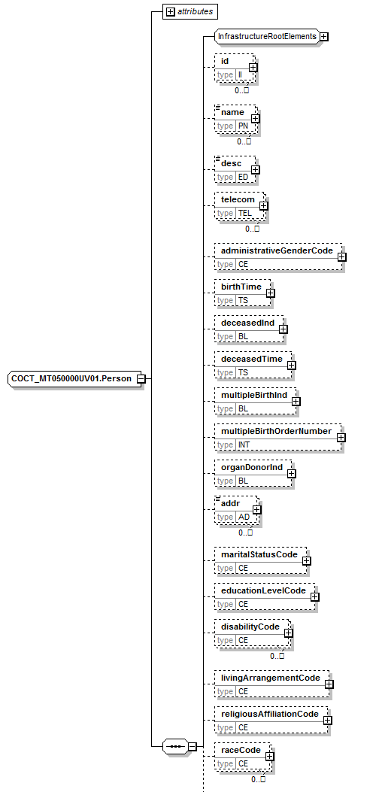
Picture 37 COCT_MT050000UV01.Person data structure (part 1)

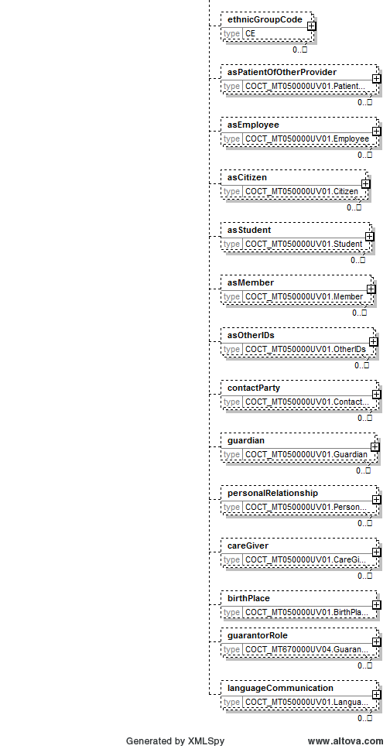
Picture 38 COCT_MT050000UV01.Person data structure (part 2)

Data structure XML schema:
<xs:complexType name="COCT_MT050000UV01.Person">
<xs:sequence>
<xs:group ref="InfrastructureRootElements"/>
<xs:element name="id" type="II" minOccurs="0" maxOccurs="unbounded"/>
<xs:element name="name" type="PN" minOccurs="0" maxOccurs="unbounded"/>
<xs:element name="desc" type="ED" minOccurs="0" maxOccurs="1"/>
<xs:element name="telecom" type="TEL" minOccurs="0" maxOccurs="unbounded"/>
<xs:element name="administrativeGenderCode" type="CE" minOccurs="0" maxOccurs="1"/>
<xs:element name="birthTime" type="TS" minOccurs="0" maxOccurs="1"/>
<xs:element name="deceasedInd" type="BL" minOccurs="0" maxOccurs="1"/>
<xs:element name="deceasedTime" type="TS" minOccurs="0" maxOccurs="1"/>
<xs:element name="multipleBirthInd" type="BL" minOccurs="0" maxOccurs="1"/>
<xs:element name="multipleBirthOrderNumber" type="INT" minOccurs="0" maxOccurs="1"/>
<xs:element name="organDonorInd" type="BL" minOccurs="0" maxOccurs="1"/>
<xs:element name="addr" type="AD" minOccurs="0" maxOccurs="unbounded"/>
<xs:element name="maritalStatusCode" type="CE" minOccurs="0" maxOccurs="1"/>
<xs:element name="educationLevelCode" type="CE" minOccurs="0" maxOccurs="1"/>
<xs:element name="disabilityCode" type="CE" minOccurs="0" maxOccurs="unbounded"/>
<xs:element name="livingArrangementCode" type="CE" minOccurs="0" maxOccurs="1"/>
<xs:element name="religiousAffiliationCode" type="CE" minOccurs="0" maxOccurs="1"/>
<xs:element name="raceCode" type="CE" minOccurs="0" maxOccurs="unbounded"/>
<xs:element name="ethnicGroupCode" type="CE" minOccurs="0" maxOccurs="unbounded"/>
<xs:element name="asPatientOfOtherProvider" type="COCT_MT050000UV01.PatientOfOtherProvider" nillable="true" minOccurs="0" maxOccurs="unbounded"/>
<xs:element name="asEmployee" type="COCT_MT050000UV01.Employee" nillable="true" minOccurs="0" maxOccurs="unbounded"/>
<xs:element name="asCitizen" type="COCT_MT050000UV01.Citizen" nillable="true" minOccurs="0" maxOccurs="unbounded"/>
<xs:element name="asStudent" type="COCT_MT050000UV01.Student" nillable="true" minOccurs="0" maxOccurs="unbounded"/>
<xs:element name="asMember" type="COCT_MT050000UV01.Member" nillable="true" minOccurs="0" maxOccurs="unbounded"/>
<xs:element name="asOtherIDs" type="COCT_MT050000UV01.OtherIDs" nillable="true" minOccurs="0" maxOccurs="unbounded"/>
<xs:element name="contactParty" type="COCT_MT050000UV01.ContactParty" nillable="true" minOccurs="0" maxOccurs="unbounded"/>
<xs:element name="guardian" type="COCT_MT050000UV01.Guardian" nillable="true" minOccurs="0" maxOccurs="unbounded"/>
<xs:element name="personalRelationship" type="COCT_MT050000UV01.PersonalRelationship" nillable="true" minOccurs="0" maxOccurs="unbounded"/>
<xs:element name="careGiver" type="COCT_MT050000UV01.CareGiver" nillable="true" minOccurs="0" maxOccurs="unbounded"/>
<xs:element name="birthPlace" type="COCT_MT050000UV01.BirthPlace" nillable="true" minOccurs="0" maxOccurs="1"/>
<xs:element name="guarantorRole" type="COCT_MT670000UV04.GuarantorRole" nillable="true" minOccurs="0" maxOccurs="unbounded"/>
<xs:element name="languageCommunication" type="COCT_MT050000UV01.LanguageCommunication" nillable="true" minOccurs="0" maxOccurs="unbounded"/>
</xs:sequence>
<xs:attributeGroup ref="InfrastructureRootAttributes"/>
<xs:attribute name="nullFlavor" type="NullFlavor" use="optional"/>
<xs:attribute name="classCode" type="EntityClass" use="optional" fixed="PSN"/>
<xs:attribute name="determinerCode" type="EntityDeterminer" use="optional" fixed="INSTANCE"/>
</xs:complexType>
Table 87 Data structure COCT_MT050000UV01.Person elements
Element | Type | Cardinality | Description
id | II | 0..unbounded | Person identifier.  Person code for Latvian citizen (OID: 1.3.6.1.4.1.38760.3.1.1).  Alternative identifier for newborns – consists of mother’s personal code and child birth time (OID: 1.3.6.1.4.1.38760.3.1.3).  Identification number for foreign country citizens (any child node in OID namespace 1.3.6.1.4.1.38760.3.1.8 except 1.3.6.1.4.1.38760.3.1.8.60).  EHIC card number can be added also (OID: 1.3.6.1.4.1.38760.3.3.1.3).
name | PN | 0..unbounded | Person name as text with added logical mark-up. The approach is similar to HTML or XML markup of text.
name. family | en.family | 0..unbouned | Logical mark-up of family name
name. given | en.given | 0..unbouned | Logical mark-up of given name
administrativeGenderCode | CE | 0..1 | Gender (OID: 1.3.6.1.4.1.38760.2.111)
birthTime | TS | 0..1 | Birth date and time
addr | AD | 0..unbounded | Address as text with added logical mark-up. The approach is similar to HTML or XML markup of text.  It is not mandatory, but very preferable because address data will be used in further data analysis.
addr. delimiter | adxp.delimiter | 0..unbounded | Logical mark-up of delimiter.
addr. country | adxp.country | 0..unbounded | Logical mark-up of country code (Text value can be taken from classifier with OID: 1.3.6.1.4.1.38760.2.7)
addr. postalCode | adxp.postalCode | 0..unbounded | Logical mark-up of postal code.
addr. county | adxp.county | 0..unbounded | Logical mark-up of county, parish and rural area (Text values can be taken from classifier with OID: 1.3.6.1.4.1.38760.2.113 for county; 1.3.6.1.4.1.38760.2.114 for parish and rural area)
addr. city | adxp.city | 0..unbounded | Logical mark-up of city or village (Text value can be taken from classifier with OID: 1.3.6.1.4.1.38760.2.116 for any city, 1.3.6.1.4.1.38760.2.114 for county city, 1.3.6.1.4.1.38760.2.8 for republic cities)
addr. streetName | adxp.streetName | 0..unbounded | Logical mark-up of street name (Text value can be taken from classifier with OID: 1.3.6.1.4.1.38760.2.9)
addr. houseNumber | adxp.houseNumber | 0..unbounded | Logical mark-up of house number.
addr. additionalLocator | adxp.additionalLocator | 0..unbounded | Logical mark-up of house name.
addr. unitID | adxp.unitID | 0..unbounded | Logical mark-up of flat number
addr. censusTract | adxp.censusTract | 0..unbounded | Logical mark-up of ATU code.  Must be one of these codes:  ATU Code 1 (OID: 1.3.6.1.4.1.38760.2.8).  ATU Code 2 (OID: 1.3.6.1.4.1.38760.2.113).  ATU Code 3 (OID: 1.3.6.1.4.1.38760.2.114)
telecom | TEL | 0.. unbounded | Phone number.  According to HL7, value must be set in URL format:  - tel:<phone number>;  - mailto:<e-mail address>.

COCT_MT230100UV.Medicine
This is complex data structure based on HL7 standard; it describes structure of medicine.
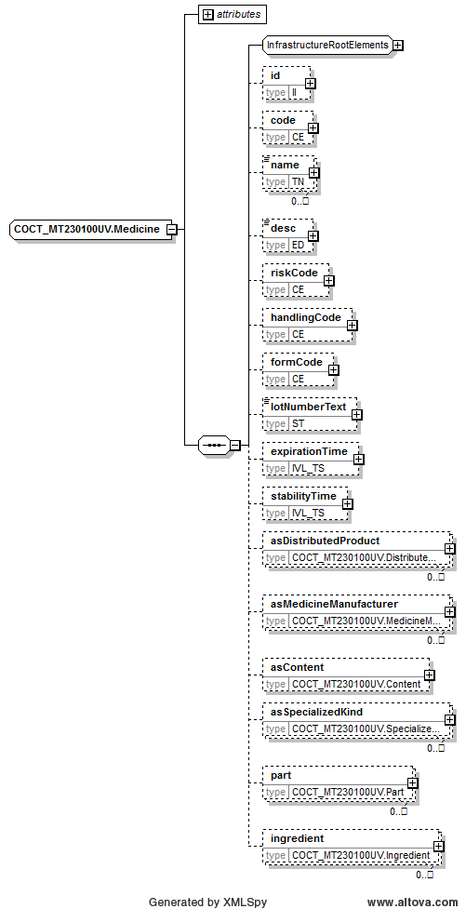
Picture 39 COCT_MT230100UV.Medicine data structure
Data structure XML schema:
<xs:complexType name="COCT_MT230100UV.Medicine">
<xs:sequence>
<xs:group ref="InfrastructureRootElements"/>
<xs:element name="id" type="II" minOccurs="0" maxOccurs="1"/>
<xs:element name="code" type="CE" minOccurs="0" maxOccurs="1"/>
<xs:element name="name" type="TN" minOccurs="0" maxOccurs="unbounded"/>
<xs:element name="desc" type="ED" minOccurs="0" maxOccurs="1"/>
<xs:element name="riskCode" type="CE" minOccurs="0" maxOccurs="1"/>
<xs:element name="handlingCode" type="CE" minOccurs="0" maxOccurs="1"/>
<xs:element name="formCode" type="CE" minOccurs="0" maxOccurs="1"/>
<xs:element name="lotNumberText" type="ST" minOccurs="0" maxOccurs="1"/>
<xs:element name="expirationTime" type="IVL_TS" minOccurs="0" maxOccurs="1"/>
<xs:element name="stabilityTime" type="IVL_TS" minOccurs="0" maxOccurs="1"/>
<xs:element name="asDistributedProduct" type="COCT_MT230100UV.DistributedProduct" nillable="true" minOccurs="0" maxOccurs="unbounded"/>
<xs:element name="asMedicineManufacturer" type="COCT_MT230100UV.MedicineManufacturer" nillable="true" minOccurs="0" maxOccurs="unbounded"/>
<xs:element name="asContent" type="COCT_MT230100UV.Content" nillable="true" minOccurs="0" maxOccurs="1"/>
<xs:element name="asSpecializedKind" type="COCT_MT230100UV.SpecializedKind" nillable="true" minOccurs="0" maxOccurs="unbounded"/>
<xs:element name="part" type="COCT_MT230100UV.Part" nillable="true" minOccurs="0" maxOccurs="unbounded"/>
<xs:element name="ingredient" type="COCT_MT230100UV.Ingredient" nillable="true" minOccurs="0" maxOccurs="unbounded"/>
</xs:sequence>
<xs:attributeGroup ref="InfrastructureRootAttributes"/>
<xs:attribute name="classCode" type="EntityClassManufacturedMaterial" use="required"/>
<xs:attribute name="determinerCode" type="EntityDeterminer" use="required"/>
</xs:complexType>
Table 88 Data structure COCT_MT230100UV.Medicine elements
Element | Type | Cardinality | Description
code | CE | 0..1 | Medical registration number (OID: 1.3.6.1.4.1.38760.2.136), compensation group (OID: 1.3.6.1.4.1.38760.2.177) or compensable medicine (OID: 1.3.6.1.4.1.38760.2.151)
name | TN | 0..unbounded | Medicine name.  For compensation group and medicine in free text format, medicine name must be supplemented with medicine strength.
desc | ED | 0..1 | Full combined medicine name, including strength, form etc.
formCode | CE | 0..1 | Medicine form code (OID: 1.3.6.1.4.1.38760.2.137)
ingredient | COCT_MT230100UV.Ingredient | 0..unbounded
ingredient. ingredientSubstance | COCT_MT230100UV.Substance | 0..1
ingredient. ingredientSubstance. code | CE | 0..1 | Active substance code (OID: 1.3.6.1.4.1.38760.2.140)
ingredient. quantity | RTO | 0..1 | Amount of active substance.  For non-classified value, attribute required:  - nullFlavor="UNC".
ingredient. quantity. numerator | PQ | 1..1 | For non-classified value, attribute required:  - nullFlavor="UNC". Use sub-element translation.originalText to fill the value. For sub-element translation, for non-classifiend value, attribute required:  - nullFlavor="UNC".
ingredient. quantity. denominator | PQ | 1..1 | Value = 1.

COCT_MT090000UV01.AssignedEntity
This is complex data structure based on HL7 standard; it describes structure of author as assigned entity.

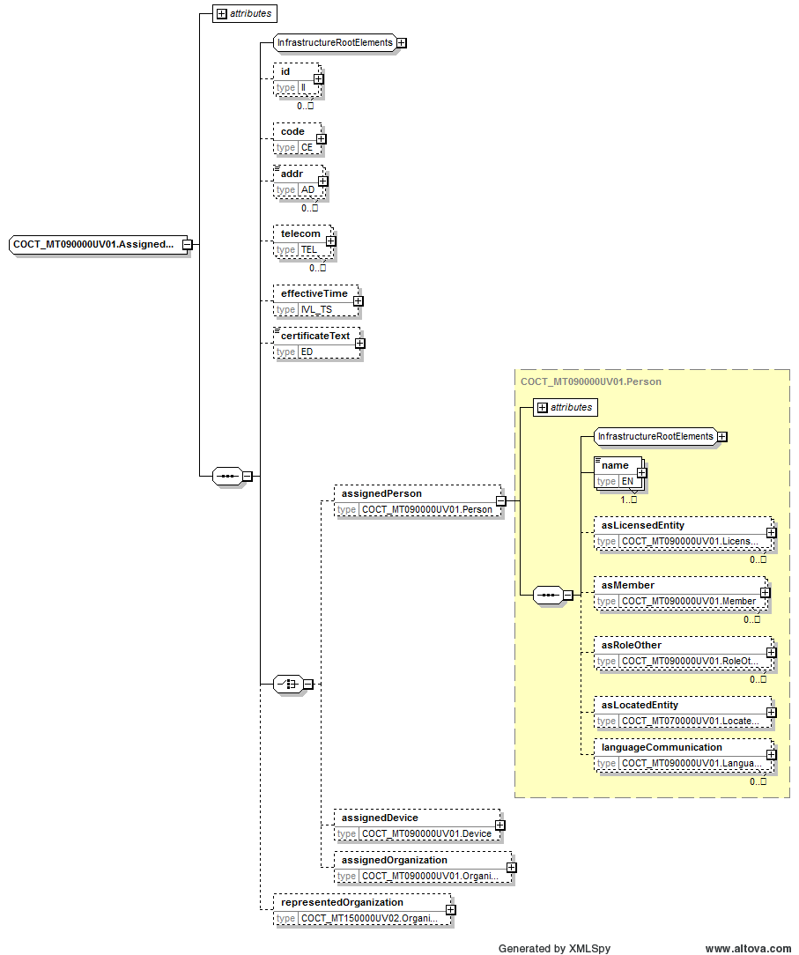
Picture 40 COCT_MT090000UV01.AssignedEntity data structure
Data structure XML schema:
<xs:complexType name="COCT_MT090000UV01.AssignedEntity">
<xs:sequence>
<xs:group ref="InfrastructureRootElements"/>
<xs:element name="id" type="II" minOccurs="0" maxOccurs="unbounded"/>
<xs:element name="code" type="CE" minOccurs="0" maxOccurs="1"/>
<xs:element name="addr" type="AD" minOccurs="0" maxOccurs="unbounded"/>
<xs:element name="telecom" type="TEL" minOccurs="0" maxOccurs="unbounded"/>
<xs:element name="effectiveTime" type="IVL_TS" minOccurs="0" maxOccurs="1"/>
<xs:element name="certificateText" type="ED" minOccurs="0" maxOccurs="1"/>
<xs:choice>
<xs:element name="assignedPerson" type="COCT_MT090000UV01.Person" nillable="true" minOccurs="0" maxOccurs="1"/>
<xs:element name="assignedDevice" type="COCT_MT090000UV01.Device" nillable="true" minOccurs="0" maxOccurs="1"/>
<xs:element name="assignedOrganization" type="COCT_MT090000UV01.Organization" nillable="true" minOccurs="0" maxOccurs="1"/>
</xs:choice>
<xs:element name="representedOrganization" type="COCT_MT150000UV02.Organization" nillable="true" minOccurs="0" maxOccurs="1"/>
</xs:sequence>
<xs:attributeGroup ref="InfrastructureRootAttributes"/>
<xs:attribute name="classCode" type="RoleClassAssignedEntity" use="required"/>
</xs:complexType>
Table 89 Data structure COCT_MT090000UV01.AssignedEntity elements
Element | Type | Cardinality | Description
id | II | 0..unbounded | Person code or other identifying code (for example, physician code)  Physician (OID: 1.3.6.1.4.1.38760.2.1).  Physician code (OID: 1.3.6.1.4.1.38760.3.1.4).  Pharmacist (OID: 1.3.6.1.4.1.38760.2.46).  Pharmacist code (OID: 1.3.6.1.4.1.38760.3.1.5).  Person code for Latvian citizen – for both physician and pharmacist (OID: 1.3.6.1.4.1.38760.3.1.1)
assignedPerson | COCT_MT090000UV01.Person | 0..1
assignedPerson. name | EN | 1..unbounded | Person name as text with added logical mark-up. The approach is similar to HTML or XML markup of text.
assignedPerson. name. family | en.family | 0..unbounded | Logical mark-up of family name
assignedPerson. name. given | en.given | 0..unbounded | Logical mark-up of given name
assignedPerson. asLicensedEntity | COCT_MT090000UV01.LicensedEntity | 0..unbounded
assignedPerson. asLicensedEntity. code | CE | 0..1 | Specialty code and name.  Physician specialty (OID: 1.3.6.1.4.1.38760.2.38).  Pharmacist specialty (OID: 1.3.6.1.4.1.38760.2.47).
representedOrganization. id | II | 1..unbounded | Physician or pharmacy organization code or branch code.  Medical institution code (OID: 1.3.6.1.4.1.38760.2.23).  Medical institution branch code (OID: 1.3.6.1.4.1.38760.2.28).  Pharmacy code (OID: 1.3.6.1.4.1.38760.2.134).
representedOrganization. name | ON | 0..unbounded | Organization name
representedOrganization. addr | AD | 0..1 | Organization address as text with added logical mark-up, if necessary. The approach is similar to HTML or XML markup of text.
representedOrganization. telecom | TEL | 0..unbounded | Organization phone number.  For medication order physician only.  According to HL7, value must be set in URL format:  - tel:<phone number>;  - mailto:<e-mail address>.

PORX_MT010120UV01_LV02.SubstanceAdministrationRequest
This is complex data structure based on HL7 standard; it describes structure of substance administration request.
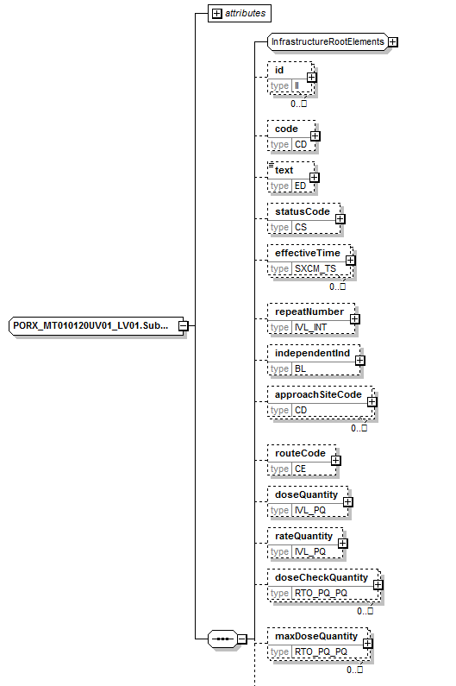
Picture 41 PORX_MT010120UV01_LV02.SubstanceAdministrationRequest data structure (part 1)

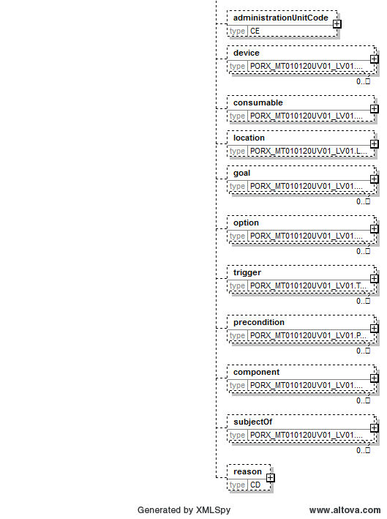
Picture 42 PORX_MT010120UV01_LV02.SubstanceAdministrationRequest data structure (part 2)
Data structure XML schema:
<xs:complexType name="PORX_MT010120UV01_LV02.SubstanceAdministrationRequest">
<xs:sequence>
<xs:group ref="InfrastructureRootElements"/>
<xs:element name="id" type="II" minOccurs="0" maxOccurs="unbounded"/>
<xs:element name="code" type="CD" minOccurs="0" maxOccurs="1"/>
<xs:element name="text" type="ED" minOccurs="0" maxOccurs="1"/>
<xs:element name="statusCode" type="CS" minOccurs="0" maxOccurs="1"/>
<xs:element name="effectiveTime" type="SXCM_TS" minOccurs="0" maxOccurs="unbounded"/>
<xs:element name="repeatNumber" type="IVL_INT" minOccurs="0" maxOccurs="1"/>
<xs:element name="independentInd" type="BL" minOccurs="0" maxOccurs="1"/>
<xs:element name="approachSiteCode" type="CD" minOccurs="0" maxOccurs="unbounded"/>
<xs:element name="routeCode" type="CE" minOccurs="0" maxOccurs="1"/>
<xs:element name="doseQuantity" type="IVL_PQ" minOccurs="0" maxOccurs="1"/>
<xs:element name="rateQuantity" type="IVL_PQ" minOccurs="0" maxOccurs="1"/>
<xs:element name="doseCheckQuantity" type="RTO_PQ_PQ" minOccurs="0" maxOccurs="unbounded"/>
<xs:element name="maxDoseQuantity" type="RTO_PQ_PQ" minOccurs="0" maxOccurs="unbounded"/>
<xs:element name="administrationUnitCode" type="CE" minOccurs="0" maxOccurs="1"/>
<xs:element name="device" type="PORX_MT010120UV01_LV02.Device" nillable="true" minOccurs="0" maxOccurs="unbounded"/>
<xs:element name="consumable" type="PORX_MT010120UV01_LV02.Consumable" nillable="true" minOccurs="0" maxOccurs="1"/>
<xs:element name="location" type="PORX_MT010120UV01_LV02.Location1" nillable="true" minOccurs="0" maxOccurs="1"/>
<xs:element name="goal" type="PORX_MT010120UV01_LV02.Goal" nillable="true" minOccurs="0" maxOccurs="unbounded"/>
<xs:element name="option" type="PORX_MT010120UV01_LV02.Option" nillable="true" minOccurs="0" maxOccurs="unbounded"/>
<xs:element name="trigger" type="PORX_MT010120UV01_LV02.Trigger" nillable="true" minOccurs="0" maxOccurs="unbounded"/>
<xs:element name="precondition" type="PORX_MT010120UV01_LV02.Precondition2" nillable="true" minOccurs="0" maxOccurs="unbounded"/>
<xs:element name="component" type="PORX_MT010120UV01_LV02.Component7" nillable="true" minOccurs="0" maxOccurs="unbounded"/>
<xs:element name="subjectOf" type="PORX_MT010120UV01_LV02.Subject1" nillable="true" minOccurs="0" maxOccurs="unbounded"/>
<xs:element name="reason" type="CD" minOccurs="0"/>
</xs:sequence>
<xs:attributeGroup ref="InfrastructureRootAttributes"/>
<xs:attribute name="nullFlavor" type="NullFlavor" use="optional"/>
<xs:attribute name="classCode" type="ActClassSubstanceAdministration" use="required"/>
<xs:attribute name="moodCode" type="ActMoodRequest" use="required"/>
</xs:complexType>
Table 90 Data structure PORX_MT010120UV01_LV02.SubstanceAdministrationRequest elements
Element | Type | Cardinality | Description
text | ED | 0..1 | Administration recommendation (signatura)
effectiveTime | SXCM_TS | 0..unbounded | Length of treatment course
reason | CD | 0..1 | Diagnosis and additional diagnosis ICD-10 code (OID: 1.3.6.1.4.1.38760.2.159)

PORX_MT010120UV01_LV02.DispenseRequest
This is complex data structure based on HL7 standard; it describes structure of medication order dispense request.
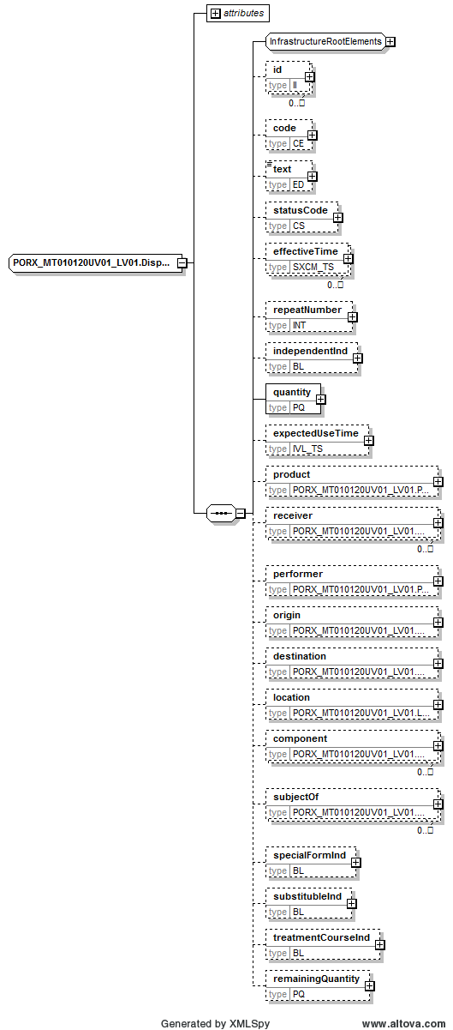
Picture 43 PORX_MT010120UV01_LV02.DispenseRequest data structure

Data structure XML schema:
<xs:complexType name="PORX_MT010120UV01_LV02.DispenseRequest">
<xs:sequence>
<xs:group ref="InfrastructureRootElements"/>
<xs:element name="id" type="II" minOccurs="0" maxOccurs="unbounded"/>
<xs:element name="code" type="CE" minOccurs="0" maxOccurs="1"/>
<xs:element name="text" type="ED" minOccurs="0" maxOccurs="1"/>
<xs:element name="statusCode" type="CS" minOccurs="0" maxOccurs="1"/>
<xs:element name="effectiveTime" type="SXCM_TS" minOccurs="0" maxOccurs="unbounded"/>
<xs:element name="repeatNumber" type="INT" minOccurs="0" maxOccurs="1"/>
<xs:element name="independentInd" type="BL" minOccurs="0" maxOccurs="1"/>
<xs:element name="quantity" type="PQ" minOccurs="1" maxOccurs="1"/>
<xs:element name="expectedUseTime" type="IVL_TS" minOccurs="0" maxOccurs="1"/>
<xs:element name="product" type="PORX_MT010120UV01_LV02.Product" nillable="true" minOccurs="0" maxOccurs="1"/>
<xs:element name="receiver" type="PORX_MT010120UV01_LV02.Receiver" nillable="true" minOccurs="0" maxOccurs="unbounded"/>
<xs:element name="performer" type="PORX_MT010120UV01_LV02.Performer" nillable="true" minOccurs="0" maxOccurs="1"/>
<xs:element name="origin" type="PORX_MT010120UV01_LV02.Origin" nillable="true" minOccurs="0" maxOccurs="1"/>
<xs:element name="destination" type="PORX_MT010120UV01_LV02.Destination" nillable="true" minOccurs="0" maxOccurs="1"/>
<xs:element name="location" type="PORX_MT010120UV01_LV02.Location2" nillable="true" minOccurs="0" maxOccurs="1"/>
<xs:element name="component" type="PORX_MT010120UV01_LV02.Component3" nillable="true" minOccurs="0" maxOccurs="unbounded"/>
<xs:element name="subjectOf" type="PORX_MT010120UV01_LV02.Subject6" nillable="true" minOccurs="0" maxOccurs="unbounded"/>
<xs:element name="specialFormInd" type="BL" minOccurs="0"/>
<xs:element name="treatmentCourseInd" type="BL" minOccurs="0"/>
<xs:element name="remainingQuantity" type="PQ" minOccurs="0"/>
</xs:sequence>
<xs:attributeGroup ref="InfrastructureRootAttributes"/>
<xs:attribute name="nullFlavor" type="NullFlavor" use="optional"/>
<xs:attribute name="classCode" type="ActClassSupply" use="required"/>
<xs:attribute name="moodCode" type="ActMoodRequest" use="required"/>
</xs:complexType>
Table 91 Data structure PORX_MT010120UV01_LV02.DispenseRequest elements
Element | Type | Cardinality | Description
id | II | 0..unbounded | Medication order paper identifier (form number) (OID: 1.3.6.1.4.1.38760.3.4.11.2)
text | ED | 0..1 | Special dispense requirements
effectiveTime | SXCM_TS | 0..unbounded | Medication order prescription time and validity time. System expects single IVL_TS type element.
quantity | PQ | 1..1 | Amount of prescribed medication.
receiver | PORX_MT010120UV01_LV02.Receiver | 0..unbounded
receiver. assignedPerson | COCT_MT090100UV01.AssignedPerson | 1..1
receiver. assignedPerson. id | II | 0..unbounded | Person identifier for delegated.  Person code for Latvian citizen (OID: 1.3.6.1.4.1.38760.3.1.1).  Identification number for foreign country citizens (any child node in OID namespace 1.3.6.1.4.1.38760.3.1.8 except 1.3.6.1.4.1.38760.3.1.8.60).
receiver. assignedPerson. assignedPerson | COCT_MT090000UV01.Person | 0..1
receiver. assignedPerson. assignedPerson. name | EN | 1..unbounded | Person name as text with added logical mark-up. The approach is similar to HTML or XML markup of text.
receiver. assignedPerson. assignedPerson. name. family | en.family | 0..unbounded | Logical mark-up of family name.
receiver. assignedPerson. assignedPerson. name. given | en.given | 0..unbounded | Logical mark-up of given name.
specialFormInd | BL | 0..1 | Indicator: special paper form (narcotic drugs and psychotropic, compensated medication)
treatmentCourseInd | BL | 0..1 | Indicator: medication order is for treatment course, which is longer than 3 months
remainingQuantity | PQ | 0..1 | Remaining amount of medication.  Calculated based on prescribed and dispensed amount of medication.

PORX_MT020070UV01_LV02.CombinedMedicationDispense
This is complex data structure based on HL7 standard; it describes structure of medication dispense.
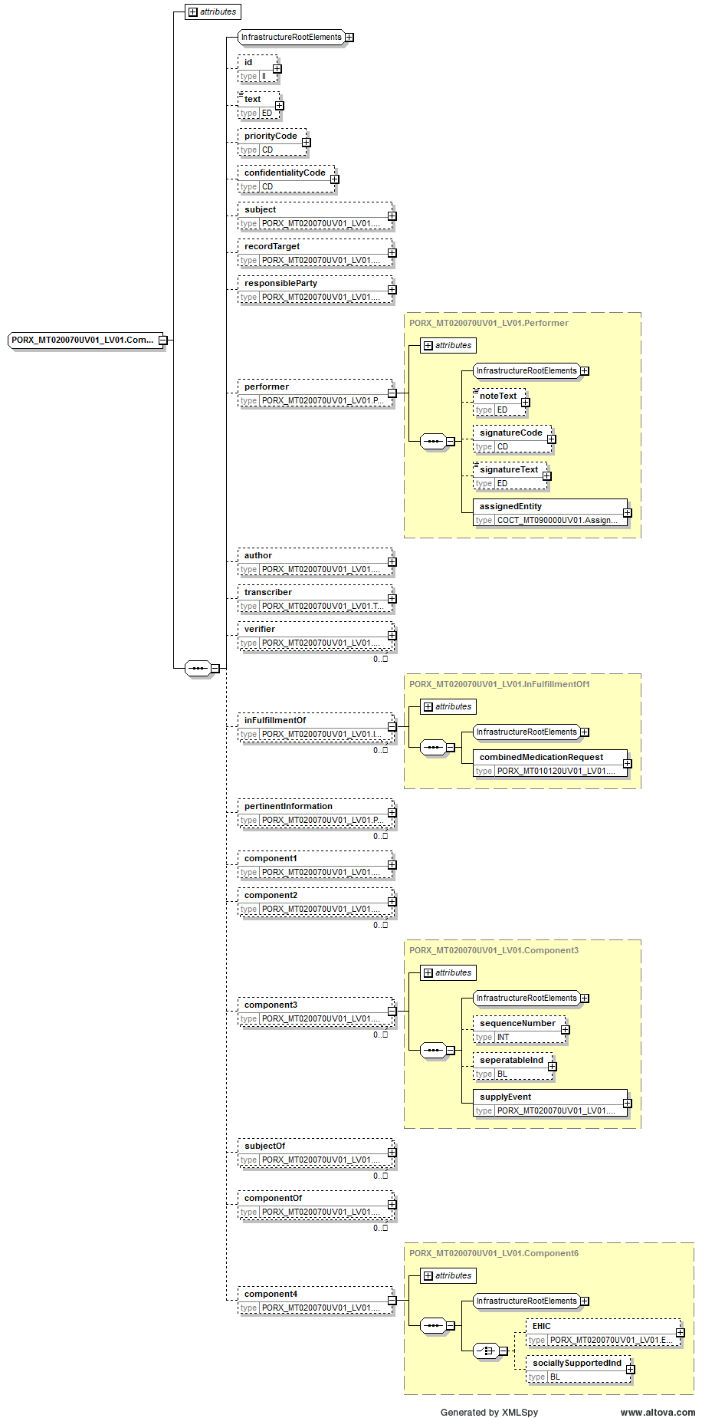
Picture 44 PORX_MT020070UV01_LV02.CombinedMedicationDispense data structure
Data structure XML schema:
<xs:complexType name="PORX_MT020070UV01_LV02.CombinedMedicationDispense">
<xs:sequence>
<xs:group ref="InfrastructureRootElements"/>
<xs:element name="id" type="II" minOccurs="0" maxOccurs="1"/>
<xs:element name="text" type="ED" minOccurs="0" maxOccurs="1"/>
<xs:element name="priorityCode" type="CD" minOccurs="0" maxOccurs="1"/>
<xs:element name="confidentialityCode" type="CD" minOccurs="0" maxOccurs="1"/>
<xs:element name="subject" type="PORX_MT020070UV01_LV02.Subject4" nillable="true" minOccurs="0" maxOccurs="1"/>
<xs:element name="recordTarget" type="PORX_MT020070UV01_LV02.RecordTarget" nillable="true" minOccurs="0" maxOccurs="1"/>
<xs:element name="responsibleParty" type="PORX_MT020070UV01_LV02.ResponsibleParty2" nillable="true" minOccurs="0" maxOccurs="1"/>
<xs:element name="performer" type="PORX_MT020070UV01_LV02.Performer" nillable="true" minOccurs="0" maxOccurs="1"/>
<xs:element name="author" type="PORX_MT020070UV01_LV02.Author2" nillable="true" minOccurs="0" maxOccurs="1"/>
<xs:element name="transcriber" type="PORX_MT020070UV01_LV02.Transcriber" nillable="true" minOccurs="0" maxOccurs="1"/>
<xs:element name="verifier" type="PORX_MT020070UV01_LV02.Verifier" nillable="true" minOccurs="0" maxOccurs="unbounded"/>
<xs:element name="inFulfillmentOf" type="PORX_MT020070UV01_LV02.InFulfillmentOf1" nillable="true" minOccurs="0" maxOccurs="unbounded"/>
<xs:element name="pertinentInformation" type="PORX_MT020070UV01_LV02.PertinentInformation" nillable="true" minOccurs="0" maxOccurs="unbounded"/>
<xs:element name="component1" type="PORX_MT020070UV01_LV02.Component1" nillable="true" minOccurs="0" maxOccurs="1"/>
<xs:element name="component2" type="PORX_MT020070UV01_LV02.Component5" nillable="true" minOccurs="0" maxOccurs="unbounded"/>
<xs:element name="component3" type="PORX_MT020070UV01_LV02.Component3" nillable="true" minOccurs="0" maxOccurs="unbounded"/>
<xs:element name="subjectOf" type="PORX_MT020070UV01_LV02.Subject3" nillable="true" minOccurs="0" maxOccurs="unbounded"/>
<xs:element name="componentOf" type="PORX_MT020070UV01_LV02.Component2" nillable="true" minOccurs="0" maxOccurs="unbounded"/>
<xs:element name="component4" type="PORX_MT020070UV01_LV02.Component6" nillable="true" minOccurs="0"/>
</xs:sequence>
<xs:attributeGroup ref="InfrastructureRootAttributes"/>
<xs:attribute name="classCode" type="ActClass" use="optional" fixed="ACT"/>
<xs:attribute name="moodCode" type="ActMood" use="optional" fixed="EVN"/>
</xs:complexType>
Table 92 Data structure PORX_MT020070UV01_LV02.CombinedMedicationDispense elements
Element | Type | Cardinality | Description
id | II | 0..1 | Medication dispense identifier (OID: 1.3.6.1.4.1.38760.3.4.11.3)
performer | PORX_MT020070UV01_LV02.Performer | 0..1
performer. noteText | ED | 0..1 | Pharmacist notes
performer. assignedEntity | COCT_MT090000UV01.AssignedEntity | 1..1 | See data structure in chapter 6.4.
inFulfillmentOf | PORX_MT020070UV01_LV02.InFulfillmentOf1 | 0..unbounded
inFulfillmentOf. combinedMedicationRequest | PORX_MT010120UV01_LV02.CombinedMedicationRequest | 1..1
inFulfillmentOf. combinedMedicationRequest. id | II | 0..unbounded | Medication order identifier (OID: 1.3.6.1.4.1.38760.3.4.11.1)
inFulfillmentOf. combinedMedicationRequest. statusCode | CD | 0..1 | Medication order status code (new – for reserved, active – for active, cancelled – for cancelled, complete – for fully dispensed).
component1 | PORX_MT020070UV01_LV02.Component1 | 0..1
component1. substitutionMade | PORX_MT020070UV01_LV02.SubstitutionMade | 1..1
component1. substitutionMade. code | CD | 1..1 | Medication substitution type code according to HL7:  - N - No substitution occurred or is permitted;  - E - equivalent (Substitution occurred or is permitted with another bioequivalent and therapeutically equivalent product).
component1. substitutionMade. reasonCode | CD | 0..unbounded | For non-classified reason, attribute required:  - nullFlavor="UNC".
component1. substitutionMade. reasonCode. originalText | ED | 0..1 | Substitution reason grounds.
component3 | PORX_MT020070UV01_LV02.Component3 | 0..unbounded
component3. supplyEvent | PORX_MT020070UV01_LV02.SupplyEvent | 1..1
component3. supplyEvent. effectiveTime | IVL_TS | 0..1 | Dispense time
component3. supplyEvent. quantity | PQ | 1..1 | Dispensed amount of medication, including amount of packages.
component3. supplyEvent. consumable | PORX_MT020070UV01_LV02.Consumable1 | 0..unbounded
component3. supplyEvent. consumable. content | COCT_MT220300UV.Content | 1..1
component3. supplyEvent. consumable. content. containedMedicine | COCT_MT220300UV.Medicine | 1..1
component3. supplyEvent. consumable. content. containedMedicine. Code | CE | 0..1 | Dispensed medication code (OID: 1.3.6.1.4.1.38760.2.144)
component3. supplyEvent. consumable. content. containedMedicine. Name | TN | 0..unbounded | Dispensed medication name
component3. supplyEvent. receiver | PORX_MT010120UV01_LV02.Receiver | 0..unbounded
component3. supplyEvent. receiver. assignedPerson | COCT_MT090100UV01.AssignedPerson | 1..1
component3. supplyEvent. receiver. assignedPerson. id | II | 0..unbounded | Person identifier for delegated.  Person code for Latvian citizen (OID: 1.3.6.1.4.1.38760.3.1.1).  Identification number for foreign country citizens (any child node in OID namespace 1.3.6.1.4.1.38760.3.1.8 except 1.3.6.1.4.1.38760.3.1.8.60).  Identification number for person document type (OID):  - 1.3.6.1.4.1.38760.3.3.1 – passport;  1.3.6.1.4.1.38760.3.3.5 – ID card.
component3. supplyEvent. receiver. assignedPerson. assignedPerson | COCT_MT090000UV01.Person | 0..1
component3. supplyEvent. receiver. assignedPerson. assignedPerson. name | EN | 1..unbounded | Person name as text with added logical mark-up. The approach is similar to HTML or XML markup of text.
component3. supplyEvent. receiver. assignedPerson. assignedPerson. name. family | en.family | 0..unbounded | Logical mark-up of family name.
component3. supplyEvent. receiver. assignedPerson. assignedPerson. name. given | en.given | 0..unbounded | Logical mark-up of given name.
component3. supplyEvent. price | MO | 0..1 | Price of medication package or unit
component3. supplyEvent. totalAmount | MO | 0..1 | Total amount of money for medication to pay
component3. supplyEvent. paymentAmount | MO | 0..1 | Amount of money for patient to pay
component3. supplyEvent. compensatedAmount | MO | 0..1 | Compensated amount of money
component3. supplyEvent. payer | CD | 0..1 | Compensation payer sponsor (OID: 1.3.6.1.4.1.38760.2.93).  For non-classified value, atribute required:  - nullFlavor=”UNC”.
Component3. supplyEvent. compensationPercent | INT | 0..1 | Amount of compensation in percentage
component4 | PORX_MT020070UV01_LV02.Component6 | 0..1
component4. sociallySupportedInd | BL | 0..1 | Indicator: patient is socially supported
component4. EHIC | PORX_MT020070UV01_LV02.EHIC | 0..1
component4. EHIC. id | II | 1..1 | EHIC identifier (OID: 1.3.6.1.4.1.38760.3.3.1.3)  Replacement certificate identifier (OID: 1.3.6.1.4.1.38760.3.3.1.29)
component4. EHIC. issueTime | TS | 0..1 | Replacement certificate issue time
component4. EHIC. effectiveTime | IVL_TS | 0..1 | Replacement certificate validity (from - to)

PORX_MT000025UV01_LV01.CancelMedicationOrderRequest
This is complex data structure based on HL7 standard; it describes structure of medication order cancellation request.
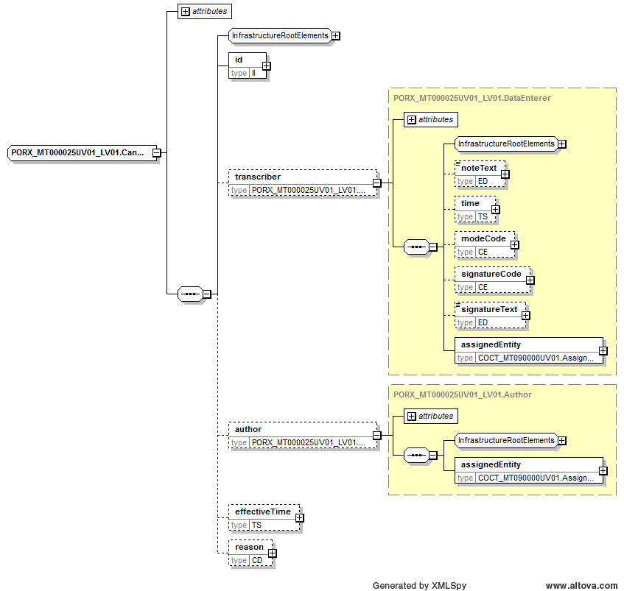
Picture 45 PORX_MT000025UV01_LV01.CancelMedicationOrderRequest data structure
Data structure XML schema:
<xs:complexType name="PORX_MT000025UV01_LV01.CancelMedicationOrderRequest">
<xs:sequence>
<xs:group ref="InfrastructureRootElements"/>
<xs:element name="id" type="II" maxOccurs="unbounded"/>
<xs:element name="transcriber" type="PORX_MT000025UV01_LV01.DataEnterer" nillable="true" minOccurs="0" maxOccurs="1"/>
<xs:element name="author" type="PORX_MT000025UV01_LV01.Author" nillable="true" minOccurs="0"/>
<xs:element name="effectiveTime" type="TS" minOccurs="0"/>
<xs:element name="reason" type="CD" minOccurs="0"/>
</xs:sequence>
<xs:attributeGroup ref="InfrastructureRootAttributes"/>
<xs:attribute name="classCode" type="ActClass" use="optional" fixed="ACT"/>
<xs:attribute name="moodCode" type="ActMood" use="optional" fixed="RQO"/>
</xs:complexType>
Table 93 Data structure PORX_MT000025UV01_LV01.CancelMedicationOrderRequest elements
Element | Type | Cardinality | Description
id | II | 0..unbounded
author | PORX_MT000025UV01_LV01.Author | 0..1
author. assignedEntity | COCT_MT090000UV01.AssignedEntity | 1..1
author. assignedEntity. id | II | 0..unbounded | Person code of person, who cancelled medication order.  Physician (OID: 1.3.6.1.4.1.38760.2.1).  Physician code (OID: 1.3.6.1.4.1.38760.3.1.4).  Person code for Latvian citizen (OID: 1.3.6.1.4.1.38760.3.1.1)
effectiveTime | TS | 1..1 | Cancellation time
reason | CD | 1..1 | Cancelation reason (OID: 1.3.6.1.4.1.38760.2.300)

PORX_MT000019UV01_LV01.ProfileSetupRequest
This is complex data structure based on HL7 standard; it describes structure of user profile.
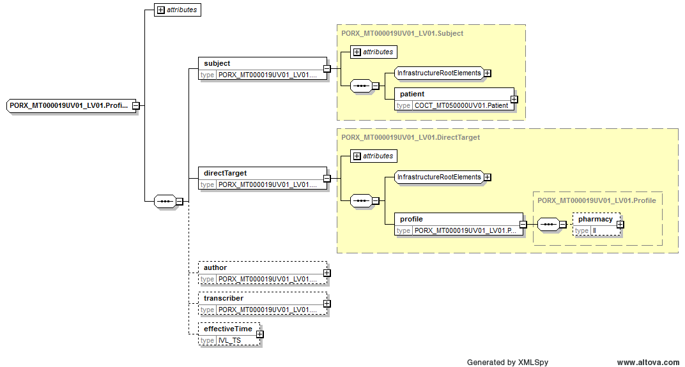
Picture 46 PORX_MT000019UV01_LV01.ProfileSetupRequest data structure
Data structure XML schema:
<xs:complexType name="PORX_MT000019UV01_LV01.ProfileSetupRequest">
<xs:sequence>
<xs:element name="subject" type="PORX_MT000019UV01_LV01.Subject"/>
<xs:element name="directTarget" type="PORX_MT000019UV01_LV01.DirectTarget"/>
<xs:element name="author" type="PORX_MT000019UV01_LV01.Author" minOccurs="0"/>
<xs:element name="transcriber" type="PORX_MT000019UV01_LV01.DataEnterer" minOccurs="0"/>
<xs:element name="effectiveTime" type="IVL_TS" minOccurs="0"/>
</xs:sequence>
<xs:attribute name="nullFlavor" type="NullFlavor" use="optional"/>
<xs:attribute name="classCode" type="ActClass" use="optional" fixed="ACT"/>
<xs:attribute name="moodCode" type="ActMoodRequest" use="required" fixed="RQO"/>
</xs:complexType>

Table 94 Data structure PORX_MT000019UV01_LV01.ProfileSetupRequest elements
Element | Type | Cardinality | Description
subject | PORX_MT000019UV01_LV01.Subject | 1..1
subject. patient | COCT_MT050000UV01.Patient | 1..1
subject. patient. id | II | 0..unbounded | Profile holder’s person identifier.  Personal code for Latvian citizen (OID: 1.3.6.1.4.1.38760.3.1.1).
directTarget | PORX_MT000019UV01_LV01.DirectTarget | 1..1
directTarget. profile | PORX_MT000019UV01_LV01.Profile | 1..1
directTarget. profile. pharmacy | II | 0..1 | Patient pharmacy code in user profile (OID: 1.3.6.1.4.1.38760.2.134)

PORX_MT000022UV01_LV01.MedicationWarning
This is complex data structure based on HL7 standard; it describes structure of medication warning.
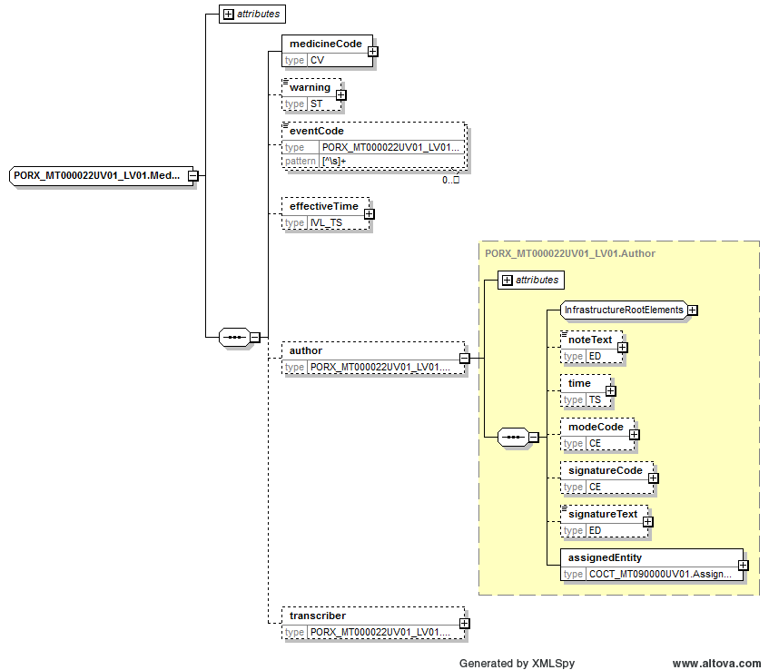
Picture 47 PORX_MT000022UV01_LV01.MedicationWarning data structure
Data structure XML schema:
<xs:complexType name="PORX_MT000022UV01_LV01.MedicationWarning">
<xs:sequence>
<xs:element name="medicineCode" type="CV"/>
<xs:element name="warning" type="ST" minOccurs="0"/>
<xs:element name="eventCode" type="PORX_MT000022UV01_LV01.MedicationWarningEventType" minOccurs="0" maxOccurs="unbounded"/>
<xs:element name="effectiveTime" type="IVL_TS" minOccurs="0"/>
<xs:element name="author" type="PORX_MT000022UV01_LV01.Author" nillable="true" minOccurs="0" maxOccurs="1"/>
<xs:element name="transcriber" type="PORX_MT000022UV01_LV01.DataEnterer" nillable="true" minOccurs="0" maxOccurs="1"/>
</xs:sequence>
<xs:attribute name="nullFlavor" type="NullFlavor" use="optional"/>
<xs:attribute name="classCode" type="ActClass" use="optional" fixed="ACT"/>
<xs:attribute name="moodCode" type="ActMoodRequest" use="required" fixed="RQO"/>
</xs:complexType>
Table 95 Data structure PORX_MT000022UV01_LV01.MedicationWarning elements
Element | Type | Cardinality |  | Description
medicineCode | CV |  | 1..1 | Medication code (OID: 1.3.6.1.4.1.38760.2.136)
warning | ST |  | 0..1 | Warning text
eventCode | PORX_MT000022UV01_LV01.MedicationWarningEventType |  | 0..unbounded | Event code declaring when to show appropriate warning
effectiveTime | IVL_TS |  | 0..1 | Medication warning registration time
author | PORX_MT000022UV01_LV01.Author |  | 0..1
author. assignedEntity | COCT_MT090000UV01.AssignedEntity |  | 1..1
author. assignedEntity. id | II |  | 0..unbounded | Person, who registered medication warning, identifier.  Person code for Latvian citizen (OID: 1.3.6.1.4.1.38760.3.1.1)

QueyContinuation Header
This is complex data structure based on HL7 standard; it describes structure of query by parameter payload header, which is used in several services for querying appropriate information.
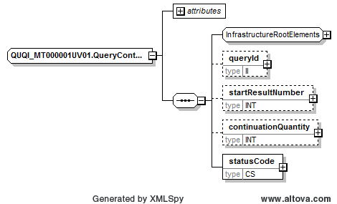
Picture 48 QueyContinuation Header data structure
Data structure XML schema:
<xs:complexType name="QUQI_MT000001UV01.QueryContinuation">
<xs:sequence>
<xs:group ref="InfrastructureRootElements"/>
<xs:element name="queryId" type="II" minOccurs="0" maxOccurs="1"/>
<xs:element name="startResultNumber" type="INT" minOccurs="0" maxOccurs="1"/>
<xs:element name="continuationQuantity" type="INT" minOccurs="0" maxOccurs="1"/>
<xs:element name="statusCode" type="CS" minOccurs="1" maxOccurs="1"/>
</xs:sequence>
<xs:attributeGroup ref="InfrastructureRootAttributes"/>
</xs:complexType>
Table 96 Data structure QueyContinuation Header elements
Element | Type | Cardinality | Description
queryId | II | 0..1 | See document [7]
startResultNumber | INT | 0..1 | See document [7]
continuationQuantity | INT | 0..1 | See document [7]
statusCode | CS | 1..1 | See document [7]

QueryByParameterPayload Header
This is complex data structure based on HL7 standard; it describes structure of query by parameter payload header, which is used in several services for querying appropriate information.
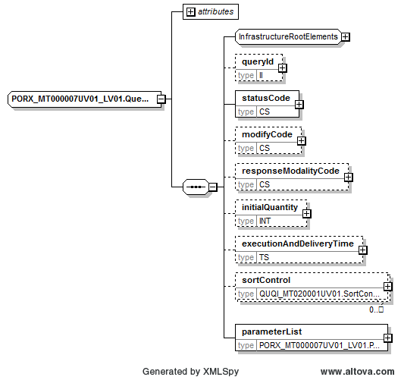
Picture 49 QueryByParameterPayload Header data structure
Data structure XML schema:
<xs:complexType name="PORX_MT000007UV01_LV02.QueryByParameterPayload">
<xs:sequence>
<xs:group ref="InfrastructureRootElements"/>
<xs:element name="queryId" type="II" minOccurs="0" maxOccurs="1"/>
<xs:element name="statusCode" type="CS" minOccurs="1" maxOccurs="1"/>
<xs:element name="modifyCode" type="CS" minOccurs="0" maxOccurs="1"/>
<xs:element name="responseModalityCode" type="CS" minOccurs="0" maxOccurs="1"/>
<xs:element name="initialQuantity" type="INT" minOccurs="0" maxOccurs="1"/>
<xs:element name="executionAndDeliveryTime" type="TS" minOccurs="0" maxOccurs="1"/>
<xs:element name="sortControl" type="QUQI_MT020001UV01.SortControl" nillable="true" minOccurs="0" maxOccurs="unbounded"/>
<xs:element name="parameterList" type="PORX_MT000007UV01_LV02.ParameterList" minOccurs="1" maxOccurs="1"/>
</xs:sequence>
<xs:attributeGroup ref="InfrastructureRootAttributes"/>
<xs:attribute name="nullFlavor" type="NullFlavor" use="optional"/>
</xs:complexType>
Table 97 Data structure QueryByParameterPayload Header elements
Element | Type | Cardinality | Description
queryId | II | 0..1 | See document [7]
statusCode | CS | 1..1 | See document [7]
modifyCode | CS | 0..1 | See document [7]
responseModalityCode | CS | 0..1 | See document [7]
initialQuantity | INT | 0..1 | See document [7]
executionAndDeliveryTime | TS | 0..1 | See document [7]
sortControl | QUQI_MT020001UV01.SortControl | 0..unbouned | See document [7]

PORX_MT000007UV01_LV02.QueryByParameterPayload
This is complex data structure based on HL7 standard; it describes structure of specific query by parameter payload body, which is used in several services for querying appropriate information.
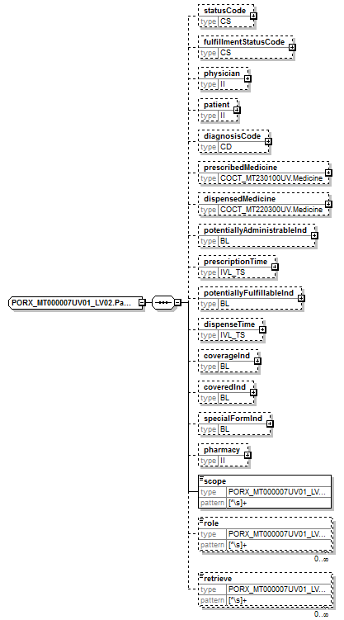
Picture 50 PORX_MT000007UV01_LV02.QueryByParameterPayload data structure
Data structure XML schema:
<xs:complexType name="PORX_MT000007UV01_LV02.ParameterList">
<xs:sequence>
<xs:element name="statusCode" type="CS" minOccurs="0" maxOccurs="1"/>
<xs:element name="fulfillmentStatusCode" type="CS" minOccurs="0" maxOccurs="1"/> <xs:element name="physician" type="II" minOccurs="0"/>
<xs:element name="patient" type="II" minOccurs="0" maxOccurs="1"/>
<xs:element name="diagnosisCode" type="CD" minOccurs="0"/>
<xs:element name="prescribedMedicine" type="COCT_MT230100UV.Medicine" minOccurs="0" maxOccurs="1"/>
<xs:element name="dispensedMedicine" type="COCT_MT220300UV.Medicine" minOccurs="0" maxOccurs="1"/>
<xs:element name="potentiallyAdministrableInd" type="BL" minOccurs="0"/>
<xs:element name="prescriptionTime" type="IVL_TS" minOccurs="0" maxOccurs="1"/>
<xs:element name="potentiallyFulfillableInd" type="BL" minOccurs="0"/>
<xs:element name="dispenseTime" type="IVL_TS" minOccurs="0" maxOccurs="1"/>
<xs:element name="coverageInd" type="BL" minOccurs="0"/>
<xs:element name="coveredInd" type="BL" minOccurs="0"/>
<xs:element name="specialFormInd" type="BL" minOccurs="0"/>
<xs:element name="pharmacy" type="II" minOccurs="0" maxOccurs="1"/>
<xs:element name="scope" type="PORX_MT000007UV01_LV02.ScopeType"/>
<xs:element name="role" type="PORX_MT000007UV01_LV02.RoleType" minOccurs="0" maxOccurs="unbounded"/>
<xs:element name="retrieve" type="PORX_MT000007UV01_LV02.RetrieveType" minOccurs="0" maxOccurs="unbounded"/>
</xs:sequence>
</xs:complexType>
Table 98 Data structure PORX_MT000007UV01_LV02.QueryByParameterPayload elements
Element | Type | Cardinality | Description
QueryByParameterPayload | PORX_MT000007UV01_LV02.QueryByParameterPayload | 1..1 | See data structure in chapter 6.12.
QueryByParameterPayload. parameterList | PORX_MT000007UV01_LV02.ParameterList | 1..1
QueryByParameterPayload. parameterList. statusCode | CS | 0..1 | Medication order status code (new – for reserved, active – for active, cancelled – for cancelled before activation, aborted – for cancelled after activation, complete – for expired or fully dispensed)
QueryByParameterPayload. parameterList. fulfillmentStatusCode | CS | 0..1 | Medication otder fulfilment status code (unfulfilled, partial – partially fulfilled, fulfilled)
QueryByParameterPayload. parameterList. physician | II | 0..1 | Person code or other identifying code (for example, physician code)  Physician (OID: 1.3.6.1.4.1.38760.2.1).  Physician code (OID: 1.3.6.1.4.1.38760.3.1.4).  Person code for Latvian citizen (OID: 1.3.6.1.4.1.38760.3.1.1)
QueryByParameterPayload. parameterList. patient | II | 0..1 | Person identifier.  Person code for Latvian citizen (OID: 1.3.6.1.4.1.38760.3.1.1).  Alternative identifier for newborns – consists of mother’s personal code and child birth time (OID: 1.3.6.1.4.1.38760.3.1.3).  Identification number for foreign country citizens (any child node in OID namespace 1.3.6.1.4.1.38760.3.1.8 except 1.3.6.1.4.1.38760.3.1.8.60).
QueryByParameterPayload. parameterList. diagnosisCode | CD | 0..1 | Diagnosis ICD-10 code (OID: 1.3.6.1.4.1.38760.2.159)
QueryByParameterPayload. parameterList. prescribedMedicine | COCT_MT230100UV. Medicine | 0..1
QueryByParameterPayload. parameterList. prescribedMedicine. code | CE | 0..1 | Prescribed medicine – medical registration number (OID: 1.3.6.1.4.1.38760.2.136), compensable medicine (OID: 1.3.6.1.4.1.38760.2.151) or compensation group (OID: 1.3.6.1.4.1.38760.2.177).
QueryByParameterPayload. parameterList. prescribedMedicine. name | TN | 0..unbound | Prescribed medicine – medicine name or part of it.
QueryByParameterPayload. parameterList. prescribedMedicine. ingredient | COCT_MT230100UV.Ingredient | 0..unbounded
QueryByParameterPayload. parameterList. prescribedMedicine. ingredient. ingredientSubstance | COCT_MT230100UV.Substance | 0..1
QueryByParameterPayload. parameterList. prescribedMedicine. ingredient. ingredientSubstance. code | CE | 0..1 | Prescribed medicine – active substance code (OID: 1.3.6.1.4.1.38760.2.140)
QueryByParameterPayload. parameterList. dispensedMedicine | COCT_MT220300UV.Medicine | 0..1
QueryByParameterPayload. parameterList. dispensedMedicine. code | CE | 0..1 | Dispensed medicine – medical registration number (OID: 1.3.6.1.4.1.38760.2.136) or medication code (OID: 1.3.6.1.4.1.38760.2.144).
QueryByParameterPayload. parameterList. dispensedMedicine. name | TN | 0..unbound | Dispensed medicine – name or part of it.
QueryByParameterPayload. parameterList. potentiallyAdministrableInd | BL | 0..1 | Indicator: get potentially administrable medicines only
QueryByParameterPayload. parameterList. prescriptionTime | IVL_TS | 0..1 | Medication order prescription time (from – to)
QueryByParameterPayload. parameterList. potentiallyFulfillableInd | BL | 0..1 | Indicator: get potentially fulfillable medication orders only  (for pharmacists – to get medication prescribed to pharmacy; for patient – to get medication orders, which are still dispensable).  Based on medication orders, which are not expired and not dispensed or partly dispensed.
QueryByParameterPayload. parameterList. dispenseTime | IVL_TS | 0..1 | Medication dispense time (from – to)
QueryByParameterPayload. parameterList. coverageInd | BL | 0..1 | Indicator: get prescribed compensable medicine only.
QueryByParameterPayload. parameterList. coveredInd | BL | 0..1 | Indicator: get dispensed compensable medicine only.
QueryByParameterPayload. parameterList. specialFormInd | BL | 0..1 | Indicator: special paper form (narcotic drugs and psychotropic, compensated medication)
QueryByParameterPayload. parameterList. pharmacy | II | 0..1 | Pharmacy (OID: 1.3.6.1.4.1.38760.2.134)
QueryByParameterPayload. parameterList. scope | PORX_MT000007UV01_LV02.ScopeType | 1..1 | * Allow to set scope of data to retrieve.  One of values:  - USR – get medication orders where user is in any of passed roles;  - PTN – get medication orders where passed patient is in any of passed roles;  - ORG – get data from passed organization pharmacy;  - ALL – get all the medication orders.  Uses with “role” element.
QueryByParameterPayload. parameterList. role | PORX_MT000007UV01_LV02.RoleType | 0..unbounded | * Allow to set role for scope.  One or more of values:  - SBJ – medication orders prescribed for user or passed patient;  - AUT – user prescribed medication orders;  - TRN – user transcribed medication orders;  - DLG – medication orders delegated for user or passed patient.  Uses with “scope” element.
QueryByParameterPayload. parameterList. retrieve | PORX_MT000007UV01_LV02.RetrieveType | 0..unbounded | ** Allow to set retrievable data structure parts.  One or more of values:  - ORD.ADM;  - ORD.DGN;  - ORD.DIS;  - ORD.REC;  - ORD.PTN;  - ORD.AUT;  - ORD.TRN;  - ORD.MED;  - ORD.CMP;  - ORD.ALL;  - DIS.SUP;  - DIS.REC;  - DIS.ALL;  - CAN.ALL.

* Specification for elements “scope” and “role” usage:
- for “scope” value “USR” there must be passed “role” value, it can be any of values “SBJ”, “AUT”, “TRN”, “DLG”;
- for “scope” value “PTN” there must be passed “role” value, it can be any of values “SBJ”, “DLG”;
- for “scope” value “ALL” there is no “role” value needed, “role” value will be ignored;
- for “scope” value “ORG” there is no “role” value needed, “role” value will be ignored.

** Specification for element “retrieve” usage, explaining each of value.
Value consists of prefix and suffix.
Prefix explains which data structure to fulfill into retrieve data structure.
Suffix explains which data structure part to fulfill into retrievable data structure.
Table 99 Element “retrieve” suffix values
Value | Data structure part to include
ORD.ADM | Data structure PORX_MT010120UV01_LV02.CombinedMedicationRequest element “component1.substanceAdministrationRequest”.  Except element “component1.substanceAdministrationRequest.reason”.
ORD.DGN | Data structure PORX_MT010120UV01_LV02.CombinedMedicationRequest element “component1.substanceAdministrationRequest.reason”.
ORD.DIS | Data structure PORX_MT010120UV01_LV02.CombinedMedicationRequest element “component2.dispenseRequest”.  Except element “component2.dispenseRequest.receiver”.
ORD.REC | Data structure PORX_MT010120UV01_LV02.CombinedMedicationRequest element “component2.dispenseRequest.receiver”.
fORD.PTN | Data structure PORX_MT010120UV01_LV02.CombinedMedicationRequest element “subject.patient.patientPerson”.
ORD.AUT | Data structure PORX_MT010120UV01_LV02.CombinedMedicationRequest element “author.assignedEntity”.
ORD.TRN | Data structure PORX_MT010120UV01_LV02.CombinedMedicationRequest element “transcriber.assignedEntity”.
ORD.MED | Data structure PORX_MT010120UV01_LV02.CombinedMedicationRequest element “directTarget.medication.administrableMedicine”.
ORD.CMP | Data structure PORX_MT010120UV01_LV02.CombinedMedicationRequest element “coverage.compensationRequest”.
ORD.ALL | Entire data structure PORX_MT010120UV01_LV02.CombinedMedicationRequest.
DIS.SUP | Data structure PORX_MT020070UV01_LV02.CombinedMedicationDispense element “component3.supplyEvent”.  Except element “component3.supplyEvent.receiver”.
DIS.REC | Data structure PORX_MT020070UV01_LV02.CombinedMedicationDispense element “component3.supplyEvent.receiver”.
DIS.ALL | Entire data structure PORX_MT020070UV01_LV02.CombinedMedicationDispense.  or  Data structure PORX_MT010120UV01_LV02.CombinedMedicationRequest element “fulfilledBy.combinedMedicationDispense”.
CAN.ALL | Data structure PORX_MT000025UV01_LV01.CancelMedicationOrderRequest element “subjectOf5.cancelMedicationOrderRequest”.

HL7 standard data structures usage examples
This chapter contains examples of HL7 standard data structures usage, including different cases.
According to HL7 standard:
- elements (of type PQ) attribute “unit” must be used for HL7 standard supported UCUM units only. Size of package (UCUM value - orig) must be used in “translation” element as it is e-Health specific classifier;
- elements “name” and “address” are to be fulfilled as texts with added logical mark-up (The approach is similar to HTML or XML markup of text).
System supports such UCUM units (http://unitsofmeasure.org/ucum.html) case insensitive:
- TimeUnits – "s", "min", "h", "d", "wk", "mo", "a";
- MassUnits – "ug", "mg", "g", "kg";
- VolumeUnits – "ml", "l", "cm3", "dm3", "m3";
- Units – "1", "{ORIG}".

Potential compensation payer (sponsor) and compensation payer (sponsor) examples
Example of potential compensation payer (sponsor) as State – use appropriate classifier (OID: 1.3.6.1.4.1.38760.2.93) value “STATE” – according to compensation condition with code Z25.1-J07BB02-50 in medication order:
<coverage typeCode="COVBY">
<compensationRequest moodCode="RQO">
<payer code="STATE" codeSystem="1.3.6.1.4.1.38760.2.93" />
<code code="Z25.1-J07BB02-50" codeSystem="1.3.6.1.4.1.38760.2.152" />
</compensationRequest>
</coverage>

Example of compensation payer (sponsor) as State – use appropriate classifier (OID: 1.3.6.1.4.1.38760.2.93) value “STATE” – according to compensation condition with code Z25.1-J07BB02-50 in medication dispense:
<supplyEvent>
…
<payer code="STATE" codeSystem="1.3.6.1.4.1.38760.2.93" />
…
<supplyEvent>

Example of potential compensation payer (sponsor) as private company with compensation percentage of 50% in medication order:
<coverage typeCode="COVBY">
<compensationRequest moodCode="RQO">
<payer code="01" codeSystem="1.3.6.1.4.1.38760.2.93" displayName="A/S Balta"/>
<percentageAmount value="50" />
</compensationRequest>
</coverage>

Example of compensation payer (sponsor) as private company with compensation percentage of 50% in medication dispense:
<supplyEvent>
…
<payer code="01" codeSystem="1.3.6.1.4.1.38760.2.93" displayName="A/S Balta"/>
<compensationPercent value="50" />
…
<supplyEvent>

Example of potential compensation payer (sponsor) as non-classified value with compensation percentage of 50% in medication order:
<coverage typeCode="COVBY">
<compensationRequest moodCode="RQO">
<payer nullFlavor="UNC">
<originalText>A/S Balta</originalText>
</payer>
<percentageAmount value="50" />
</compensationRequest>
</coverage>

Example of compensation payer (sponsor) as non-classified value with compensation percentage of 50% in medication dispense:
<supplyEvent>
…
<payer nullFlavor="UNC">
<originalText>A/S Balta</originalText>
</payer>
<compensationPercent value="50" />
…
<supplyEvent>

Example of both potential compensation payers (sponsors) State compensation (according to compensation condition with code Z25.1-J07BB02-50) and private company compensation (with compensation percentage of 50%)in medication order:
<coverage typeCode="COVBY">
<compensationRequest moodCode="RQO">
<payer code="STATE" codeSystem="1.3.6.1.4.1.38760.2.93" />
<code code="Z25.1-J07BB02-50" codeSystem="1.3.6.1.4.1.38760.2.152" />
</compensationRequest>
</coverage>
<coverage typeCode="COVBY">
<compensationRequest moodCode="RQO">
<payer code="01" codeSystem="1.3.6.1.4.1.38760.2.93" displayName="A/S Balta"/>
<percentageAmount value="50" />
</compensationRequest>
</coverage>

Person identification and documents examples
Example of receiver person identification by his Latvian citizen person code (OID: 1.3.6.1.4.1.38760.3.1.1; person code = 01018211119) and passport (OID: 1.3.6.1.4.1.38760.3.3.1.1; passport number = LV0000001) in medication dispense:
<supplyEvent>
…
<receiver typeCode="RCV">
<assignedPerson classCode="ASSIGNED">
<id root="1.3.6.1.4.1.38760.3.1.1" extension="01018211119" />
<id root="1.3.6.1.4.1.38760.3.3.1.1" extension="LV0000001" />
<assignedPerson classCode="PSN" determinerCode="INSTANCE">
<name use="L">
<given>Jānis</given>
<family>Liepiņš</family>
</name>
</assignedPerson>
</assignedPerson>
</receiver>
…
<supplyEvent>

Foreign citizen identification and documents examples
Example of patient person identification by his foreign citizen identifier code (OID: 1.3.6.1.4.1.38760.3.1.8.77) and EHIC card number (OID: 1.3.6.1.4.1.38760.3.3.1.3) in medication order:

<combinedMedicationRequest moodCode="RQO">
…
<subject typeCode="SBJ">
<patient classCode="PAT">
<patientPerson>
<id root="1.3.6.1.4.1.38760.3.1.8.77" extension="AB123456C" />
<id root="1.3.6.1.4.1.38760.3.3.1.3" extension="123412341234" />
<name use="L">
<given>Mery</given>
<family>Smith</family>
</name>
<administrativeGenderCode code="S" codeSystem="1.3.6.1.4.1.38760.2.111" />
<birthTime value="19811012000000.0000+0300" />
<addr>
Building 407 St John Street, London, <country>GB</country>
</addr>
</patientPerson>
</patient>
</subject>
…
</combinedMedicationRequest>

Medication usage examples
For medication strength there must be used medication data structure element “name”, which should be like this:
[medication name from classifier] [medication strength with unit]

Example of active substance of compensation group (OID: 1.3.6.1.4.1.38760.2.177) with code = 2 (Maravirocum), strength = 200mg, formCode = 1141:
<administrableMedicine classCode="MMAT" determinerCode="INSTANCE">
<code code="1" codeSystem="1.3.6.1.4.1.38760.2.177" />
<name>Maravirocum 200mg</name>
<formCode code="1141" codeSystem="1.3.6.1.4.1.38760.2.137" />
</administrableMedicine>

Example of medication (OID: 1.3.6.1.4.1.38760.2.137) with code = 05-0604:
<administrableMedicine classCode="MMAT" determinerCode="INSTANCE">
<code code="05-0604" codeSystem="1.3.6.1.4.1.38760.2.136" />
</administrableMedicine>

Example of compensable medicine (OID: 1.3.6.1.4.1.38760.2.151) with code = 10-0149-01:
<administrableMedicine classCode="MMAT" determinerCode="INSTANCE">
<code code="10-0149-01" codeSystem="1.3.6.1.4.1.38760.2.151" />
</administrableMedicine>
Example of medication with free text format with name = Maravirocum, strength = 200mg, formCode = 1141:
<administrableMedicine classCode="MMAT" determinerCode="INSTANCE">
<name>Maravirocum 200mg</name>
<formCode code="1141" codeSystem="1.3.6.1.4.1.38760.2.137" />
</administrableMedicine>

Example of medication consisting of active substances (OID: 1.3.6.1.4.1.38760.2.140) with code = 523, strength = 150mg, formCode = 1141:
<administrableMedicine classCode="MMAT" determinerCode="INSTANCE">
<ingredient classCode="INGR">
<ingredientSubstance classCode="MMAT" determinerCode="KIND">
<code code="523" codeSystem="1.3.6.1.4.1.38760.2.140"/>
</ingredientSubstance>
<quantity nullFlavor="UNC">
<numerator xsi:type="PQ" nullFlavor="UNC">
<translation nullFlavor="UNC">
<originalText>150 mg</originalText>
</translation>
</numerator>
<denominator xsi:type="PQ"/>
</quantity>
</ingredient>
<formCode code="1141" codeSystem="1.3.6.1.4.1.38760.2.137" />
</administrableMedicine>

Period usage examples
Example of administration period duration 30 days:
<width value="30" unit="d" />

Quantity usage examples
Example of 10 tablets:
<quantity value="10" />

- using HL7 units:
<quantity value="10" unit="ml" />

Example of 10 mililiters (ml), which is half of package (for medication dispense):
<quantity value="10" unit="ml" >
<translation value="0.5" unit="{ORIG}" />
</quantity>

Name usage examples
According to HL7 standard, person element “name” is textual with logical mark-ups. It means that such text may contain some special tags (mark-ups), which are surrounding and therefore identifying appropriate fields (example of mark-up: <myMarkUp>Some code value</myMarkUp>). Only marked fields will be processed.

For each of names there can be used such mark-ups (other mark-ups will be ignored):
- given – given name (name, firstname) mark-up;
- family – family name (surname, lastname) mark-up;

Example of name with marked given and family names:
<name><given>Jānis</given> <family>Bērziņš</family></name>

Example of name with marked given, family names and prefix:
<name><prefix >Mr.</prefix> <given>Jānis</given> <family>Bērziņš</family></name>

Address usage examples
According to HL7 standard, element “address” is a textual with logical mark-ups. It means that such text may contain some special tags (mark-ups), which are surrounding and therefore identifying appropriate fields (example of mark-up: <myMarkUp>Some code value</myMarkUp>). Only marked fields will be processed.
Any address can be used in 2 different forms:
- Non-structured – element “address” doesn’t contain any of mark-up (should be used in very limited cases, when there is no chance to structure any part of address);
- Structured – element “address” contain at least one mark-up – contry code mark-up “country” (for example: addreses … <country>LV</country>).
Non-structured form is not preferable because address data will be used for furthere data analysis, it means that non-strucuted form should be used only in limited cases!

Foreign country address
Foreign country address can be used in non-structured or structured form. For each of foreign country citizen addresses there should be used such mark-ups (other mark-ups will be ignored):
- country – country code mark-up (mandatory).

Non-structured form is not preferable because address data will be used for furthere data analysis, it means that non-structured form should be used only in case, when there is no chance to identify the country!

Example of foreign citizen address in non-structured form (not preferable):
- 3300 Washtenaw Avenue, Suite 227 Ann Arbor, MI 48104 US
<addr>3300 Washtenaw Avenue, Suite 227 Ann Arbor, MI 48104, US</addr>

Example of foreign citizen address:
- 3300 Washtenaw Avenue, Suite 227 Ann Arbor, MI 48104 US
<addr>3300 Washtenaw Avenue, Suite 227 Ann Arbor, MI 48104 <country>US</country></addr>

Latvian address
Latvian address can be used in non-structured or structured form. Correct form of Latvian address should be like this:
[street name] [house number | house name]–[flat number], [city | village], [parish | rural area], [county], [postal code], [country] [ATU code]

For each of Latvian addresses there can be used such mark-ups (other mark-ups will be ignored):
- streetName – street name mark-up;
- houseNumber – house number mark-up;
- additionalLocation – house name mark-up;
- unitID – flat number mark-up;
- city – city or village mark-up;
- county – county, parish and rural area mark-up;
- postalCode – postal code mark-up;
- country – country code mark-up;
- censusTract – ATU code mark-up;
- delimiter – any other text between mark-ups can be surrounded by delimiter mark-ups to make all the address text marked.

Depending on Latvian address case, some fields may be omitted, there are such main rules for Latvian addresses mark-ups:
- postalCode – mandatory;
- censusTract – mandatory;
- city | county – at least one of these is mandatory;
- additionalLocation | streetName + houseNumber – at least one of these is mandatory;
- streetName + houseNumber – if there is one of these than other must be.

Non-structured form is not preferable because address data will be used for furthere data analysis, it means that non-structured form should be used only in case, when there is no chance to identify the address structure!

Example of address in non-structurel form (not preferable):
- Bišu iela 3, Gulbene, Gulbenes nov., LV-4401, LV
<addr>Bišu iela 3, Gulbene, Gulbenes nov., LV-4401, LV</addr>

Example of address with marked street name, house number, city, county, postal code, country and ATU code, buy without delimiter markups:
- Bišu iela 3, Gulbene, Gulbenes nov., LV-4401
<addr><streetName>Bišu iela</streetName> <houseNumber>3</houseNumber>, <city>Gulbene</city>, <county>Gulbenes nov.</county>, <postalCode>LV-4401</postalCode>, <country>LV</country><censusTract>0500201</censusTract></addr>

Example of address with marked street name, house number, city, county, postal code, country, ATU code and delimiters between them:
- Bišu iela 3, Gulbene, Gulbenes nov., LV-4401
<addr><streetName>Bišu iela</streetName><delimiter> </delimiter><houseNumber>3</houseNumber><delimiter>, </delimiter><city>Gulbene</city><delimiter>, </delimiter><county>Gulbenes nov.</county><delimiter>, </delimiter><postalCode>LV-4401</postalCode>, <country>LV</country><censusTract>0500201</censusTract></addr>

Examples of addresses with correct postal code:
- Dāboltiņi, Bringi, Mežvidu pag., Kārsavas nov., LV-5753
<addr><additionalLocator>Dāboltiņi</additionalLocator>, <city>Bringi</city>, <county>Mežvidu pag.</county>, <county>Kārsavas nov.</county>, <postalCode>LV-5753</postalCode>, <country>LV</country><censusTract>0681070</censusTract></addr>

Examlpes of addresses with correct street names:
- Melnsila iela 6, Rīga, LV-1046
<addr><streetName>Melnsila iela</streetName> <houseNumber>6</houseNumber>, <city>Rīga</city>, <postalCode>LV-1046</postalCode>, <country>LV</country><censusTract>0010000</censusTract></addr>

- Kārļa Ulmaņa gatve 2A, Rīga, LV-1004
<addr><streetName>Kārļa Ulmaņa gatve</streetName> <houseNumber>2A</houseNumber>, <city>Rīga</city>, <postalCode>LV-1004</postalCode>, <country>LV</country><censusTract>0010000</censusTract></addr>

- Aspazijas bulvāris 24, Rīga, LV-1050
<addr><streetName>Aspāzijas bulvāris</streetName> <houseNumber>24</houseNumber>, <city>Rīga</city>, <postalCode>LV-1050</postalCode>, <country>LV</country><censusTract>0010000</censusTract></addr>

- Ūbeļu iela 16-51, Ādaži, Ādažu nov., LV-2164
<addr><streetName>Ūbeļu iela</streetName> <houseNumber>16</houseNumber>-<unitID>16</unitID>, <city>Gulbene</city>, <county>Gulbenes nov.</county>, <postalCode>LV-4401</postalCode>, <country>LV</country><censusTract>0804400</censusTract></addr>

Examples of addresses with correct house numbers (with street name; building block must be passed as "k-XXX", not separated of house number with slash.):
- Zaļā iela 3–11, Namiķi, Lutriņu pag., Saldus nov., LV-3861
<addr><streetName>Zāļu iela</streetName> <houseNumber>3</houseNumber>-<unitID>11</unitID>, <city>Namiķi</city>, <county>Lutriņu pag.</county>, <county>Saldus nov.</county>, <postalCode>LV-3861</postalCode>, <country>LV</country><censusTract>0840266</censusTract></addr>

- Vienības gatve 168–50, Rīga, LV-1058
<addr><streetName>Vienības gatve </streetName> <houseNumber>168</houseNumber>-<unitID>50</unitID>, <city>Rīga</city>, <postalCode>LV-1058</postalCode>, <country>LV</country><censusTract>0010000</censusTract></addr>

- Miera iela 15A, Strūžāni, Stružānu pag., Rēzeknes nov., LV-4643
<addr><streetName>Miera iela</streetName> <houseNumber>15A</houseNumber>, <city>Stružāni</city>, <county>Stružānu pag.</county>, <county>Rēzeknes nov.</county>, <postalCode>LV-4643</postalCode>, <country>LV</country><censusTract>0780294</censusTract></addr>

- Kolkasraga iela 16/18–1, Rīga, LV-1002
<addr><streetName>Kolkasraga iela</streetName> <houseNumber>16/18</houseNumber>-<unitID>1</unitID>, <city>Rīga</city>, <postalCode>LV-1002</postalCode>, <country>LV</country><censusTract>0010000</censusTract></addr>

- Katrīnas dambis 26 k-4, Rīga, LV-1045
<addr><streetName>Katrīnas dambis </streetName> <houseNumber>26 k-4</houseNumber>, <city>Rīga</city>, <postalCode>LV-1045</postalCode>, <country>LV</country><censusTract>0010000</censusTract></addr>

Examples of addresses with correct house names (without street name):
- Kalna Vēliņi, Raunas pag., Raunas nov., LV-4131
<addr><additionalLocator>Kalna Vēliņi</additionalLocator>, <county>Raunas pag.</county>, <county>Raunas nov.</county>, <postalCode>LV-4131</postalCode>, <country>LV</country><censusTract>0427776</censusTract></addr>

- Ziedkalni–8, Grenči, Zemītes pag., Kandavas nov., LV-3136
<addr><additionalLocator>Ziedkalni-8</additionalLocator>, <city>Grenči</city>, <county>Zemītes pag.</county>, <county>Kandavas nov.</county>, <postalCode>LV-3136</postalCode>, <country>LV</country><censusTract>0901294</censusTract></addr>

- Jaunsaules, Dzērbenes pag., Vecpiebalgas nov., LV-4118
<addr><additionalLocator>Jaunsaules</additionalLocator>, <county>Dzērbenes pag.</county>, <county>Vecpiebalgas nov.</county>, <postalCode>LV-4118</postalCode>, <country>LV</country><censusTract>0429350</censusTract></addr>

- Kalniņi 2, Lejasciema pag., Gulbenes nov., LV-4413
<addr><additionalLocator>Kalniņi 2</additionalLocator>, <county>Lejasciema pag.</county>, <county>Gulbenes nov.</county>, <postalCode>LV-4413</postalCode>, <country>LV</country><censusTract>0500264</censusTract></addr>

- Dzelzceļa ēka 23. km, Olaines pag., Olaines nov., LV-2127
<addr><additionalLocator>Dzelceļa ēka 23. km</additionalLocator>, <county>Olaines pag.</county>, <county>Olaines nov.</county>, <postalCode>LV-2127</postalCode>, <country>LV</country><censusTract>0801080</censusTract></addr>

- Druvienas, Kaspari, Mežvidu pag., Kārsavas nov., LV-5725
<addr><additionalLocator>Kalniņi 2</additionalLocator>, <county>Lejasciema pag.</county>, <county>Gulbenes nov.</county>, <postalCode>LV-5725</postalCode>, <country>LV</country><censusTract>0681070</censusTract></addr>

Examples of addresses with correct flat numbers:
- Brīvības iela 20–4, Ogre, Ogres nov., LV-5001
<addr><streetName>Brīvības iela</streetName> <houseNumber>20</houseNumber>-<unitID>4</unitID>, <city>Ogre</city>, <county>Ogres pag.</county>, <postalCode>LV-5001</postalCode>, <country>LV</country><censusTract>0740201</censusTract></addr>

- Artilērijas iela 6–6, Rīga, LV-1001
<addr><streetName>Artilērijas iela</streetName> <houseNumber>6</houseNumber>-<unitID>6</unitID>, <city>Rīga</city>, <postalCode>LV-1001</postalCode>, <country>LV</country><censusTract>0010000</censusTract></addr>

- Mārupes iela 6–2A, Rīga, LV-1002
<addr><streetName>Mārupes iela</streetName> <houseNumber>6</houseNumber>-<unitID>2A</unitID>, <city>Rīga</city>, <postalCode>LV-1002</postalCode>, <country>LV</country><censusTract>0010000</censusTract></addr>

- Sīmaņa iela 6–34/35, Rīga, LV-1005
<addr><streetName>Sīmaņa iela</streetName> <houseNumber>6</houseNumber>-<unitID>34/35</unitID>, <city>Rīga</city>, <postalCode>LV-1005</postalCode>, <country>LV</country><censusTract>0010000</censusTract></addr>

- Ziedkalnes 2–18, Mūrmuiža, Vilces pag., Jelgavas nov., LV-3027
<addr><additionalLocator>Ziedkalnes 2</additionalLocator>-<unitID>18</unitID>, <city>Mūrmuiža</city>, <county>Vilces pag.</county>, <county>Jelgavas nov.</county>, <postalCode>LV-3027</postalCode>, <country>LV</country><censusTract>0540290</censusTract></addr>

Examples of republic cities address:
- Dūņu iela 1, Jelgava, LV-3001
<addr><streetName>Dūņu iela</streetName> <houseNumber>1</houseNumber>, <city>Jelgava</city>, <postalCode>LV-3001</postalCode>, <country>LV</country><censusTract>0090000</censusTract></addr>

- Višķu iela 1-44, Rīga, LV-1063
<addr><streetName>Višķu iela</streetName> <houseNumber>1</houseNumber>-<unitID>44</unitID>, <city>Rīga</city>, <postalCode>LV-1063</postalCode>, <country>LV</country><censusTract>0010000</censusTract></addr>

Examples of county cities address:
- Bērzpils iela 3–4, Balvi, Balvu nov., LV-4501
<addr><streetName>Bērzpils iela</streetName> <houseNumber>3</houseNumber>-<unitID>4</unitID>, <city>Balvi</city>, <county>Balvu no.</county>, <postalCode>LV-4501</postalCode>, <country>LV</country><censusTract>0380201</censusTract></addr>

- Vārpu iela 1-2, Ikšķile, Ikšķiles nov., LV-5052
<addr><streetName>Vārpu iela</streetName> <houseNumber>1</houseNumber>-<unitID>2</unitID>, <city>Ikšķile</city>, <county>Ikšķiles pag.</county>, <postalCode>LV-5052</postalCode>, <country>LV</country><censusTract>0740605</censusTract></addr>

Examples of village address:
- Daugavas prospekts 3-2, Ādamlauks, Ikšķiles l.t., Ikšķiles nov., LV-5052
<addr><streetName>Daugavpils prospekts</streetName> <houseNumber>3</houseNumber>-<unitID>2</unitID>, <city>Ādamlauks</city>, <county>Ikšķiles l.t.</county>, <county>Ikšķiles nov.</county>, <postalCode>LV-5052</postalCode>, <country>LV</country><censusTract>0740605</censusTract></addr>

Examples of county, parish or rural area address:
- Jaunbirzgaļi, Kārļi, Drabešu pag., Amatas nov., LV-4138
<addr><additionalLocator>Jaunbirzgaļi</additionalLocator>, <city>Kārļi</city>, <county>Drabiešu pag.</county>, <county>Amatas nov.</county>, <postalCode>LV-4138</postalCode>, <country>LV</country><censusTract>0424746</censusTract></addr>

- Upītes, Apes l. t., Apes nov., LV-4337
<addr><additionalLocator>Upītes</additionalLocator>, <county>Apes l.t.</county>, <county>Apes nov.</county>, <postalCode>LV-4337</postalCode>, <country>LV</country><censusTract>0360825</censusTract></addr>

Permission delegation
From patient perspective medication order and patient profile access is allowed only for the person which is specified in medication order as patient or specified as holder of profile. However System supports medication order and profile access permission delegation via security token delegates.
In order to access other patient medication orders or profiles, security token should contain corresponding Delegations attribute. For detailed information on security token structure see [7].
Security token example:
<o:Security s:mustUnderstand="1" xmlns:o="http://docs.oasis-open.org/wss/2004/01/oasis-200401-wss-wssecurity-secext-1.0.xsd">
<saml:Assertion MajorVersion="1" MinorVersion="1" AssertionID="_46ded6f3-7b83-462f-a240-db201f329684" Issuer="https://eves-prod.abc/ip.sts/1.0" IssueInstant="2015-11-20T13:30:51.337Z" xmlns:saml="urn:oasis:names:tc:SAML:1.0:assertion">
…
<saml:AttributeStatement>
…
<saml:Attribute AttributeName="Delegations">
<Actor>
<saml:Attribute AttributeName="PatientType">
<saml:AttributeValue>P8_DELEGATE</saml:AttributeValue>
</saml:Attribute>
<saml:Attribute AttributeName="privatepersonalidentifier">
<saml:AttributeValue>10077610501</saml:AttributeValue>
</saml:Attribute>
<saml:Attribute AttributeName="givenname">
<saml:AttributeValue>Sanita</saml:AttributeValue>
</saml:Attribute>
<saml:Attribute AttributeName="surname">
<saml:AttributeValue>Vitola</saml:AttributeValue>
</saml:Attribute>
<saml:Attribute AttributeName="role">
<saml:AttributeValue>Patient</saml:AttributeValue>
</saml:Attribute>
<saml:Attribute AttributeName="action">
<saml:AttributeValue>GetProfile</saml:AttributeValue>
<saml:AttributeValue>QueryMedicationDispenses</saml:AttributeValue>
<saml:AttributeValue>QueryMedicationOrders</saml:AttributeValue>
<saml:AttributeValue>SetProfile</saml:AttributeValue>
</saml:Attribute>
</Actor>
</saml:Attribute>
…
</saml:AttributeStatement>
</saml:Assertion>
</o:Security>

Traceability matrix
Table 100 Traceability matrix
TS Requirement | System Requirement
 | Chapter, identifier, Name
E-Health 1st stage requirements
(005) Sistēmai jānodrošina šādu pamata dokumentu aprite, par dokumentu uzskatot:  - Izrakstīto e-recepti, kopā ar tās saistīto informāciju. Šim dokumentam iespējami dažādi veidi – parastā recepte vai īpašā recepte, kas var būt kompensējamā medikamenta recepte vai recepte, kas satur narkotisko un psihotropo vielu saturošus medikamentus.  - Ziņojumu par medikamenta izsniegšanu pret e-recepti  - Ziņojumu par e-receptes anulēšanu, norādot anulēšanas iemeslu  - Ziņojumu par ārstniecības personas licences apturēšanu vai anulēšanu  - Ziņojumu par medikamenta pieejamības tirgū statusa maiņu  - Ziņojumu par farmaceita statusa maiņu  - Ziņojumu par medikamenta atsaukšanu.  Sistēmā izmantojamo ziņojumu saraksts un to informācijas apjoms, aprakstīts XML shēmu formā, sniegts pielikumā (Ziņojumi un XML shēmas 47.lpp). Minētais saraksts, kā arī pielikumā norādītās shēmas Izstrādātājam jāpapildina ar nepieciešamajām definīcijām vai jāpārstrādā, izveidojot datu apmaiņas standartu ar aptieku un ārsta prakses sistēmām. | Documents are described in 6. Data structures.  These documents are not System responsibility:  - “Ziņojums par ārstniecības personas licences apturēšanu vai anulēšanu”;  - “Ziņojums par medikamenta pieejamības tirgū statusa maiņu”;  - “Ziņojums par farmaceita statusa maiņu”.
(013) Sistēmai automātiski, izmantojot tīmekļa pakalpi, jānosūta informācija par kompensējamiem izsniegtajiem ārstniecības līdzekļiem e-booking finanšu norēķinu modulim. Piegādātājam, sadarbībā ar e-booking izstrādātāju, prasību analīzes laikā jāveic datu formāta sagatavošana un saskaņošana. | Data structure for dispense is 6.7. PORX_MT020070UV01_LV02.CombinedMedicationDispense.
(055) Sistēmā jārealizē datu apmaiņas saskarne ar ārsta prakses IS, kurās ir nodrošināta sadarbspēja darbam e-receptes tīklā, nodrošinot izrakstīto recepšu nodošanu e-receptes servisam, kā arī citu saistīto ziņojumu apmaiņu. | Such services:  - 5.1. BookMedicationOrders  - 5.2. GetCompensationConditionList  - 5.3. RegisterMedicationOrder  - 5.4. GetMedicationOrderData  - 5.5. CancelMedicationOrder  - 5.6. GetMedicationOrderList  - 5.8. GetMedicineList  - 5.9. GetDiagnosisList
(056) Sistēmā jārealizē datu apmaiņas saskarne ar tām aptieku IS, kurās ir nodrošināta sadarbspēja darbam e-receptes tīklā, nodrošinot informācijas par izsniegto ārstniecības līdzekli nodošanu e-receptes servisam, kā arī citu saistīto ziņojumu apmaiņu. | Such services:  - 5.4. GetMedicationOrderData  - 5.6. GetMedicationOrderList  - 5.3. RegisterMedicationOrder  - 5.10. BookMedicationDispense  - 5.11. RegisterMedicationDispense  - 5.12. CancelMedicationDispense  - 5.13. GetMedicationDispenseList
(107) Ziņojumapmaiņas funkcionalitātei ir jābūt balstītai uz SOA principiem un izmantojot tīkla servisu platformu.  Tīkla servisu platformas pamatu pamatos tiek izmantoti tīkla servisi, kuru saskarnes tiek aprakstītas ar WSDL (valoda tīkla servisu saskarņu aprakstīšanai) un XML Schema (valoda XML struktūru aprakstīšanai) starpniecību, bet datu apmaiņa starp servisiem notiek ar SOAP (datu apmaiņas protokols, kas ļauj apmainīt SOAP ziņojumus jeb elektroniskas aploksnes, izmantojot dažādus transporta protokolus – HTTP, SMTP, FTP u.c.) protokola palīdzību. | 3. Interface description  5. Services  6. Data structures
(108) Ziņojumu formātam ir jāizmanto XML. | 6. Data structures
(109) XML struktūru aprakstam ir jāizmanto XML Schema2 (XSD). | 6. Data structures
E-Health 2nd stage requirements
REC-02 Ārsta kontaktinformācija e-receptē (Obligāta) | 6.2. COCT_MT050000UV01.Person  6.3. COCT_MT230100UV.Medicine  6.14. HL7 standard data structures usage examples  9.1.3.3. Get recipe data  10.1. Error list
REC-05 Recepšu izsniegšanas brīdinājumi (Obligāta) | 6.7. PORX_MT020070UV01_LV02.CombinedMedicationDispense  9.2.1.1. Book medication dispense  9.2.1.3. Register medication dispense
POR-17 E-recepšu izrakstīšanas ekrānformas uzlabojumi (Obligāta) | 6.1. PORX_MT010120UV01_LV02.CombinedMedicationRequest  6.3. COCT_MT230100UV.Medicine  6.6. PORX_MT010120UV01_LV02.DispenseRequest  6.7. PORX_MT020070UV01_LV02.CombinedMedicationDispense  6.13. PORX_MT000007UV01_LV02.QueryByParameterPayload  6.14. HL7 standard data structures usage examples  9.1.3.3. Get recipe data  9.2.1.1. Book medication dispense  9.2.1.2. Validate medication dispense  9.2.1.3. Register medication dispense
POR-19 E-recepšu izrakstīšanas uzlabojumi sarakstā (Obligāta) | 6.1. PORX_MT010120UV01_LV02.CombinedMedicationRequest  6.13. PORX_MT000007UV01_LV02.QueryByParameterPayload  6.14. HL7 standard data structures usage examples  9.1.1.6. Book recipe number  9.1.3.3. Get recipe data
POR-20 Izsniedzamo ĀL saraksta uzlabojumi (Obligāta) | 6.13. PORX_MT000007UV01_LV02.QueryByParameterPayload  6.14. HL7 standard data structures usage examples
POR-23 ĀL izsniegšanas uzlabojumi (Obligāta) | 6.6. PORX_MT010120UV01_LV02.DispenseRequest  6.7. PORX_MT020070UV01_LV02.CombinedMedicationDispense  6.13. PORX_MT000007UV01_LV02.QueryByParameterPayload  6.14. HL7 standard data structures usage examples  9.1.3.3. Get recipe data  9.2.1.1. Book medication dispense  9.2.1.2. Validate medication dispense  9.2.1.3. Register medication dispense
POR-24 ĀL izsniegšanas vēlamie uzlabojumi (Vēlama) | 6.1. PORX_MT010120UV01_LV02.CombinedMedicationRequest  6.7. PORX_MT020070UV01_LV02.CombinedMedicationDispense  6.14. HL7 standard data structures usage examples
POR-26 Ekstemporāli pagatavojamo zāļu un bezrecepšu zāļu receptes (Obligāta) | 6.3. COCT_MT230100UV.Medicine  6.13. PORX_MT000007UV01_LV02.QueryByParameterPayload  6.14. HL7 standard data structures usage examples

Services usage explanation

Physician processes
Physician goal is to operate with recipes (also known as prescriptions, medication orders or combined medication requests), including its prescription, reservation, cancelation and getting list of recipes.

Recipe prescription
Recipe prescription is complex process, which consists of such steps as booking recipe number, getting different kind of information during the prescription process (medicines used by patient, frequently used diagnoses, frequently prescribed medicines by physician or to patient) and recipe prescription.
Getting different kind of information during the prescription process is optional; it should be used to provide physician with additional information to eliminate the risk of mistake during prescription process. To submit recipe data to System, there must be called at least 2 mandatory services:
- BookMedicationOrder – to book and recieve recipe number;
- RegisterMedicationOrder – to submit recipe with appropriate recipe number.

Further, there are listed most common steps during recipe prescription process.

Get patient potentially used medicines
Optional step

Step provides physician with information on patient potentially used medicines ordered by prescription date. These medicines considered to be:
- Partly or totally dispensed medicines based on recipes with valid expiration date;
- Partly or totally dispensed medicines based on recipes with valid or reciently ended treatment course.

To get patient potentially used medicines, use service GetMedicationOrderList with parameters:
- patient = [Patient person code] (in example: 01018211119);
- potentiallyAdministrableInd = true (return potentially administrable medicines only);
- scope = PTN, role = SBJ (get recipes where patient is recipe subject);
- retrieve = ORD.MED (fulfill medication data).

Input data example:
<parameterList>
<patient root="1.3.6.1.4.1.38760.3.1.1" extension="01018211119"/>
<potentiallyAdministrableInd value="true"/>
<scope>PTN</scope>
<role>SBJ</role>
<retrieve>ORD.MED</retrieve>
</parameterList>

Output data is list of recipe data structures with appropriate data fulfilled; full recipe data structure example shown in chapter “9.1.3.3 Get recipe data” as output data example.

Get frequently used physician diagnoses
Optional step

Step provides physician with information on frequently used diagnoses by physician during last X months (X – System parameter) ordered by prescription frequency ascending and date descending.
To get frequently used physician diagnoses, use service GetDiagnosisList with no parameters:
- scope = USR, role = AUT (get recipes where user is author).

Input data example:
<parameterList>
<scope>USR</scope>
<role>AUT</role>
</parameterList>

Output data example (list with two diagnoses: Z25.1, J10.0):
<diagnosis code="Z25.1" codeSystem="1.3.6.1.4.1.38760.2.159" displayName="Nepieciešamība imunizēt pret gripu"/>
<diagnosis code="J10.0" codeSystem="1.3.6.1.4.1.38760.2.159" displayName="Gripa ar pneimoniju, ja vīruss identificēts"/>

Get medicines frequently prescribed to patient
Optional step

Step provides physician with information on medicines frequently prescribed to appropriate patient during last X months (X – System parameter) ordered by prescription frequency ascending and date descending.
To get medicines frequently prescribed to patient, use service GetMedicineList with parameters:
- patient = [Patient person code] (in example: 01018211119);
- scope = PTN, role = SBJ (get recipes where patient is recipe subject).

Input data example:
<parameterList>
<patient root="1.3.6.1.4.1.38760.3.1.1" extension="01018211119"/>
<scope>PTN</scope>
<role>SBJ</role>
</parameterList>

Output data example (list of two medicines: 01-0294, 03-0498):
<medicine classCode="MMAT" determinerCode="INSTANCE">
<code code="01-0294" codeSystem="1.3.6.1.4.1.38760.2.136" displayName="Singulair 4 mg chewable tablets"/>
<desc>Singulair 4 mg košļājamās tabletes</desc>
</medicine>
<medicine classCode="MMAT" determinerCode="INSTANCE">
<code code="03-0498" codeSystem="1.3.6.1.4.1.38760.2.136" displayName="Anzatax 30 mg/5 ml concentrate for solution for infusion"/>
<desc>Anzatax 30 mg/5 ml koncentrāts infūziju šķīduma pagatavošan</desc>
</medicine>

Get medicines frequently prescribed by physician
Optional step

Step provides physician with information on medicines frequently prescribed by him patient during last X months (X – System parameter) ordered by prescription frequency ascending and date descending.
To get medicines frequently prescribed by physician, use service GetMedicineList with parameters:
- scope = USR, role = AUT (get recipes where user is author).

Input data example:
<parameterList>
<scope>USR</scope>
<role>AUT</role>
</parameterList>

Output data is list of medicine data structures with appropriate data fulfilled; full medicine data structure example shown in chapter “9.1.1.3 Get medicines frequently prescribed to patient” as output data example.

Get compensation conditions
Optional step

Step provides physician with information on compensation conditions for requested data (patient data, medication, physician specialty and diagnoses).
To get compensation conditions, use service GetCompensationConditionList with parameters:
- effectiveTime = [Today or other date (yyyyMMddHHmmss.ffffzz00)];
- patientId = [Patient person code] (in example: 01018211119)
- patientBirthDate = [Patient birth date (yyyyMMddHHmmss.ffffzz00)];
- patientGenderCode = [Patient gender code (male = V, female = S)];
- diagnosisCode = [Appropriate diagnosis code (ICD-10 code)] (in example: Z25.1 – diagnosis, Z33.0 – additional diagnosis);
- physicianSpecialtyCode = [specialty code physician with which he is working at the moment (logged in)] (in example: A161);
- medicine.code = [Medicine code] (in example: 05-0197);
- medicine.formCode = [Medicine form code] (in example: empty).

Input data example:
<parameterList>
<effectiveTime value="20121122000000.0000-0800"/>
<patientId root="1.3.6.1.4.1.38760.3.1.1" extension="01018211119"/>
<patientBirthDate value="19471002000000.0000-0700"/>
<patientGenderCode code="S" codeSystem="1.3.6.1.4.1.38760.2.111"/>
<diagnosisCode code="Z25.1" codeSystem="1.3.6.1.4.1.38760.2.159">
<qualifier>
<value code="Z33.0" codeSystem="1.3.6.1.4.1.38760.2.159"/>
</qualifier>
</diagnosisCode>
<physicianSpecialtyCode code="A161" codeSystem="1.3.6.1.4.1.38760.2.38"/>
<medicine classCode="MMAT" determinerCode="INSTANCE">
<code code="05-0197" codeSystem="1.3.6.1.4.1.38760.2.136"/>
</medicine>
</parameterList>

Output data example (compensation code: 3, percentage: 50, special conditions: “grūtniecēm (receptē papildus norādot diagnozes kodu ""Z33"")”):
<compensationCondition>
<code code="3" codeSystem="1.3.6.1.4.1.38760.2.152" displayName="Z25 - Vaccinum influenzae"/>
<compensationPercent value="50"/>
<conditions>grūtniecēm (receptē papildus norādot diagnozes kodu ""Z33"")</conditions>
</compensationCondition>

Book recipe number
Mandatory step
Step provides recipe number booking for further data submitting to System. It serves like transaction mechanism to avoid network errors during recipe prescription.
To book recipe number, use service BookMedicationOrders with parameters:
- count = 1 (to book one recipe number);
- permanentInd = false (book temporary recipe number).

Input data example:
<bookMedicationOrderRequest>
<count value="1"/>
<permanentInd value="false"/>
</bookMedicationOrderRequest>

Output data example (empty recipe data structure with transcriber data fulfilled):
<combinedMedicationRequest moodCode="RQO">
<id root="1.3.6.1.4.1.38760.3.4.11.1" extension="23345349511101265"/>
<effectiveTime xsi:type="IVL_TS">
<low value="20121122000000.0000+0200"/>
<high value="20130222000000.0000+0200"/>
</effectiveTime>
<statusCode code="new"/>
<transcriber typeCode="TRANS">
<assignedEntity classCode="ASSIGNED">
<id root="1.3.6.1.4.1.38760.3.1.1" extension="01015110638"/>
<assignedPerson classCode="PSN" determinerCode="INSTANCE">
<name xsi:type="PN" use="L">
<given>Tatjana</given>
<family>Farbtuha</family>
</name>
</assignedPerson>
<representedOrganization classCode="ORG" determinerCode="INSTANCE">
<id root="1.3.6.1.4.1.38760.3.2.2" extension="409635213"/>
<name use="L">Viesturu doktorāts</name>
</representedOrganization>
</assignedEntity>
</transcriber>
</combinedMedicationRequest>

Prescribe recipe
Mandatory step

Step submits all the recipe data to System and does necessary validations.
To prescribe recipe, use service RegisterMedicationOrder with all the gathered recipe information, including recipe number got from BookMedicationOrders response.
Input and output data are full recipe data structures; full recipe data structure example shown in chapter “9.1.3.3 Get recipe data” as output data example.

Recipe reservation
Recipe reservation allows booking one or more recipes permanently for further usage at home visit to patients. Recipe reservation allows printing out recipe numbers on paper form for further manipulation with it.

Recipe reservation
To reserve recipe permanently for its further usage at home visit to patients, use service BookMedicationOrders with parameters:
- count = 1 (reserve one recipe);
- permanentInd = true (recipe reservation create permanent record in database, because it returns recipe number, which is printed on recipe form).

Input data example:
<bookMedicationOrderRequest>
<count value="1"/>
<permanentInd value="true"/>
</bookMedicationOrderRequest>

Output data is empty recipe data structure with transcriber data fulfilled; empty recipe data structure example shown in chapter “9.1.1.6 Book recipe number” as output data example.

Get list of recipes
System services provide elastic way of getting data by different parameters, for example getting patient recipes or recipes prescribed by physician.

Further, there are listed most common which physician can be interested in.

Get recipes prescribed by physician
To get recipes prescribed by physician ordered by prescription date discending, use service GetMedicationOrderList with parameters:
- scope = USR, role = AUT (get recipes where user is author);
- retrieve = ORD.DGN, ORD.PTN, ORD.MED (fulfill diagnosis, patient, medication data).

Input data example:
<parameterList>
<scope>USR</scope>
<role>AUT</role>
<retrieve>ORD.DGN</retrieve>
<retrieve>ORD.PTN</retrieve>
<retrieve>ORD.MED</retrieve>
</parameterList>

Output data is list of recipe data structures with appropriate data fulfilled; full recipe data structure example shown in chapter “9.1.3.3 Get recipe data” as output data example.

Get patient recipes
To get patient recipes ordered by prescription date discending, use service GetMedicationOrderList with parameters:
- patient = [Patient person code] (in example: 01018211119 – if passed, only this patient recipes will be returned; if no patient passed – all the appropriate patients recipes will be returned);
- scope = PTN, role = SBJ (get recipes where patient is recipe subject);
- retrieve = ORD.DGN, ORD.AUT, ORD.MED (fulfill diagnosis, physician, medication data).

Input data example:
<parameterList>
<patient root="1.3.6.1.4.1.38760.3.1.1" extension="01018211119"/>
<scope>PTN</scope>
<role>SBJ</role>
<retrieve>ORD.DGN</retrieve>
<retrieve>ORD.AUT</retrieve>
<retrieve>ORD.MED</retrieve>
</parameterList>

Output data is list of recipe data structures with appropriate data fulfilled; full recipe data structure example shown in chapter “9.1.3.3 Get recipe data” as output data example.

Get recipe data
To get specific recipe data by recipe number, use service GetMedicationOrderData with parameters:
- id = [recipe number] (in example: 23345349511101265).

Input data example:
<parameterList>
<id root="1.3.6.1.4.1.38760.3.4.11.1" extension="23345349511101265"/>
</parameterList>

Output data example (full recipe data structure):
<combinedMedicationRequest moodCode="RQO">
<id root="1.3.6.1.4.1.38760.3.4.11.1" extension="23345349511101265"/>
<effectiveTime xsi:type="IVL_TS">
<low value="20121122000000.0000+0200"/>
<high value="20130222000000.0000+0200"/>
</effectiveTime>
<statusCode code="active"/>
<fulfillmentStatusCode code="unfulfilled"/>
<subject typeCode="SBJ">
<patient classCode="PAT">
<patientPerson>
<id root="1.3.6.1.4.1.38760.3.1.1" extension="01018211119"/>
<name use="L">
<given>Pēteris</given>
<family>Liepiņš</family>
</name>
<administrativeGenderCode code="V" codeSystem="1.3.6.1.4.1.38760.2.111" displayName="Vīrietis"/>
<birthTime value="19820101000000.0000+0200"/>
<addr><streetName>Bišu iela</streetName> <houseNumber>3</houseNumber>, <city>Gulbene</city>, <county>Gulbenes nov.</county>, <postalCode>LV-4401</postalCode>, <country>LV</country></addr>
</patientPerson>
</patient>
</subject>
<directTarget typeCode="DIR">
<medication classCode="ADMM">
<administrableMedicine classCode="MMAT" determinerCode="INSTANCE">
<code code="05-0604" codeSystem="1.3.6.1.4.1.38760.2.136" displayName="Carboplatin "Ebewe" 10 mg/ml concentrate for solution for infusion"/>
<name>Carboplatin "Ebewe" 10 mg/ml</name>
<desc>Carboplatin "Ebewe" 10 mg/ml koncentrāts infūziju šķīduma p</desc>
<formCode code="150" codeSystem="1.3.6.1.4.1.38760.2.137" displayName="Koncentrāts infūziju šķīduma pagatavošanai"/>
</administrableMedicine>
</medication>
</directTarget>
<author typeCode="AUT">
<assignedEntity classCode="ASSIGNED">
<id root="1.3.6.1.4.1.38760.3.1.1" extension="01015110638"/>
<id root="1.3.6.1.4.1.38760.3.1.4" extension="10640008696"/>
<id root="1.3.6.1.4.1.38760.2.1" extension="01015110638"/>
<telecom value="tel:29292929"/>
<telecom value="mailto:vards.uzvards@iestade.lv"/>
<assignedPerson classCode="PSN" determinerCode="INSTANCE">
<name xsi:type="PN" use="L">
<given>Tatjana</given>
<family>Farbtuha</family>
</name>
<asLicensedEntity classCode="LIC">
<code code="A161" codeSystem="1.3.6.1.4.1.38760.2.38" displayName="onkoloģijas ķīmijterapeits"/>
</asLicensedEntity>
</assignedPerson>
<representedOrganization classCode="ORG" determinerCode="INSTANCE">
<id root="1.3.6.1.4.1.38760.3.2.2" extension="409635213"/>
<id root="1.3.6.1.4.1.38760.2.23" extension="409635213"/>
<name use="L">Viesturu doktorāts</name>
<addr><additionalLocator>Ziedkalni-8</additionalLocator>, <city>Grenči</city>, <county>Zemītes pag.</county>, <county>Kandavas nov.</county>, <postalCode>LV-3136</postalCode>, <country>LV</country></addr>
</representedOrganization>
</assignedEntity>
</author>
<transcriber typeCode="TRANS">
<assignedEntity classCode="ASSIGNED">
<id root="1.3.6.1.4.1.38760.3.1.1" extension="01015110638"/>
<assignedPerson classCode="PSN" determinerCode="INSTANCE">
<name xsi:type="PN" use="L">
<given>Tatjana</given>
<family>Farbtuha</family>
</name>
</assignedPerson>
<representedOrganization classCode="ORG" determinerCode="INSTANCE">
<id root="1.3.6.1.4.1.38760.3.2.2" extension="409635213"/>
<name use="L">Viesturu doktorāts</name>
</representedOrganization>
</assignedEntity>
</transcriber>
<coverage typeCode="COVBY">
<compensationRequest moodCode="RQO">
<substitutionReason nullFlavor="UNC">
<originalText>Aizvietošanas pamatojums</originalText>
</substitutionReason>
</compensationRequest>
</coverage>
<component1 typeCode="COMP">
<substanceAdministrationRequest classCode="SBADM" moodCode="RQO">
<text>Dzert trīs tabletes pirms katras ēdienreizes.</text>
<effectiveTime xsi:type="IVL_TS">
<width value="2" unit="wk"/>
</effectiveTime>
</substanceAdministrationRequest>
</component1>
<component2 typeCode="COMP">
<dispenseRequest classCode="SPLY" moodCode="RQO">
<id root="1.3.6.1.4.1.38760.3.4.11.2" extension="ABC123"/>
<effectiveTime xsi:type="IVL_TS">
<low value="20121122000000.0000+0200"/>
<high value="20130222000000.0000+0200"/>
</effectiveTime>
<quantity value="10" unit="ml" />
<receiver typeCode="RCV">
<assignedPerson classCode="ASSIGNED">
<id extension="01015110638" root="1.3.6.1.4.1.38760.3.1.1"/>
<assignedPerson classCode="PSN" determinerCode="INSTANCE">
<name>
<given>Vārds</given>
<family>Uzvārds</family>
</name>
</assignedPerson>
</assignedPerson>
</receiver>
<specialFormInd value="false"/>
<treatmentCourseInd value="false"/>
<remainingQuantity value="10" unit="ml" />
</dispenseRequest>
</component2>
<subjectOf4 typeCode="SUBJ">
<substitutionPermission classCode="SUBST" moodCode="PERM">
<code code="N"/>
<reasonCode nullFlavor="UNC">
<originalText>ĀL aizvietošanas aizlieguma pamatojums</originalText>
</reasonCode>
</substitutionPermission>
</subjectOf4>
</combinedMedicationRequest>

Cancel recipe
System provides to cancel recipe by its number, if it is necessary. Before cancelling recipe, it is important to make sure it is recipe to be canceled. For this purpose, there can be called service GetMedicationOrderData, which returns all the recipe data.

Get recipe
To get all the recipe data for make sure it is recipe to be canceled, use service GetMedicationOrderData with parameters:
- id = [recipe number] (in example: 23345349511101265).

Input data example:
<parameterList>
<id root="1.3.6.1.4.1.38760.3.4.11.1" extension="23345349511101265"/>
</parameterList>

Output data is full recipe data structure; full recipe data structure example shown in chapter “9.1.3.3 Get recipe data” as output data example.

Cancel recipe
To cancel recipe and add cancellation information to recipe (reason, person, etc), use service CancelMedicationOrder with parameters:
- id = [recipe number] (in example: 23345349511101265);
- author.assignedEntity.id = [physician code] (in example: 01015110638);
- effectiveTime = [Today or other date (yyyyMMddHHmmss.ffffzz00)];
- reason = [Cancellation reason] (in example: ERR).

Input data example:
<cancelMedicationOrderRequest>
<id root="1.3.6.1.4.1.38760.3.4.11.1" extension="23345349511101265"/>
<author>
<assignedEntity classCode="ASSIGNED">
<id root="1.3.6.1.4.1.38760.3.1.1" extension="01015110638"/>
</assignedEntity>
</author>
<effectiveTime value="20121122000000.0000-0800"/>
<reason code="ERR" codeSystem="1.3.6.1.4.1.38760.2.300"/>
</cancelMedicationOrderRequest>

No specific output data.

Pharmacist services
Pharmacist goal is to operate with recipe dispensing (also known as dispense, medication dispense or combined medication dispense), including its booking recipe for dispense, dispensing medication, cancelling dispense, importing paper recipe data to System for getting compensation repayment, prescribed medications to pharmacy and dispensed medications from pharmacy.

Medications dispense and dispense cancellation
Medication dispense is complex process, which consists of booking medication dispense and registration or cancelling of medication dispense.
To submit dispense data to System, there must be called at least 2 mandatory services:
- BookMedicationDispense – to book and recieve dispense number;
- RegisterMedicationDispense – to submit dispense with appropriate dispense number.

Book medication dispense
Mandatory step

Step provides dispense number booking for further data submitting to System. It serves like transaction mechanism to avoid network errors during process.
To book medication dispense, use service BookMedicationDispense with parameters:
- id = [recipe number] (in example: 23345349511101265);
- effectiveTime = [Today or other date (yyyyMMddHHmmss.ffffzz00)].

Input data example:
<bookMedicationDispenseRequest>
<id root="1.3.6.1.4.1.38760.3.4.11.1" extension="23345349511101265"/>
<effectiveTime value="20121122000000.0000-0800"/>
</bookMedicationDispenseRequest>

Output data example (empty medication dispense data structure with transcriber and full recipe data fulfilled):
<combinedMedicationDispense>
<id root="1.3.6.1.4.1.38760.3.4.11.3" extension="27656621496472507"/>
<effectiveTime xsi:type="IVL_TS">
<low value="20121122000000.0000+0200"/>
<high value="20130222000000.0000+0200"/>
</effectiveTime>
<transcriber typeCode="TRANS">
<assignedEntity classCode="ASSIGNED">
<id root="1.3.6.1.4.1.38760.3.1.1" extension="01014511827"/>
<assignedPerson classCode="PSN" determinerCode="INSTANCE">
<name xsi:type="PN" use="L">
<given>Iraīda</given>
<family>Širovska</family>
</name>
</assignedPerson>
<representedOrganization classCode="ORG" determinerCode="INSTANCE">
<id root="1.3.6.1.4.1.38760.3.2.2" extension="41503015136"/>
<id root="1.3.6.1.4.1.38760.2.2.5" extension="60290"/>
<name use="L">VSabiedrība ar ierobežotu atbildību “ESPLANĀDE FARM” aptieka Nr.1</name>
</representedOrganization>
</assignedEntity>
</transcriber>
<inFulfillmentOf>
<combinedMedicationRequest moodCode="RQO">
<id root="1.3.6.1.4.1.38760.3.4.11.1" extension="23345349511101265"/>
<statusCode code="active"/>
<fulfillmentStatusCode code="unfulfilled"/>
<subject typeCode="SBJ">
<patient classCode="PAT">
<patientPerson>
<id root="1.3.6.1.4.1.38760.3.1.1" extension="01018211119"/>
<name use="L">
<given>Pēteris</given>
<family>Liepiņš</family>
</name>
<administrativeGenderCode code="V" codeSystem="1.3.6.1.4.1.38760.2.111"/>
<birthTime value="19820101000000.0000+0200"/>
<addr><streetName>Bišu iela</streetName> <houseNumber>3</houseNumber>, <city>Gulbene</city>, <county>Gulbenes nov.</county>, <postalCode>LV-4401</postalCode>, <country>LV</country><censusTract>0500201</censusTract></addr>
</patientPerson>
</patient>
</subject>
<directTarget typeCode="DIR">
<medication classCode="ADMM">
<administrableMedicine classCode="MMAT" determinerCode="INSTANCE">
<code code="01-0294" codeSystem="1.3.6.1.4.1.38760.2.136"/>
<name>Singulair 4 mg chewable tablets</name>
<formCode code="141" codeSystem="1.3.6.1.4.1.38760.2.137" displayName="Košļājamās tabletes"/>
</administrableMedicine>
</medication>
</directTarget>
<author typeCode="AUT">
<assignedEntity classCode="ASSIGNED">
<id root="1.3.6.1.4.1.38760.3.1.1" extension="01015110638"/>
<id root="1.3.6.1.4.1.38760.3.1.4" extension="10640008696"/>
<id root="1.3.6.1.4.1.38760.2.1" extension="01015110638"/>
<assignedPerson classCode="PSN" determinerCode="INSTANCE">
<name xsi:type="PN" use="L">
<given>Tatjana</given>
<family>Farbtuha</family>
</name>
<asLicensedEntity classCode="LIC">
<code code="A161" codeSystem="1.3.6.1.4.1.38760.2.38" displayName="onkoloģijas ķīmijterapeits"/>
</asLicensedEntity>
</assignedPerson>
<representedOrganization classCode="ORG" determinerCode="INSTANCE">
<id root="1.3.6.1.4.1.38760.3.2.2" extension="409635213"/>
<id root="1.3.6.1.4.1.38760.2.23" extension="409635213"/>
<name use="L">Viesturu doktorāts</name>
</representedOrganization>
</assignedEntity>
</author>
<transcriber typeCode="TRANS">
<assignedEntity classCode="ASSIGNED">
<id root="1.3.6.1.4.1.38760.3.1.1" extension="01015110638"/>
<id root="1.3.6.1.4.1.38760.3.1.4" extension="10640008696"/>
<id root="1.3.6.1.4.1.38760.2.1" extension="01015110638"/>
<assignedPerson classCode="PSN" determinerCode="INSTANCE">
<name xsi:type="PN" use="L">
<given>Tatjana</given>
<family>Farbtuha</family>
</name>
</assignedPerson>
<representedOrganization classCode="ORG" determinerCode="INSTANCE">
<id root="1.3.6.1.4.1.38760.3.2.2" extension="409635213"/>
<id root="1.3.6.1.4.1.38760.2.23" extension="409635213"/>
<name use="L">Viesturu doktorāts</name>
</representedOrganization>
</assignedEntity>
</transcriber>
<component1 typeCode="COMP">
<substanceAdministrationRequest classCode="SBADM" moodCode="RQO">
<text>Dzert trīs tabletes pirms katras ēdienreizes.</text>
<effectiveTime xsi:type="IVL_TS">
<width value="2" unit="wk"/>
</effectiveTime>
</substanceAdministrationRequest>
</component1>
<component2 typeCode="COMP">
<dispenseRequest classCode="SPLY" moodCode="RQO">
<id root="1.3.6.1.4.1.38760.3.4.11.2" extension="ABC123"/>
<effectiveTime xsi:type="IVL_TS">
<low value="20121122000000.0000+0200"/>
<high value="20130222000000.0000+0200"/>
</effectiveTime>
<quantity value="10" unit="ml"/>
<specialFormInd value="false"/>
<treatmentCourseInd value="false"/>
<remainingQuantity value="10" unit="ml" />
</dispenseRequest>
</component2>
</combinedMedicationRequest>
</inFulfillmentOf>
<component1 typeCode="COMP">
<substitutionMade classCode="SUBST" moodCode="EVN">
<code code="E"></code>
<reasonCode nullFlavor="UNC">
<originalText>ĀL aizvietošanas pamatojums</originalText>
</reasonCode>
</substitutionMade>
</component1>
<component3>
<supplyEvent>
<statusCode code="new"/>
<effectiveTime value="20121122000000.0000+0200"/>
<receiver typeCode="RCV">
<assignedPerson classCode="ASSIGNED">
<id extension="01014511827" root="1.3.6.1.4.1.38760.3.1.1"/>
<assignedPerson classCode="PSN" determinerCode="INSTANCE">
<name>
<given>Vārds</given>
<family>Uzvārds</family>
</name>
</assignedPerson>
</assignedPerson>
</receiver>
</supplyEvent>
</component3>
</combinedMedicationDispense>

Validate medication dispense
Conditional step

Before register medication dispense, one can validate all the filled data. To validate medication dispense, use service ValidateMedicationDispnese with all the gathered dispense information, including dispense number got from BookMedicationDispense response.

Input data is full medication dispense data; full medication dispense data structure example shown in chapter “9.2.1.3. Register medication dispense” as input data example.

No specific output data.

Register medication dispense
Conditional step
Step submits all the dispense data to System and does necessary validations.
To register medication dispense, use service RegisterMedicationDispense with all the gathered dispense information, including dispense number got from BookMedicationDispense response.

Input data example:
<combinedMedicationDispense>
<id root="1.3.6.1.4.1.38760.3.4.11.3" extension="27656621496472507"/>
<performer typeCode="PRF">
<assignedEntity classCode="ASSIGNED">
<id root="1.3.6.1.4.1.38760.3.1.1" extension="01014511827"/>
<assignedPerson classCode="PSN" determinerCode="INSTANCE">
<asLicensedEntity classCode="LIC">
<code code="F-0324" codeSystem="1.3.6.1.4.1.38760.2.47"/>
</asLicensedEntity>
</assignedPerson>
<telecom value="tel:29292929"/>
<telecom value="mailto:vards.uzvards@iestade.lv"/>
<representedOrganization classCode="ORG" determinerCode="INSTANCE">
<id root="1.3.6.1.4.1.38760.3.2.5" extension="60290"/>
</representedOrganization>
</assignedEntity>
</performer>
<inFulfillmentOf>
<combinedMedicationRequest moodCode="RQO">
<id root="1.3.6.1.4.1.38760.3.4.11.1" extension="23345349511101265"/>
<fulfillmentStatusCode code="fulfilled"/>
</combinedMedicationRequest>
</inFulfillmentOf>
<component1 typeCode="COMP">
<substitutionMade classCode="SUBST" moodCode="EVN">
<code code="E"></code>
<reasonCode nullFlavor="UNC">
<originalText>ĀL aizvietošanas pamatojums</originalText>
</reasonCode>
</substitutionMade>
</component1>
<component3>
<supplyEvent>
<effectiveTime value="20121122000000.0000+0200"/>
<quantity>
<translation value="0.3571"/>
</quantity>
<consumable>
<content classCode="CONT">
<containedMedicine classCode="MMAT" determinerCode="INSTANCE">
<code code="01-0294-03" codeSystem="1.3.6.1.4.1.38760.2.144"/>
</containedMedicine>
</content>
</consumable>
<receiver typeCode="RCV">
<assignedPerson classCode="ASSIGNED">
<id extension="01014511827" root="1.3.6.1.4.1.38760.3.1.1"/>
<assignedPerson classCode="PSN" determinerCode="INSTANCE">
<name>
<given>Vārds</given>
<family>Uzvārds</family>
</name>
</assignedPerson>
</assignedPerson>
</receiver>
<price value="28.13"/>
<totalAmount value="10.05"/>
<paymentAmount value="10.05"/>
<compensatedAmount value="0"/>
</supplyEvent>
</component3>
<component4>
<sociallySupportedInd value="false"/>
</component4>
</combinedMedicationDispense>

Output data is full medication dispense data structures as in input data example, including full recipe data substructure.

Cancel medication dispense
Conditional step

Step cancels dispense process, it must be called after BookMedicationdispense service to cancel dispense process and clear unnecessary dispense numbers from System.
To cancel medication dispense, use service BookMedicationDispense with parameters:
- medicationOrderId = [recipe number] (in example: 23345349511101265);
- medicationDispenseId = [dispense number, got from BookMedicationDispense response] (in example: 27656621496472507).

Input data example:
<cancelMedicationDispenseRequest moodCode="RQO">
<medicationOrderId root="1.3.6.1.4.1.38760.3.4.11.1" extension="23345349511101265"/>
<medicationDispenseId root="1.3.6.1.4.1.38760.3.4.11.3" extension="27656621496472507"/>
</cancelMedicationDispenseRequest>

No specific output data.

Paper recipe importing
Pharmacist can import paper only recipe to System, providing registration of paper recipe to System and bar code printout on paper recipe. Taking into account that during the paper recipe import process, pharmacist must fulfill all the data according to paper recipe, which can be written wrong, there is ability to edit imported paper recipe for pharmacist. Editing differs from importing only with recipe number passed to service.

Get paper recipe data and number
To get paper recipe data and its number, use service GetMedicationOrderData with parameters:
- id = [recipe number] (in example: 23345349511101265).

Input data example:
<parameterList>
<id root="1.3.6.1.4.1.38760.3.4.11.1" extension="23345349511101265"/>
</parameterList>

Output data is full recipe data structure; full recipe data structure example shown in chapter “9.1.3.3 Get recipe data” as output data example.

Import or edit paper recipe data
To import or edit paper recipe data, use service RegisterMedicationOrder with all the gathered recipe information, no need to query BookMedicationOrders before.
Input and output data are list of recipe data structures; full recipe data structure example shown in chapter “9.1.3.3 Get recipe data” as output data example.

Pharmacy medication
Within e-Health project, patient is able to set its favorite pharmacy. This allows pharmacies to plan medication purchase. Additionally, pharmacy can get all the medications dispensed from it.

Get medications prescribed to pharmacy
To get all the medications prescribed to appropriate pharmacy, use service GetMedicationOrderList with parameters:
- prescription.low = [Date from which get medications in format (yyyyMMddHHmmss.ffffzz00)];
- prescription.high = [Date till which get medications in format (yyyyMMddHHmmss.ffffzz00)];
- potentiallyFulfillableInd = true (return potentially fulfilable medications only – based on medication orders, which are not expired and not dispensed or partly dispensed);
- scope = ORG (get recipes for organization pharmacy);
- retrieve = ORD.DIS, ORD.MED (fulfill dispense request and medication data).

Input data example:
<parameterList>
<prescriptionTime>
<low value="20130101000000.0000+0200"/>
<high value="20130201000000.0000+0200"/>
</prescriptionTime>
<potentiallyFulfillableInd value="true"/>
<scope>ORG</scope>
<retrieve>ORD.DIS</retrieve>
<retrieve>ORD.MED</retrieve>
</parameterList>

Output data is list of recipe data structures with appropriate data fulfilled; full recipe data structure example shown in chapter “9.1.3.3 Get recipe data” as output data example.

Get medications dispensed from pharmacy
To get all the medications dispensed form appropriate pharmacy, use service GetMedicationDispenseList with parameters:
- prescription.low = [Date from which get medications in format (yyyyMMddHHmmss.ffffzz00)];
- prescription.high = [Date till which get medications in format (yyyyMMddHHmmss.ffffzz00)];
- scope = ORG (get recipes for organization pharmacy).

Input data example:
<parameterList>
<dispenseTime>
<low value="20130101000000.0000+0200"/>
<high value="20130201000000.0000+0200"/>
</dispenseTime>
<scope>ORG</scope>
</parameterList>

Output data is list of medication dispense data structures with appropriate data fulfilled; full medication dispense data structure example shown in chapter “9.2.1.3 Register medication dispense” as output data example.

Patient recipes
System provides service for getting patient recipes by patient person code.
Note:
This is demonstration process only; it shows the opportunities of centralized System. This process will be able to use legally for dispensing only after complete dematerialization of recipes in Latvia, for now pharmacist must demand paper recipe from patient and dispensing medication by it.

Patient recipes by person code (demo)
To get patient recipes by person code ordered by prescription date, use service GetMedicationOrderList with parameters:
- patient = [Patient person code] (in example: 01018211119);
- scope = PTN, role = SBJ, DLG (get recipes where patient is recipe subject or delegate);
- retrieve = ORD.DGN, ORD.AUT, ORD.MED, DIS.ALL (fulfill diagnosis, physician, medication, dispense data).

Input data example:
<parameterList>
<patient root="1.3.6.1.4.1.38760.3.1.1" extension="01018211119"/>
<scope>PTN</scope>
<role>SBJ</role>
<role>DLG</role>
<retrieve>ORD.DGN</retrieve>
<retrieve>ORD.AUT</retrieve>
<retrieve>ORD.MED</retrieve>
<retrieve>DIS.ALL</retrieve>
</parameterList>

Output data is list of recipe data structures with appropriate data fulfilled; full recipe data structure example shown in chapter “9.1.3.3 Get recipe data” as output data example.

Patient services
Patient can observe his and his delegates recipes, also providing his favorite pharmacy, from where patient consider getting medications. Patient pharmacy can be used by pharmacies to plan medication purchase.

Patients recipes
Patient can observe his recipes and its’ dispenses, additionally he can observe his delegates recipes (children etc).

Get patient recipes
To get patient recipes ordered by prescription date, use service GetMedicationOrderList with parameters:
- patient = [Patient person code] (in example: 01018211119);
- potentiallyFulfillableInd = true (return potentially fulfilable medicines only– based on medication orders, which are not expired and not dispensed or partly dispensed);
- scope = USR, role = SBJ, DLG (get recipes where patient is recipe subject or delegate);
- retrieve = ORD.DGN, ORD.AUT, ORD.MED, DIS.ALL (fulfill diagnosis, physician, medication, dispense data).

Input data example:
<parameterList>
<patient root="1.3.6.1.4.1.38760.3.1.1" extension="01018211119"/>
<potentiallyFulfillableInd value="true"/>
<scope>USR</scope>
<role>SBJ</role>
<role>DLG</role>
<retrieve>ORD.DGN</retrieve>
<retrieve>ORD.AUT</retrieve>
<retrieve>ORD.MED</retrieve>
<retrieve>DIS.ALL</retrieve>
</parameterList>

Output data is list of recipe data structures with appropriate data fulfilled; full recipe data structure example shown in chapter “9.1.3.3 Get recipe data” as output data example.

Get recipe data
To get all the information of recipe, use service GetMedicationOrderData with parameters:
- id = [recipe number] (in example: 23345349511101265).

Input data example:
<parameterList>
<id root="1.3.6.1.4.1.38760.3.4.11.1" extension="23345349511101265"/>
</parameterList>

Output data is full recipe data structure; full recipe data structure example shown in chapter “9.1.3.3 Get recipe data” as output data example.

Patient pharmacy
Patient can set or get his favorite pharmacy to or from his user profile.

Get pharmacy
To get pharmacy from patient user profile, use service GetProfile with parameters:
- patient = [Patient person code] (in example: 01018211119).

Input data example:
<parameterList>
<patient root="1.3.6.1.4.1.38760.3.1.1" extension="01018211119"/>
</parameterList>

Output data example (full profile data structure):
<profileSetupRequest moodCode="RQO">
<subject typeCode="SBJ">
<patient classCode="PAT">
<id root="1.3.6.1.4.1.38760.3.1.1" extension="01018211119"/>
</patient>
</subject>
<directTarget typeCode="DIR">
<profile>
<pharmacy root="1.3.6.1.4.1.38760.2.134" extension="60290"/>
</profile>
</directTarget>
</profileSetupRequest>

Set pharmacy
To set new pharmacy to patient user profile, use service SetProfile with parameters:
- subject.patientid = [Patient person code] (in example: 01018211119);
- directTarget.profile.pharmacy = [Pharmacy code] (in example: 123456).

Input data is full profile data structure; full profile data structure example shown in chapter “9.3.2.1 Get pharmacy” as output data example.

No specific output data.

Supervisor institution services
Supervisor institution goal is to supervise and control recipe chain process, by identifying wrong recipes and cancelling them, managing warnings on medications, getting patients data in emergency cases (when there has been prescribed medications which are cancelled).

Recipe management
Supervisor institution can get list of recipes, filter them and search by different parameters to find required information and recipes. If required, supervisor institution can cancel recipe.

Get recipes
To get all the available recipes, use service GetMedicationOrderList with parameters (attention: to avoid unnecessary load on System, use more precise filter parameters, for example, specific patient etc.):
- subject.patientid = [Patient person code] (in example: 01018211119);
- scope = ALL (get all recipes);
- retrieve = ORD.DGN, ORD.AUT, ORD.MED, DIS.ALL (fulfill diagnosis, physician, medication, dispense data).

Input data example:
<parameterList>
<patient root="1.3.6.1.4.1.38760.3.1.1" extension="01018211119"/>
<scope>ALL</scope>
<retrieve>ORD.DGN</retrieve>
<retrieve>ORD.AUT</retrieve>
<retrieve>ORD.MED</retrieve>
<retrieve>DIS.ALL</retrieve>
</parameterList>

Output data is list of recipe data structures with appropriate data fulfilled; full recipe data structure example shown in chapter “9.1.3.3 Get recipe data” as output data example.

Get recipe data
To get all the recipe information, use service GetMedicationOrderData with parameters:
- id = [recipe number] (in example: 23345349511101265).

Input data example:
<parameterList>
<id root="1.3.6.1.4.1.38760.3.4.11.1" extension="23345349511101265"/>
</parameterList>

Output data is full recipe data structure; full recipe data structure example shown in chapter “9.1.3.3 Get recipe data” as output data example.

Cancel recipe
To cancel recipe and add cancellation information to recipe (reason, person, etc), use service CancelMedicationOrder with parameters:
- subject.combinedMedicationRequest.id = [recipe number];
- author.assignedEntity.id = [person code];
- effectiveTime = [Today];
- reason = [Cancellation reason].

Input data is the same as in chapter “9.1.4.2 Cancel recipe”.
No specific output data.

Medication management
Supervisor institution can manage medication warnings by registering them. If required, supervisor institution can get patients contact information to whom there were prescribed medications, which are cancelled or dangerous, for further actions (sending mails, calling etc.).

Get medication warnings
To get medication warnings for its review and managing, use service GetMedicationWarningList with parameters:
- prescription.low = [Date from which get warnings in format (yyyyMMddHHmmss.ffffzz00)];
- prescription.high = [Date till which get warnings in format (yyyyMMddHHmmss.ffffzz00)];
- status = [Warning status] (in example: active).

Input data example:
<parameterList>
<effectiveTime>
<low value="20130101000000.0000+0200"/>
<high value="20130201000000.0000+0200"/>
</effectiveTime>
<status code="active"/>
</parameterList>

Output data is list of full medication warning data structures; full medication warning data structure example shown in chapter “9.4.2.2 Register medication warning” as input data example.

Register medication warning
To register new medication warning, use service RegisterMedicationWarning with parameters:
- medicineCode = [Madicine code to register warning to] (in example: 99-0863);
- warning = [Warning text] (in example: Dangerous medicine);
- eventCode = [Event code to show for prescriptors and dispensers] (in example: REG, DSP);
- effectiveTime = [Tomorrow];
- author.assignedEntity.id = [Person code].
Input data example:
<medicationWarning moodCode="RQO">
<medicineCode code="99-0863" codeSystem="1.3.6.1.4.1.38760.2.136"/>
<warning>Dangerous medicine</warning>
<eventCode>REG</eventCode>
<eventCode>DSP</eventCode>
<effectiveTime value="20120810000000.0008+0300"/>
<author typeCode="AUT">
<assignedEntity classCode="ASSIGNED">
<id root="1.3.6.1.4.1.38760.3.1.1" extension="01018211119"/>
</assignedEntity>
</author>
</medicationWarning>

No specific output data.

Get patients contact information by medication
To get patients contact information by specific medication, use service GetPatientContactList with parameters:
- prescribedMedicine.code = [Medicine code to get by] (in example: 99-0863)
- scope = ALL (get all recipes).

Input data example:
<parameterList>
<prescribedMedicine classCode="MMAT" determinerCode="KIND">
<code code="99-0863" codeSystem="1.3.6.1.4.1.38760.2.136"/>
</prescribedMedicine>
<scope>USR</scope>
</parameterList>

Output data example (list of two persons with ids: 01018211119, 02024222206):
<person>
<id root="1.3.6.1.4.1.38760.3.1.1" extension="01018211119"/>
<name use="L">
<given>Andris</given>
<family>Bērziņš</family>
</name>
<administrativeGenderCode code="V" codeSystem="1.3.6.1.4.1.38760.2.111"/>
<birthTime value="19820810000000.0000+0300"/>
<addr><streetName>Bišu iela</streetName> <houseNumber>3</houseNumber>, <city>Gulbene</city>, <county>Gulbenes nov.</county>, <postalCode>LV-4401</postalCode>, <country>LV</country</addr>
</person>
<person>
<id root="1.3.6.1.4.1.38760.3.1.1" extension="02024222206"/>
<name use="L">
<given>Anna</given>
<family>Kalniņa</family>
</name>
<administrativeGenderCode code="S" codeSystem="1.3.6.1.4.1.38760.2.111"/>
<birthTime value="19420202000000.0000+0300"/>
<addr><streetName>Bišu iela</streetName> <houseNumber>3</houseNumber>, <city>Gulbene</city>, <county>Gulbenes nov.</county>, <postalCode>LV-4401</postalCode>, <country>LV</country>addr>
</person>

Appendixes

Error list
Errors are divided into two groups:
- Base errors – can occur in any of services;
- Services errors – service specific errors.
Table 101 Error list
# | Error text
Common errors
System errors
1 | System error.
2 | Outer system error.
Request validation errors
100 | Request sent to the wrong IS.
101 | Invalid query ID or query continuation expired.
Security token validations
111 | Person specified in security token can not be found in physician registry.
112 | Organization specified in security token can not be found in medical institution registry.
113 | Person specified in security token can not be found in pharmacist registry.
114 | Organization specified in security token can not be found in pharmacy registry.
115 | Person specified in security token doesn’t represent organization specified in security token.
Data enterer validations
121 | Person specified in data enterer structure can not be found in physician registry.
122 | Organization specified in data enterer structure can not be found in medical institution registry.
123 | Person specified in data enterer structure can not be found in pharmacist registry.
124 | Organization specified in data enterer structure can not be found in pharmacy registry.
125 | Person specified in data enterer structure doesn’t represent organization specified in security token.
No permission to execute operation errors
200 | No permissions to execute operation.
201 | No permissions to execute operation with specific input data.
202 | No permissions to retrieve object.
203 | No permissions to update object.
Incorrect input data errors
300 | Mandatory attribute is missing.
301 | Warning: Attribute will be ignored.
302 | Incorrect attribute value.
303 | Incorrect attribute value: Future date/time specified.
304 | Incorrect attribute value: Specified date/time is too long in the past.
305 | Incorrect attribute value: Invalid time interval specified.
306 | Incorrect attribute value: Invalid identity specified.
307 | Incorrect attribute value: Invalid person name specified.
308 | Incorrect attribute value: Invalid identity sheme (root) specified.
309 | Incorrect attribute value: Invalid classifier sheme (code system) specified.
310 | Incorrect attribute value: Specified value can not be found in classifier.
311 | Incorrect attribute value: Unsupported type.
312 | Incorrect attribute value: Value too long.
313 | Incorrect attribute value: Values is not in URL format.
314 | Incorrect attribute value: Values is not in supported URL format.
315 | Incorrect attribute value: Value too short.
316 | Incorrect attribute value: Multiple conflicting identities specified.
Service errors
BookMedicationOrders errors
10100 | Booked order limit exceeded.
GetMedicationOrderData errors
10200 | e-Rescription not found.
GetCompensationConditionList errors
10300 | Specified medication not compensable.
10301 | Specified patient diagnosis does not meet compensation conditions.
10302 | Specified patient age does not meet compensation conditions.
10303 | Specified patient gender does not meet compensation conditions.
10304 | Specified physicians specialty does not meet compensation conditions.
10305 | Common medication name or prescribed medicine substitution reason will be required in prescription.
Get Patient card validations
10400 | Patient not found.
10401 | Patient data conflicts with EHR.
10402 | Patient deceased.
RegisterMedicationOrder errors
10500 | e-Rescription already registered.
10501 | Narcotic substances can be prescribed only on special prescription form.
10502 | Teratogenic substances can be prescribed only on special prescription form.
10503 | Compensable medication can be prescribed only on special prescription form.
10504 | Long administration period medications can be prescribed only on normal prescription form.
10505 | Administration perdion can not be longer than 12 months.
10506 | Specified presciprion validity date does not comply with regulations.
10507 | Specified medican can not be prescribed for administration period longer than 3 months.
10508 | Prescribed narcotic substance quantity exceeds limit specified by regulations.
10509 | Specified medication can not be prescribed.
10510 | Medication prescription warning.
10512 | Administration period too long.
Author validations
10520 | Specified author information conflicts with security token.
10521 | Specified author can not be found in physician registry.
10522 | Organization represented by specified author can not be found in medical institution registry.
10523 | Specified author does not represents specified organization.
10524 | Specified author does not has specified specality.
10525 | Specified author can not prescribe medications.
Compensation validations
10530 | Compensated medications can be prescribed for patients with EHR.
10200 | See GetMedicationOrderData errors
10300 - 10304 | See GetCompensationConditionList errors
10900 - 10915 | See RegisterMedicationDispense errors
10400 - 10402 | Get Patient card validations
CancelMedicationOrder errors
10600 | e-Prescription already cancelled.
10601 | Specified author information conflicts with security token.
10602 | e-Prescription already completed.
10200 | See GetMedicationOrderData errors
BookMedicationDispense errors
10700 | Can no dispense imported prescriptions.
10701 | e-Prescription cancelled.
10702 | e-Prescription expired.
10703 | e-Prescription fully dispensed.
10704 | e-Prescription blocked for dispension in other pharmacy.
10705 | Patient is deceased.
10706 | e-Prescription not compensable.
10707 | Special dispense conditions.
10708 | Dispense warning.
10200 | See GetMedicationOrderData errors
10402 | See Get Patient card validations
Get medication dispense validations
10800 | Invalid dispense transaction ID.
RegisterMedicationDispense errors
10900 | Specified quanity unit does not match quanity unit in prescription.
10901 | Specified total amount does not match patient and compensation amounts.
10902 | Specified total amount does not match package price multifying package amount.
10903 | Invalid substitution certificate date.
10904 | Substitution certificate expired.
10905 | e-Prescription ID doesn’t match reserved one.
10906 | Medication dispense date doesn’t match reserved one.
10911 | e-Prescription not covered by state.
10912 | State coverage percent does not match with specified in e-Prescription.
10913 | Compensated amount does not match coverage percent.
10914 | Compensation amount can be specified only for special prescriptions.
10915 | EHIC certificate issue date in the future.
10916 | Partial dispense can not be performed for “special” prescriptions.
10917 | Only medicine products from classifier "Kompensējamo zāļu saraksts" (1.3.6.1.4.1.38760.2.151) or related products from classifier "Medikamentu saraksts" (1.3.6.1.4.1.38760.2.144) are allowed for state covered dispenses.
Author validations
10920 | Specified author information conflicts with security token.
10921 | Specified author can not be found in pharmacist registry.
10922 | Organization represented by specified author can not be found in pharmacy registry.
10923 | Specified author does not represents specified organization.
10924 | Specified author does not has specified specality.
10925 | Specified author can not dispense medications.
10200 | See GetMedicationOrderData errors
10800 | See Get medication dispense validations
CancelMedicationDispense errors
10200 | See GetMedicationOrderData errors
10800 | See Get medication dispense validations
GetMedicationOrderList
GetMedicineList
GetDiagnosisList
GetMedicationDispenseList
GetProfile
SetProfile
GetPatientContactList
RegisterMedicationWarning errors
11000 | Medication warning author conflicts with user data.
GetMedicationWarningList
ValidateMedicationDispense errors
11101 | Medication dispense already cancelled.
11102 | Medication dispense already registered.

W3C (World Wide Web Consortium) ieteiktais standarts sk. http://www.w3.org/TR/wsdl
W3C (World Wide Web Consortium) ieteiktais standarts sk. http://www.w3.org/XML/Schema
W3C (World Wide Web Consortium) ieteiktais standarts sk. http://www.w3.org/TR/soap/
W3C (World Wide Web Consortium) ieteiktais standarts sk. http://www.w3.org/XML/

